

DELHI NORTH DISTRICT ROAD SAFETY REPORT APPENDIX



**Report by:**



**Data support by:**



**Supported by:**







# ACKNOWLEDGMENTS

This report was made possible with the support of the Transport Department, Delhi Traffic Police (DTP), Bloomberg Initiative for Global Road Safety.

Data encoding, analysis and report writing was done collectively by the Transportation Research and Injury Prevention Centre ((TRIP Centre) at IIT Delhi, Vital Strategies and the BIGRS embedded staff with inputs from BIGRS partners.

The report covers detailed proposals and budget estimates for 3 high risk locations and 1 school zone for the district. In collaboration with TRIP centre, proposals with budget estimations for selected high-risk locations have been prepared by SG Architects under the leadership of Dr. Sandeep Gandhi. Under the leadership of Ruchi Varma, HumanQind Design Foundation (HumanQind) is the lead partner of TRIP Centre, IIT Delhi to pilot the Safe School Zone Initiative with school road safety clubs in each district. HumanQind has prepared the detailed proposal and budget estimates for the school zone location.

The report was edited and compiled by Ishan Gogoi (Vital Strategies) and co-authored by Rahul Goel (TRIP Centre, IIT Delhi), Shivanshu Singh (SG Architects), Ruchi Varma and Aastha Khatri (HumanQind) under the leadership of Prof. Geetam Tiwari (TRIP Centre, IIT Delhi).

Rohit David, Divya Jindal, Kirori Lal Yadav and Farhan Shaikh from BIGRS Delhi and Archana Singh and Shyla Basu from TRIP Centre, IIT Delhi supported throughout the process.

Table of Contents

ACKNOWLEDGMENTS 3

List of Figures and Tables 6

List of Abbreviations 8

Key Highlights 10

Introduction 11

Methodology 12

About the District 13

**A** **: Road Safety situation and trends in North district** 14

A.1 : Road crash death trends 14

A.1.1 : Fatal Road crashes 14

A.1.2 : Road crash fatalities by road user types 15

A.1.3 : Road crash deaths by months 16

A.1.4 : Road crash deaths by time and day of week 17

A.2 : Road crash deaths by age and gender (Age and Gender) 19

A.2.1 : Road crash deaths by gender 19

A.2.2 : Road crash deaths by age-groups and gender 19

A.3 : Road crash deaths by road user types (Road user types) 20

A.3.1 : Total Road crash deaths by road user types (2019, 2021, 2022) 20

A.3.2 : Timewise Road crash deaths by road user types 21

A.3.3 : Who-hit-whom matrix 22

A.4 : Hit-and-runs in fatal road crashes (Hit-and-runs) 23

A.4.1 : Percentage of hit-and-run and non-hit-and-run cases. 23

A.4.2 : Hit-and-run Road user types 23

A.5 : Road crash heatmaps (Heatmaps) 24

A.5.1 : Heatmap of all road crash deaths 24

A.5.2 : Heatmap of all pedestrian deaths in fatal road crashes 24

A.5.3 : Heatmap of all motorcycle (rider + pillion) related deaths 25

A.6 : High risk locations 26

A.6.1 : List of high-risk locations 26

A.6.2 : Map of all high-risk locations 26

A.6.3 : High risk corridors 27

**B** **: Data to Action** 28

B.1 : Mukarba Chowk 28

B.1.1 : General description of the site 28

B.1.2 : Existing scenario 29

B.1.3 : Issues identified 30

B.1.4 : Proposed design 32

B.2 : Azadpur Junction 37

B.2.1 : General description of the site: 37

B.2.2 : Existing land use 37

B.2.3 : Land use evolution 37

B.2.4 : Existing scenario 38

B.2.5 : Traffic volume count 38

B.2.6 : Peak hour traffic flow 40

B.2.7 : Issues identified 40

B.2.8 : Proposed design 42

B.2.9 Summary budget estimates 44

B.2.10 : Detailed budget estimates 49

B.3 : Kingsway Camp 80

B.3.1 : General description of the site 80

B.3.2 : Existing land use 80

B.3.3 : Land use evolution 81

B.3.4 : Existing scenario 81

B.3.5 : Traffic volume count 82

B.3.6 : Peak hour traffic flow 84

B.3.7 : Conflict Points 84

B.3.8 : Issues identified 85

B.3.9 : Proposed design 87

B.3.10 Summary budget estimates 88

B.3.11 : Detailed budget estimates 93

B.4 : Safe School Zone: Sachdeva Public School, Rohini 126

B.4.1 : Engagement Timeline 126

B.4.2 General description of the site 127

B.4.3 : Existing Scenario 128

B.4.4 : Issues Identified 132

B.4.5 : Activity Map 133

B.4.6 : Proposed Design 135

B.4.7 Summary Budget estimate 138

B.4.8 : Detailed budget estimate 143

# List of Figures and Tables

Figure 1: Fatal crashes and road crash deaths 14

Figure 2: Road crash deaths by road user types 15

Figure 3: Average Road crash deaths over months 16

Figure 4: Road crash deaths over months for years 2019, 2021 and 2022 16

Figure 5: Road crash deaths by gender 19

Figure 6: Road crash deaths by age groups and gender 19

Figure 7: Road crash deaths by road user types (2019, 2021 and 2022) 20

Figure 8: Road crash deaths by road user types for months 21

Figure 9: Timewise road crash deaths by road user type 21

Figure 10: Percentage of hit-and-run and non-hit-and-run cases 23

Figure 11: Hit-and-run victims road user types 23

Figure 12: Heatmap of all road crash deaths in North District 24

Figure 13: Heatmap of all pedestrian deaths due to road crashes in North District 24

Figure 14: Heatmap of all motorcycle related deaths due to road crashes in North District 25

Figure 15: Map of all high-risk locations intervened in North District 26

Figure 16: Vulnerable Road users on corridors 27

Figure 17: Vulnerable Road users’ death per km 27

Figure 1‑1: Suggested measures at flyover level 34

Figure 1‑2:Suggested measures at ground level 35

Figure 1‑3: Suggested measures at subway level 35

Figure 21: Traffic volume count: Azadpur Junction 38

Figure 22: Hourly traffic flow: Azadpur Junction 39

Figure 23: Mode wise hourly traffic distribution: Azadpur Junction 39

Figure 24: Traffic volume count: Kingsway camp 82

Figure 25: Hourly traffic flow: Kinsgway camp 83

Figure 26: Mode wise traffic flow: Kingsway camp 83

Figure 27: Home to School travel modal distribution: SPS Rohini 128

Figure 28: School to home travel modal distribution 128

Figure 29: Commute distance to and from school 129

Figure 30: Infrastructure change expected: SPS Rohini 130

Table 1: Road crash deaths by time and day of week 18

Table 2: Who-hit-whom matrix 22

Table 3: List of high-risk locations 26

# List of Abbreviations

* **GNCTD** Government of National Capital Territory of Delhi
* **DM** District Magistrate
* **DMRC** Delhi Metro Rail Corporation
* **DRSC** District Road Safety Committee
* **DTC** Delhi Transport Corporation
* **DTP** Delhi Traffic Police
* **FIR** First Information Report
* **FOB** Foot Over Bridge
* **GIS** Geographic Information System
* **GT** Grand Trunk
* **HV** Heavy Vehicle
* **IACP** International Association of Chiefs of Police
* **IIT** Indian Institute of Technology
* **IPC** Indian Penal Code
* **IRC** Indian Road Congress
* **iRAD** Integrated Road Accident Database
* **ISBT** Inter State Bus Terminal
* **KM** Kilometre
* **LMV** Light Motor Vehicle
* **MACT** Motor Accident Claims Tribunal
* **MCD** Municipal Corporation of Delhi
* **MoRTH** Ministry of Road Transport and Highways
* **MPD** Master Plan for Delhi
* **MTW** Motorised Two-Wheeler
* **NCR** National Capital Region
* **NCT** National Capital Territory
* **NGO** Non-Governmental Organisation
* **NH** National Highway
* **NHAI** National Highways Authority of India
* **NIC** National Informatics Centre
* **NSP** Netaji Subhash Place
* **PCR** Police Control Room
* **QGIS** Quantum Geographic Information System
* **RSLA** Road Safety Lead Agency
* **SKV** Sarvodaya Kanya Vidyalaya
* **SOP** Standard Operating Procedure
* **TRIPC** Transportation Research and Injury Prevention Centre
* **UT** Union Territory
* **WHO** World Health Organisation

# Key Highlights

* The most vulnerable users in the north district are pedestrians and motorcyclists amounting to 44% and 39% respectively.
* The age group most at risk in the North district is those aged 20 to 29 years (24%), followed by individuals in the 30 to 39 years (21%) age range.
* Most of the fatal road crashes were hit and runs amounting to 69% of the total crashes; of these 52% crashes had pedestrians as the victims.
* Most of the fatal road crashes occurred between 2200 to 0200 with a sudden spike on the weekends.
* Pedestrians and Motorcyclists were among the major victims of the fatal road crashes where they were hit primarily by cars and trucks.
* There are five high risk locations which have detailed recommendations on the infrastructure changes along with the summary budget estimates.

# Introduction

There has been an increase of road crash fatalities in Delhi since the easing of pandemic mobility restrictions. Vulnerable road users such as pedestrians, two-wheeler occupants and three-wheeler occupants are most at risk of severe injuries and - in worst case scenarios - death in a road crash. This risk which hinders the basic right of mobility for the road users warrants that effective and evidence-based road safety interventions and programs must be implemented regularly and systematically to mitigate the effects of road crashes.

In the year 2023, the Transport Department released the ‘Data to Action’ report which analysed 2019 to 2021 data and identified high-risk locations for each of the eleven districts in Delhi. The report provided detailed maps, overall analysis for the National Capital Territory (NCT) of Delhi, and general recommendations for each district. The report was presented to the District Road Safety Committees (DRSCs) to guide them in implementing road safety interventions and address the most urgent road safety risk factors in their jurisdictions. The DRSCs take the lead in drafting the district road safety plan. They are instrumental in planning road safety interventions for high-risk locations in the district, implement interventions on the ground, and disburse road safety funds.

As a next logical step, to take evidence-based action in order to reduce crashes, the Transport Department are producing highly customised district specific road safety reports (DRSR) for the District Road Safety Committees (DRSCs). These reports include detailed findings on road crashes in the given district including a list of high-risk locations and provide specific recommendations to reduce crashes. The purpose of these DRSR is to guide DRSCs in implementing evidence-based interventions to reduce crash fatalities in high-risk locations and provide detailed infrastructure designs for specific locations which can be readily implemented on ground. The ultimate goal of this process is to inform and train the DRSC members in replicating the evidence-based action in the future.

# Methodology

*Data Source*

The District Road Safety Report (DRSRs) focused on road crash fatalities’ data in the National Capital Territory (NCT) of Delhi from the years 2019, 2021 and 2022. The data source for this report is police road crash data records from the Motor Accident Claims Tribunal (MACT) cells of the districts. In addition, this data is supplemented by the FIR lists from the Delhi Traffic Police. The dataset was compiled, digitised, and cleaned at the Transport Department.

Data Analysis

The digitised datasets were compiled and analysed using MS Access to produce descriptive statistics and were mapped using Quantum Geographic Information Systems (QGIS) platform, to identify high-risk locations including high-risk corridors in each district. Similar process will be followed for producing district road safety reports for the remaining districts.

On-site Investigation of High-risk Locations and Corridors

An in-depth and on-site investigation was conducted for the identified high-risk locations. At the site, both qualitative and quantitative data were collected which informed the design of the interventions. The data collection was based on the following parameters:

* Inspection of the road infrastructure and land use at the site.
* Identification of hazards and conflict points, especially pedestrians’ movement, bus stop locations.
* Assessment of the type and quality of enforcement
* Observations on road user behaviour, parked vehicles, street vendors and accessibility of vulnerable road users
* Identification of types of road users and traffic mix and speed.

These data points were collated and presented for the selected high-risk sites, and were used to inform the design of the proposed interventions.

Report Structure

Each district has a dedicated report. There will be a total of 11 reports - one for each district in NCT Delhi. The report is divided into three parts. The first part includes the introduction of road safety in the context of the district, and methodology that was followed to produce the report. The second part covers the discussion on the road safety situation in the given district. Finally, the last part of the report provides detailed investigation and recommendations for the selected high-risk sites in the district.

# About the District

North Delhi is an administrative district of the National Capital Territory of Delhi in India. Alipur is the administrative headquarters of this district. North Delhi is bounded by the Yamuna River and the district of Central Delhi on the east and by the district of North West Delhi to the west. Administratively, the district is divided into three subdivisions, Model Town, Narela, and Alipur.

Area: 291.66 sq km

Municipality: 1

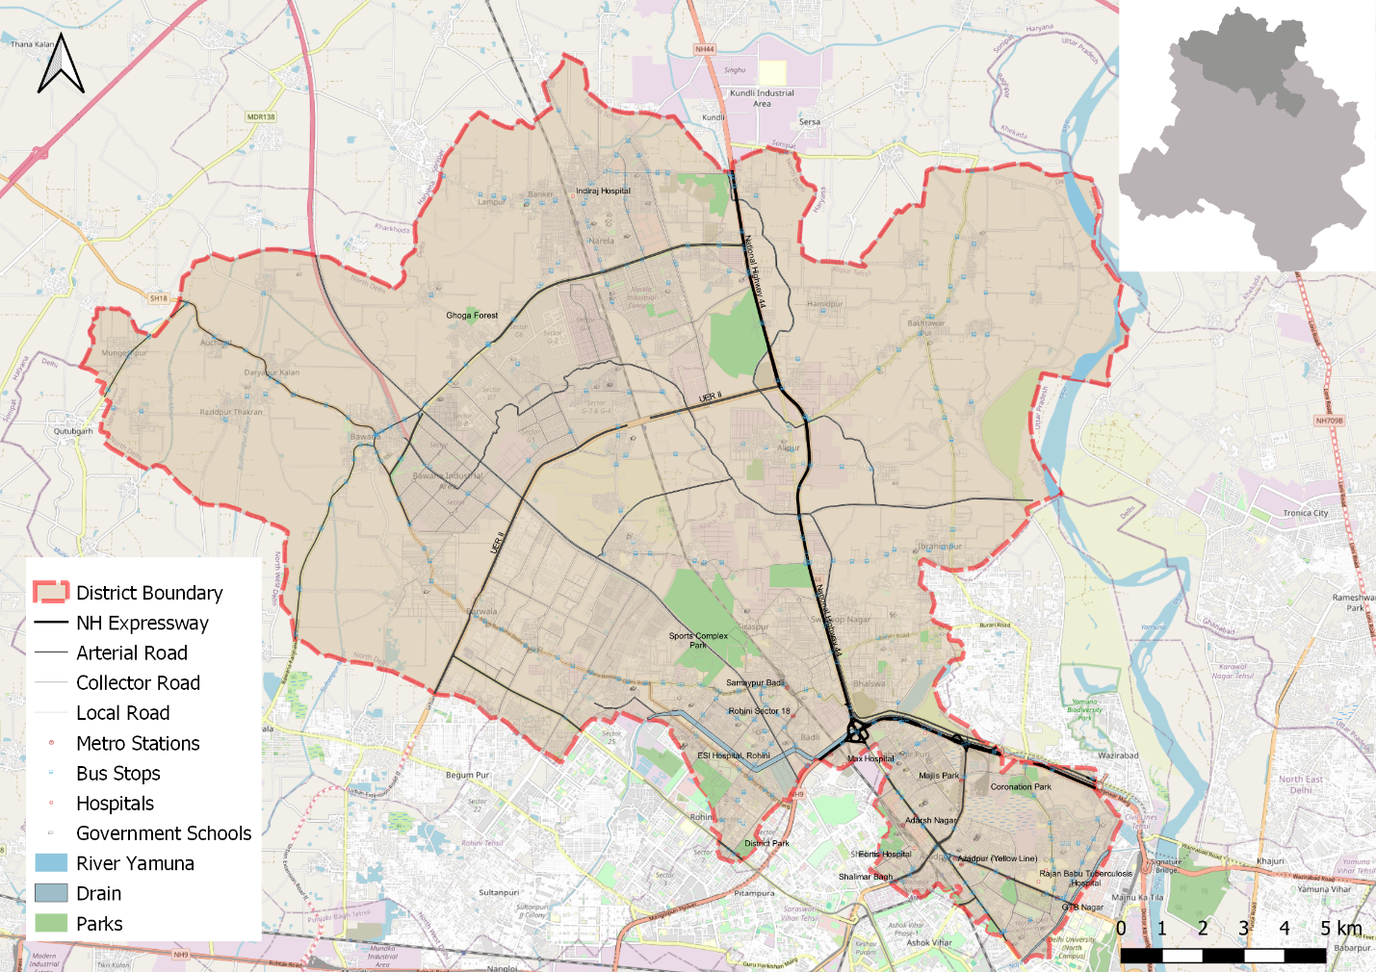

# **: Road Safety situation and trends in North district**

## : Road crash death trends

### : Fatal Road crashes

Figure 1: Fatal crashes and road crash deaths

There were 262 fatal road crashes in the North District of Delhi in 2022 with 267 persons killed in these crashes. There is a 36% increase compared to the previous year 2021 which is 196. One person is killed in road crashes in the North District every one to two days.

### : Road crash fatalities by road user types

Figure 2: Road crash deaths by road user types

Motorcyclists, auto rickshaw occupants and pedestrians formed a majority of persons killed in road crashes in the North District across all three years. Between the highlighted categories, the motorcyclist and autorickshaw occupants’ fatalities surpassed the pedestrian fatalities in 2021 and 2022.

### : Road crash deaths by months

Figure 3: Average Road crash deaths over months

January, March and August witnessed the highest number of persons killed followed by April and October, there is no discernible pattern of fatalities by month.

Figure 4: Road crash deaths over months for years 2019, 2021 and 2022

### : Road crash deaths by time and day of week

|  |  |  |  |  |  |  |  |  |  |
| --- | --- | --- | --- | --- | --- | --- | --- | --- | --- |
|  | **Monday** | **Tuesday** | **Wednesday** | **Thursday** | **Friday** | **Saturday** | **Sunday** | **<NA>** | **Total** |
| **00:00-00:59** | 1 | 5 | 4 | 9 | 2 | 6 | 4 |  | 31 |
| **01:00-01:59** | 6 | 3 | 5 | 5 | 3 | 3 | 3 |  | 28 |
| **02:00-02:59** | 1 | 4 | 1 | 1 | 0 | 4 | 3 |  | 14 |
| **03:00-03:59** | 2 | 1 | 2 | 3 | 1 | 0 | 2 |  | 11 |
| **04:00-04:59** | 2 | 3 | 1 | 1 | 2 | 4 | 0 |  | 13 |
| **05:00-05:59** | 2 | 2 | 0 | 1 | 2 | 2 | 4 |  | 13 |
| **06:00-06:59** | 2 | 1 | 2 | 7 | 1 | 2 | 3 |  | 18 |
| **07:00-07:59** | 3 | 1 | 2 | 7 | 1 | 5 | 4 |  | 23 |
| **08:00-08:59** | 3 | 1 | 2 | 5 | 4 | 3 | 3 |  | 21 |
| **09:00-09:59** | 2 | 3 | 1 | 3 | 1 | 5 | 3 |  | 18 |
| **10:00-10:59** | 2 | 2 | 4 | 3 | 3 | 1 | 3 |  | 18 |
| **11:00-11:59** | 4 | 6 | 1 | 1 | 2 | 2 | 3 |  | 19 |
| **12:00-12:59** | 1 | 3 | 6 | 4 | 3 | 4 | 1 |  | 22 |
| **13:00-13:59** | 2 | 2 | 2 | 4 | 3 | 0 | 2 |  | 15 |
| **14:00-14:59** | 4 | 1 | 1 | 2 | 3 | 3 | 1 |  | 15 |
| **15:00-15:59** | 2 | 1 | 8 | 8 | 4 | 3 | 5 |  | 31 |
| **16:00-16:59** | 9 | 4 | 8 | 6 | 4 | 8 | 1 | 2 | 42 |
| **17:00-17:59** | 2 | 1 | 3 | 5 | 2 | 8 | 1 |  | 22 |
| **18:00-18:59** | 6 | 4 | 2 | 2 | 3 | 2 | 3 |  | 22 |
| **19:00-19:59** | 7 | 1 | 1 | 11 | 3 | 3 | 7 |  | 33 |
| **20:00-20:59** | 2 | 6 | 12 | 9 | 9 | 4 | 3 |  | 45 |
| **21:00-21:59** | 9 | 6 | 4 | 1 | 6 | 10 | 11 |  | 47 |
| **22:00-22:59** | 8 | 14 | 12 | 18 | 9 | 11 | 7 | 1 | 80 |
| **23:00-23:59** | 9 | 10 | 13 | 6 | 7 | 6 | 10 |  | 61 |
| **Total** | **91** | **85** | **97** | **122** | **78** | **99** | **87** | **3** | **662** |

Table 1: Road crash deaths by time and day of week

Thirty percent of the total road crash deaths occurred at night 10:00 pm to 2:00 pm. Similarly, 38% of the total deaths occurred either on Saturdays or on Sundays.

## : Road crash deaths by age and gender (Age and Gender)

### : Road crash deaths by gender

Figure 5: Road crash deaths by gender

### : Road crash deaths by age-groups and gender

Figure 6: Road crash deaths by age groups and gender

Looking at the absolute numbers, the males had a higher number of fatalities 89% compared to females. Among the males, the fatalities were observed to be highest in the age group of 20-29 years, followed by 30-39 years.

## : Road crash deaths by road user types (Road user types)

### : Total Road crash deaths by road user types (2019, 2021, 2022)

**Total fatalities:662**

Figure 7: Road crash deaths by road user types (2019, 2021 and 2022)

*Other includes cycle rickshaws, converted rickshaws and hand carts

Ninety percent of fatalities were among vulnerable road users (i.e., pedestrians, motorcyclists, cyclists, and auto rickshaw occupants). Among this, forty four percent of road crash deaths in the North district were among pedestrians, followed by motorcyclists (39%).

### : Timewise Road crash deaths by road user types

Figure 8: Road crash deaths by road user types for months

Figure 9: Timewise road crash deaths by road user type

### : Who-hit-whom matrix

|  |  |  |  |  |  |  |  |  |  |
| --- | --- | --- | --- | --- | --- | --- | --- | --- | --- |
| **Victim Road User** | **Impacting Vehicle** | | | | | | | | |
| **Motorcycle** | **3-Wheeler** | **Car** | **Bus** | **Truck/Tractor** | **Single Vehicle Crash** | **Other** | **Unknown** | **Total** |
| **Pedestrian** | 12 | 3 | 34 | 6 | 66 | 0 | 4 | 167 | 292 |
| **Cyclist** | 3 | 0 | 5 | 0 | 6 | 0 | 0 | 2 | 16 |
| **Motorcyclist** | 9 | 3 | 27 | 8 | 81 | 19 | 2 | 113 | 262 |
| **3-Wheeler Occupant** | 1 | 0 | 7 | 0 | 4 | 4 | 1 | 11 | 28 |
| **Car Occupant** | 0 | 0 | 5 | 4 | 12 | 4 | 2 | 4 | 31 |
| **Truck/Tractor Occupant** | 2 | 0 | 1 | 2 | 10 | 4 | 3 | 5 | 27 |
| **Other** | 2 | 0 | 1 | 0 | 0 | 2 | 0 | 1 | 6 |
| **Total** | 29 | 6 | 80 | 20 | 179 | 33 | 12 | 303 | 662 |

Table 2: Who-hit-whom matrix

Note: Other includes cycle rickshaws, converted rickshaws and hand carts

Among all fatal road crashes where the impacting vehicle was known, pedestrians and motorcyclists were found to be the most vulnerable category of road users. They were often hit by trucks and tractors. Hit-and-run crashes dominate both the categories of cases where the impacting vehicle was not known for 167 cases in case of pedestrians and 113 in case of motorcyclists.

## : Hit-and-runs in fatal road crashes (Hit-and-runs)

### : Percentage of hit-and-run and non-hit-and-run cases.

Figure 10: Percentage of hit-and-run and non-hit-and-run cases

Overall, Three out of five crashes are hit-and-run cases. The high rate of hit-and-run cases is indicative of non-reporting of accused vehicles as well as non-reporting of crashes by the public.

### : Hit-and-run Road user types

Figure 11: Hit-and-run victims road user types

## : Road crash heatmaps (Heatmaps)

### : Heatmap of all road crash deaths

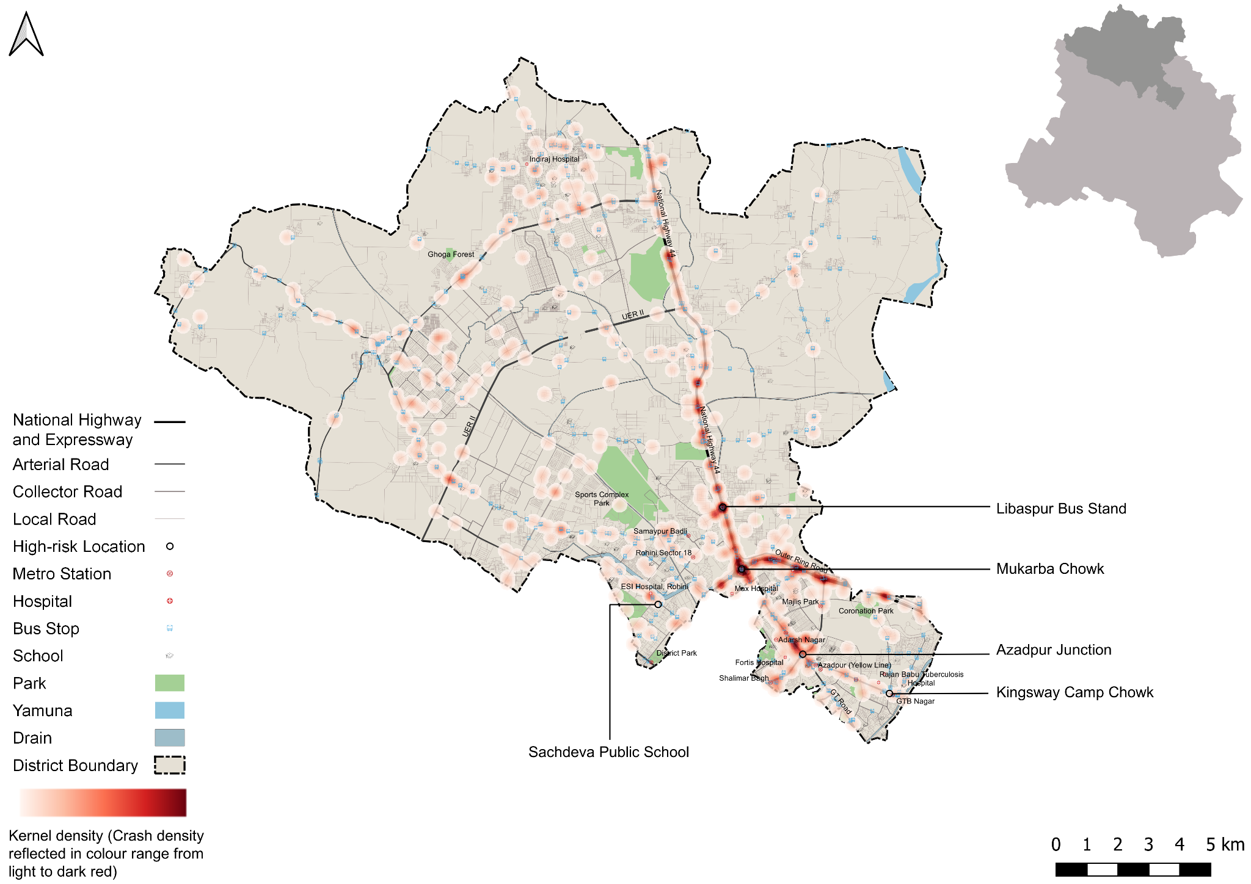

Figure 12: Heatmap of all road crash deaths in North District

### : Heatmap of all pedestrian deaths in fatal road crashes

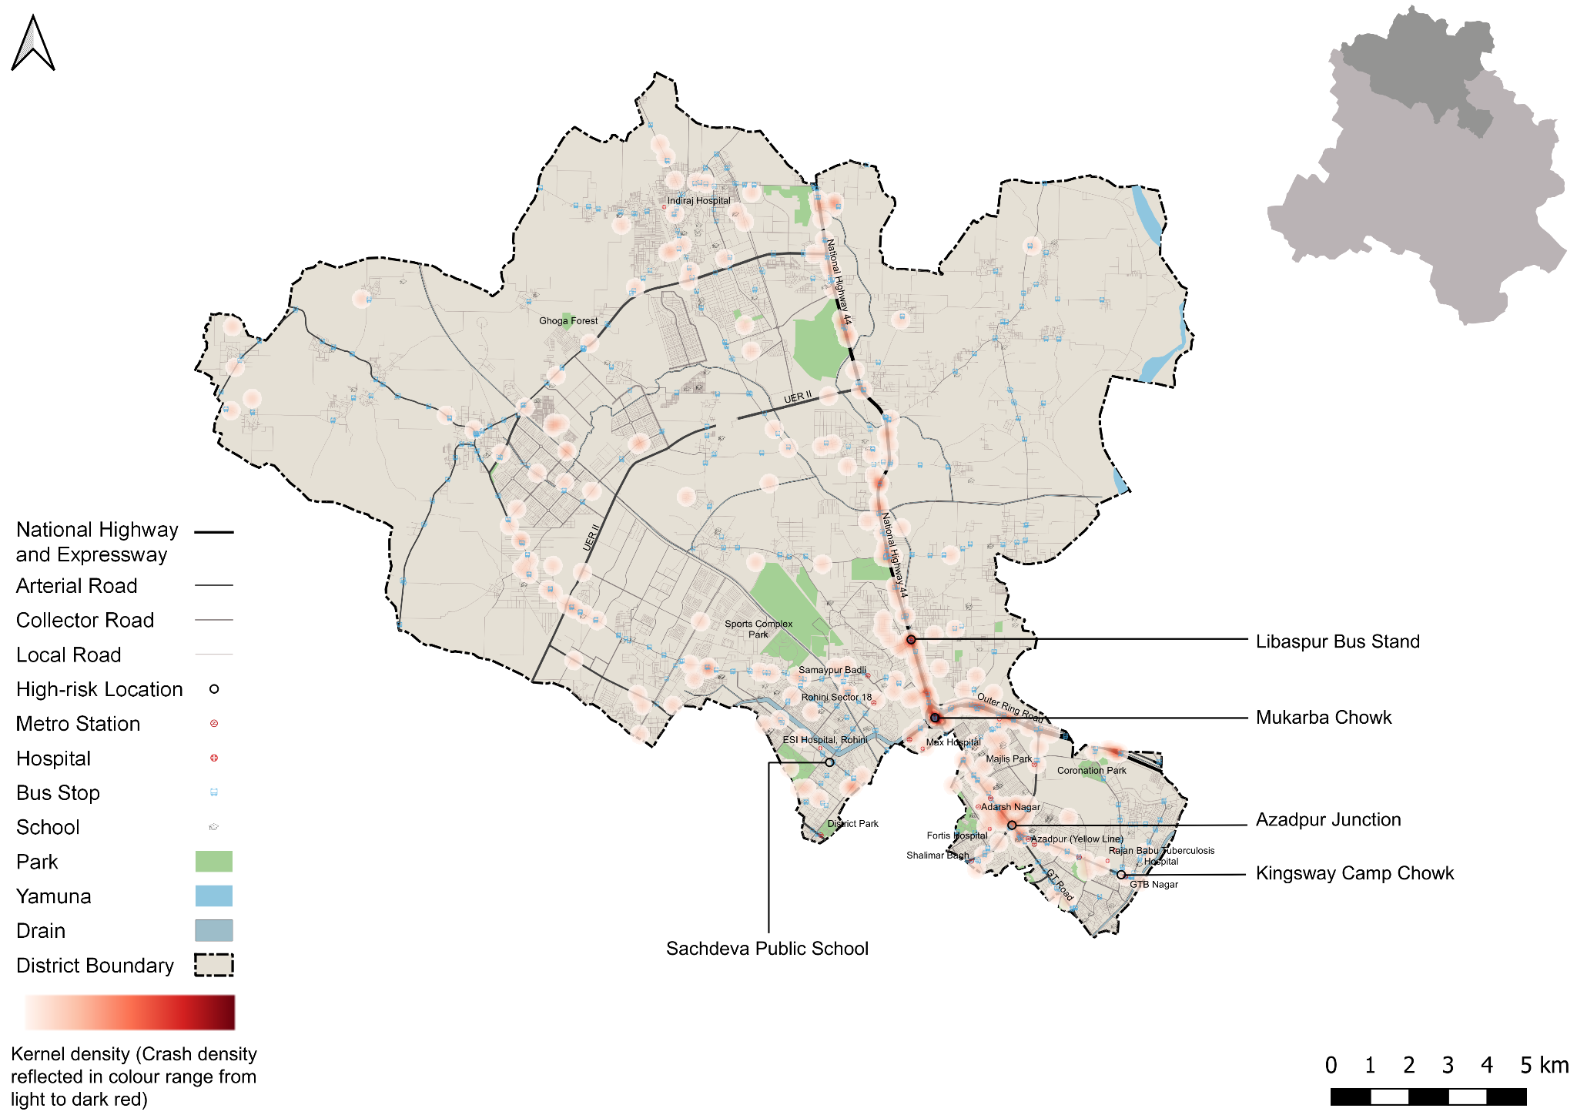

Figure 13: Heatmap of all pedestrian deaths due to road crashes in North District

### : Heatmap of all motorcycle (rider + pillion) related deaths

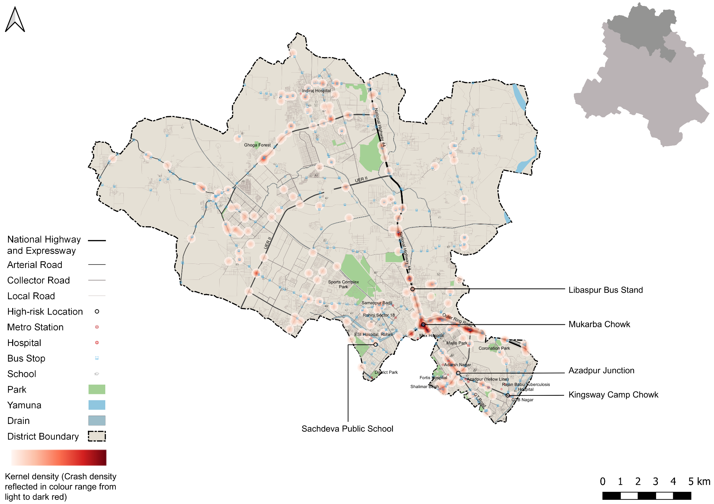

Figure 14: Heatmap of all motorcycle related deaths due to road crashes in North District

## : High risk locations

### : List of high-risk locations

The following is a list of high-risk locations in the North district which includes the number of fatal crashes, hit-and-run crashes, and deaths occurred during these crashes in years 2019, 2021 and 2022. Mukarba Chowk has the highest number of fatal incidents and fatalities out of all the identified locations. This is followed by Azadpur Junction and Libaspur Bus Stand.

|  |  |  |  |
| --- | --- | --- | --- |
| **High Risk Location** | **Total fatal crashes** | **Total hit and run fatal crashes** | **Total persons killed** |
| Mukarba Chowk | 36 | 29 | 36 |
| Azadpur Junction | 13 | 8 | 13 |
| Libaspur Bus Stand | 9 | 7 | 10 |
| Kingsway Camp Chowk | 1 | 1 | 1 |
| Sachdeva Public School | 1 | 1 | 1 |

Table 3: List of high-risk locations

### : Map of all high-risk locations

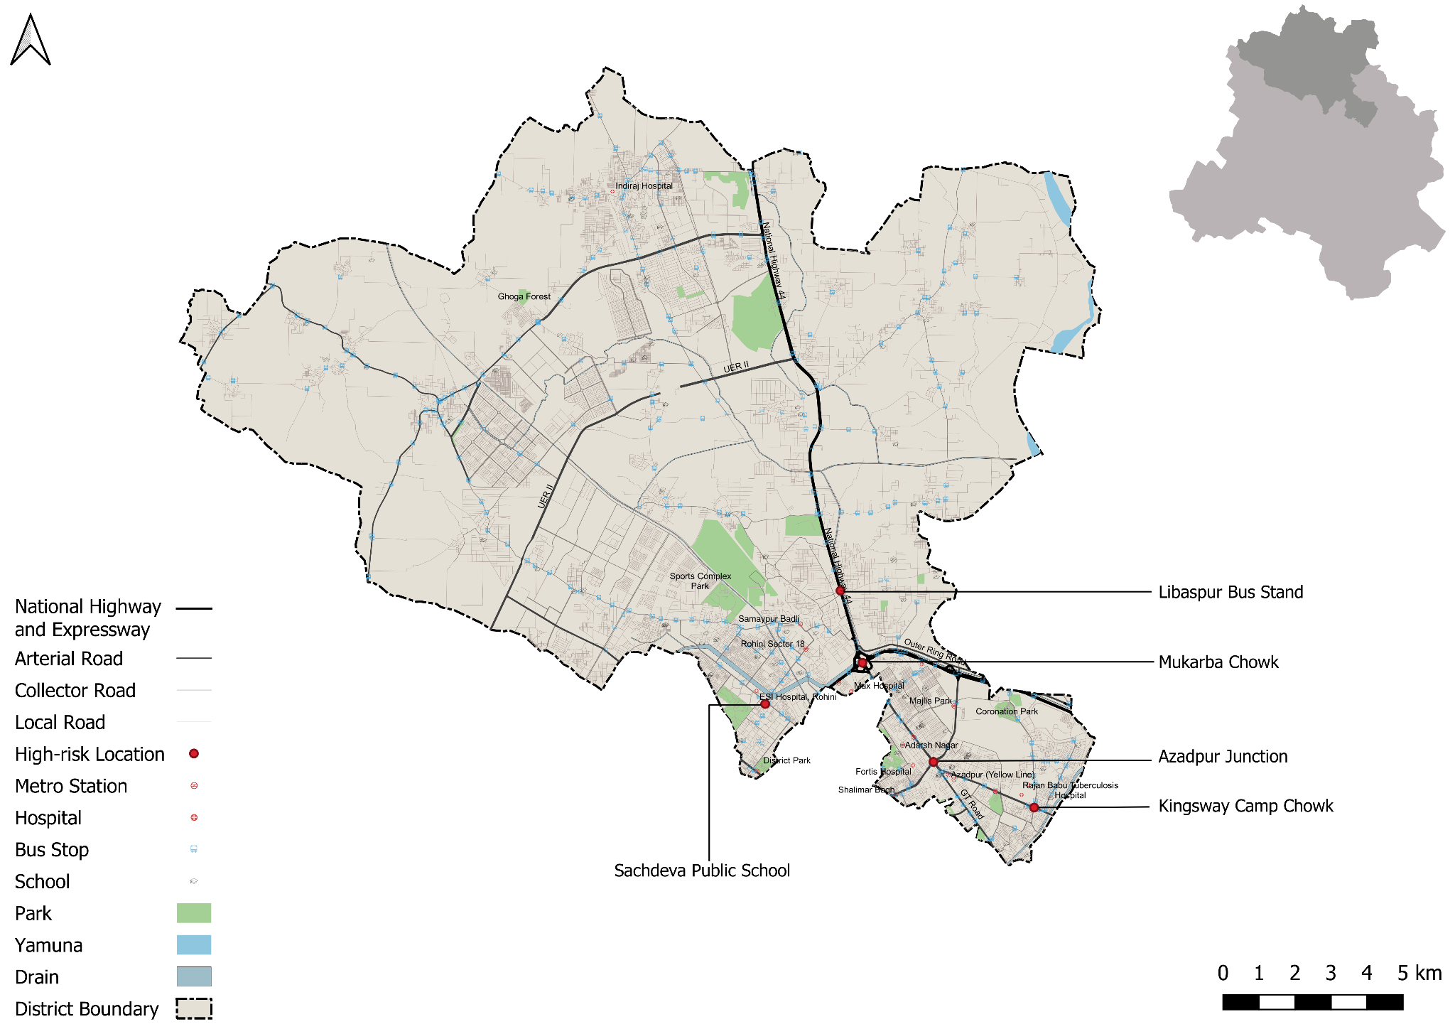

Figure 15: Map of all high-risk locations intervened in North District

### : High risk corridors

Figure 16: Vulnerable Road users on corridors

Figure 17: Vulnerable Road users’ death per km

# **: Data to Action**

## : Mukarba Chowk

### : General description of the site

Mukarba chowk (Latitude 28° 44 '05.6"N Longitude 77° 09' 20.9"E) has been a blackspot for the last three years. It intersects the Grand Trunk Road and the outer ring road. It is served by the yellow line, the nearest metro stations being Haiderpur Badli Mor and Jahangirpuri. The Mukarba Chowk intersection is a very large-scale high speed vehicular infrastructure with an area of 3,00,000 sqm, making it challenging for other street users to navigate their desired routes through it. This busy intersection with multiple lanes and levels including cloverleafs is a meeting point for major arterial roads. However, it is part of a huge urban area surrounded by residential & industrial neighbourhoods such as Sanjay Gandhi Transport Nagar, Bhalswa, Jahangir Nagar, Jahangirpuri industrial area, Baldi village & Bhalswa landfill site as activity generators.

Apart from the neighbouring context, Intersection also acts as a major grade separated interchange for public transport. This makes it a hub of pedestrian movements accessing various nodes around it & connected to the rest of the city through public transport located at the centre of the intersection.

The scale of the intersection represents a complicated modern urban planning approach prioritizing vehicular movement over people friendly mobility. This has resulted in undefined infrastructure for pedestrian movement leading to multiple conflict points throughout the designed infrastructure.

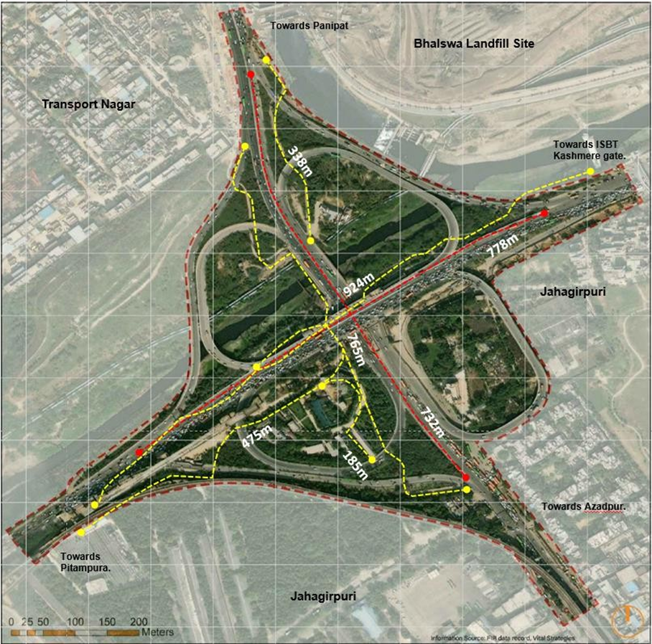

### : Existing scenario

Getting through Mukarba Chowk is a challenge for vulnerable road users including pedestrian two- wheelers & intermediate public transport, due to lack of dedicated infrastructure, high speed movement of bigger vehicles and lack of directional information.

There are dedicated paths provided by pedestrians & NMT users at ground level to pass through this intersection, but are not in usable condition due to less legibility, low maintenance and completely isolated from the eyes on the street posing safety & security risk.

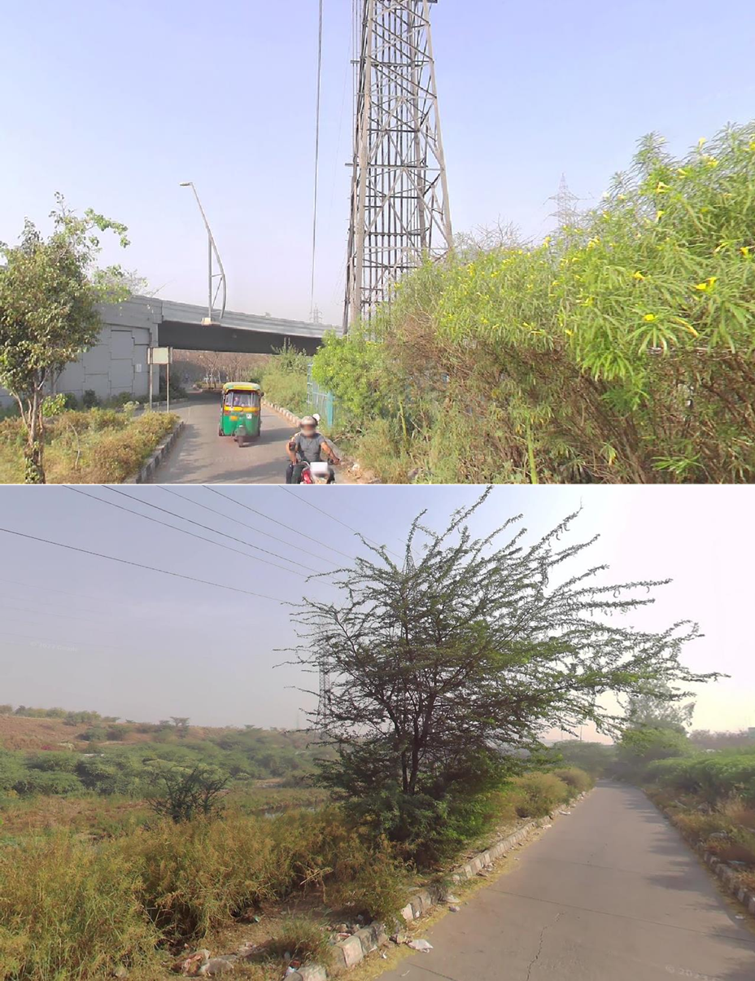

The planned routes are unsafe & isolated, also it becomes unreasonable to expect people to walkthrough distance ranging from 300m to up to 1 km including level changes.

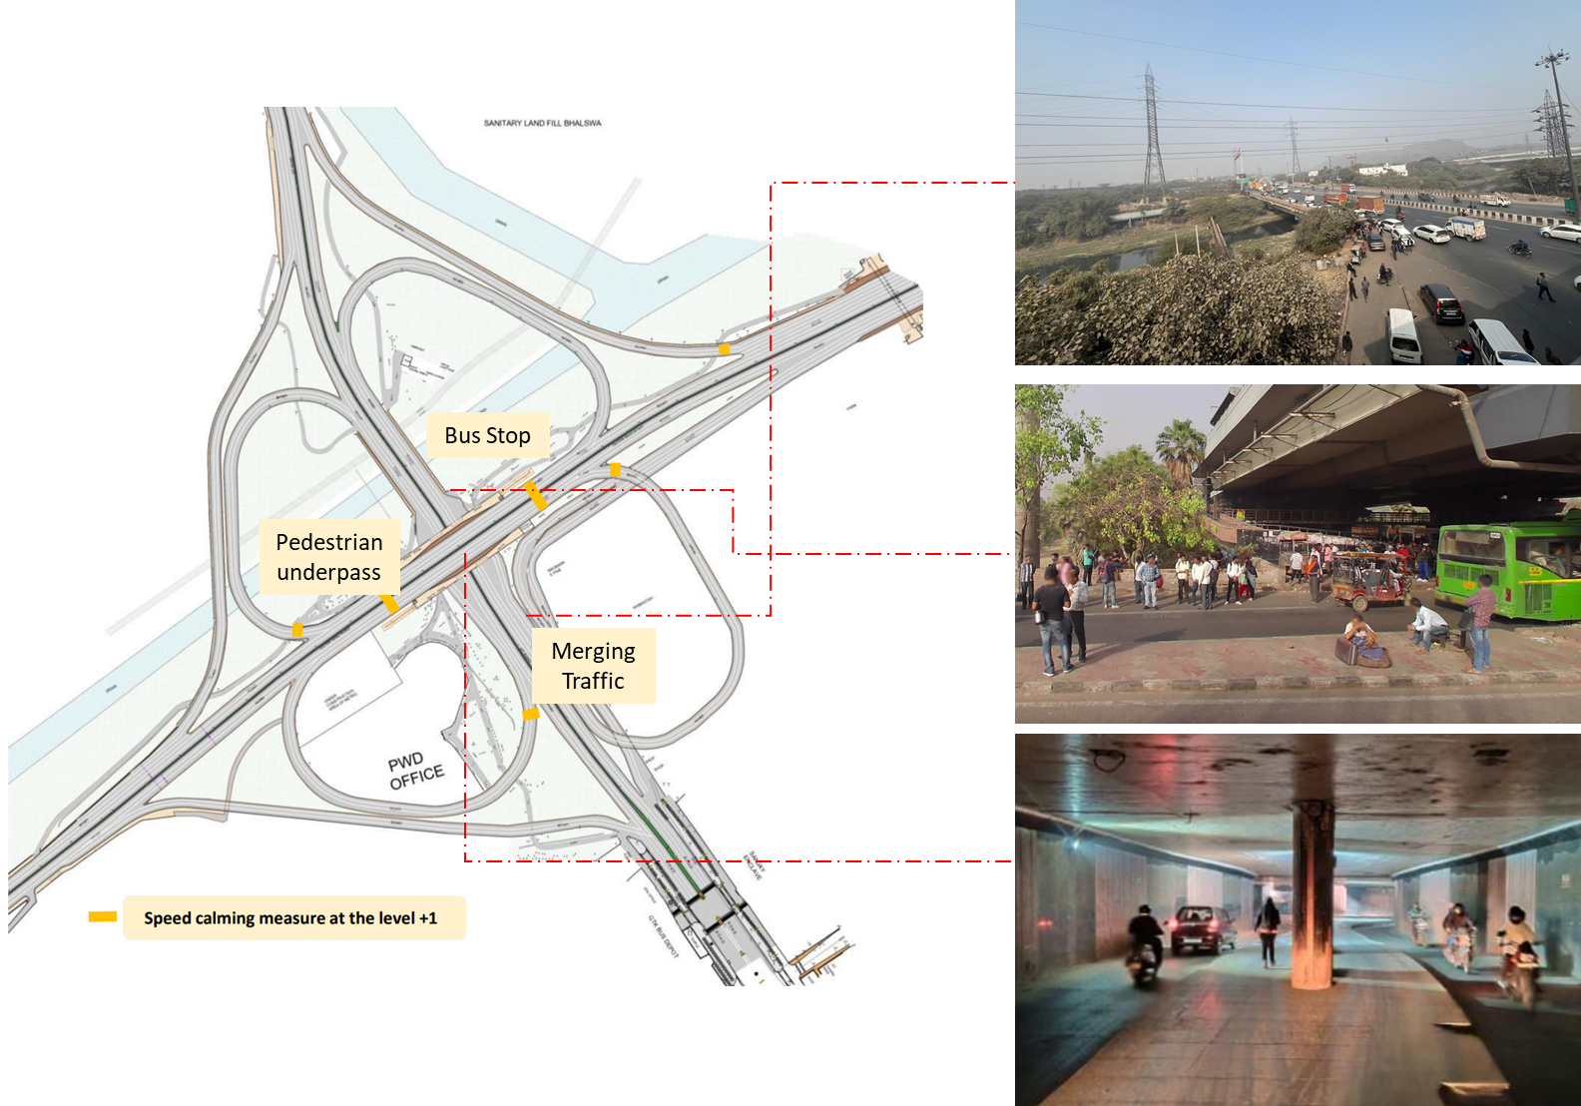

### : Issues identified

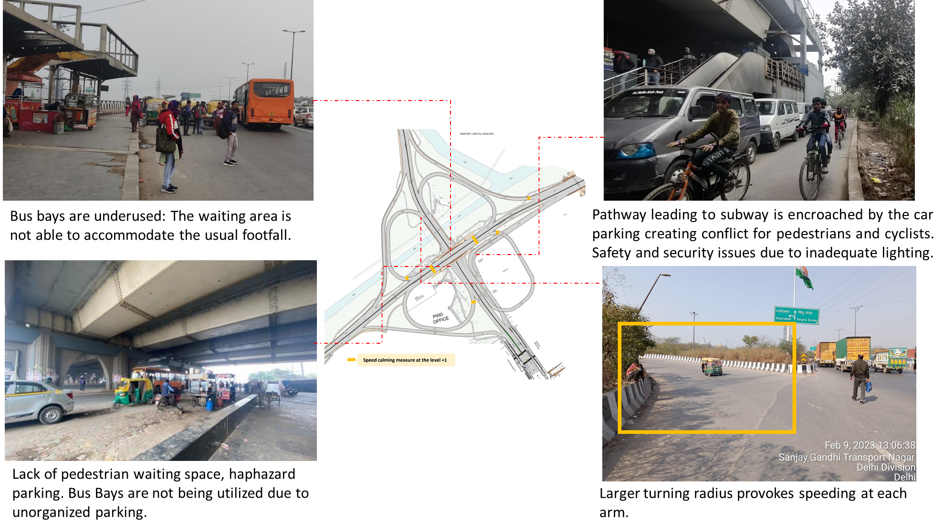

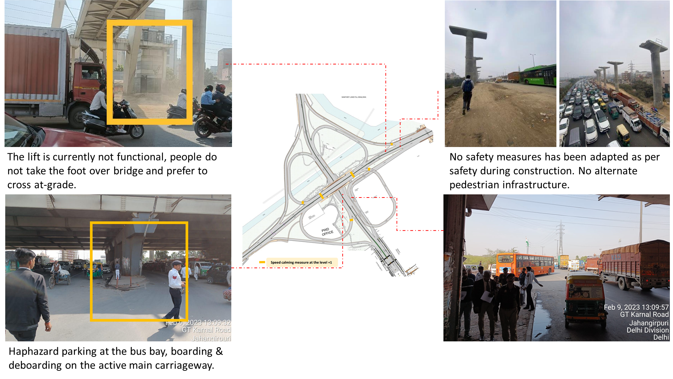

1. The bus bays on the flyover are not wide enough to accommodate the footfall.
2. No safety measures have been adapted as per safety during construction such as an alternate pedestrian path during the construction time.
3. Lack of pedestrian waiting space for buses. Haphazard on-street parking stopping to pick up passengers and underutilised bus stops leads to further congestion.
4. Pathway Leading to subway is encroached by the car parking creating conflict for pedestrian & cyclist, safety & security Issue due to inadequate Lighting.
5. The lifts at the foot over bridges were not functional, people prefer to cross at grade then take the stairs of the foot over bridges.
6. People are dropped off under the flyover and they walk up to the nearby villages/ bus stops that do not have a continuous pedestrian path.
7. Haphazard parking at the bus bay, boarding & deboarding happening on the main carriageway.
8. Larger turning radius encourages speeding at entry/exit points of the arms of the intersection.

### : Proposed design

The infrastructure has been designed in purview to accommodate vehicular demands, without incorporating human-scale components. Hence, it is suggested to develop a comprehensive public space beneath this intersection at the ground level, which is vibrant with multiple activities, supported by adequate lighting & directional signage.

It should have a well-designed landscape along with a planned cycle of maintenance, continuous pedestrian infrastructure connecting the central public transport interchange, bus stops located at the edges of the intersection and neighbourhoods. It is recommended to hire a design consultant to develop this comprehensive public space area approx. 93,000 sqm, to be completely segregated from the current vehicular infrastructure.

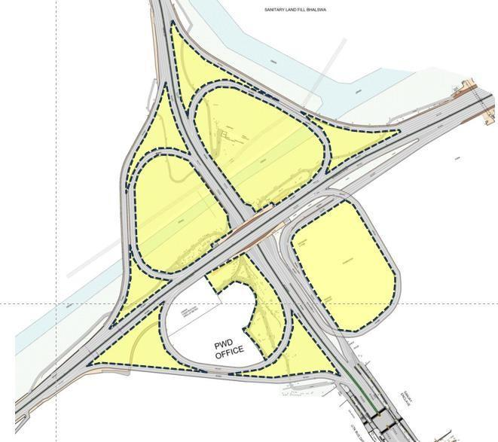

A comprehensive public space design needs to be developed for approx. 92,000 sqm at the ground level, completely segregated from the current vehicular infrastructure.

* In addition to public space intervention, there is a need to improve vehicle infrastructure for the safety of all road users.
* Improvement of the existing infrastructure on three levels at the centre of the intersection is crucial as it is a public transport interchange hub, due to the presence of bus stops & IPT systems for last-mile connectivity at multiple levels. Pedestrians commuting to reach their destinations frequently board and alight from buses and IPT at these levels, raising multiple conflicts with vehicular movements.
* To address these pressing issues the road crashes at Mukarba Chowk should be investigated on the spot for better understanding of causes and remedial measures.
* Meanwhile, at the existing infrastructure, WRI India has suggested six key measures, i.e Geometrical correction, Signage, Speed calming measures, Lighting, CCTV surveillance & road marking to improve the safety & security of the intersection at three levels as marked on the conceptual drawings submitted to PWD & Transport department.

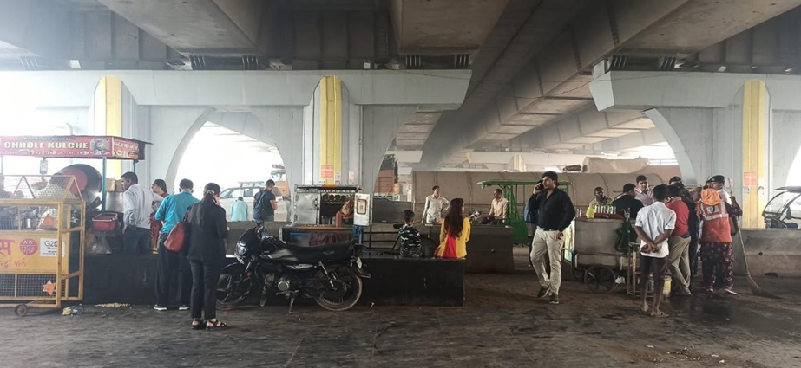

IPT interchange with lack of legibility, People prefer to cross the interchange at ground level risking their lives to avoid larger crossing distance.

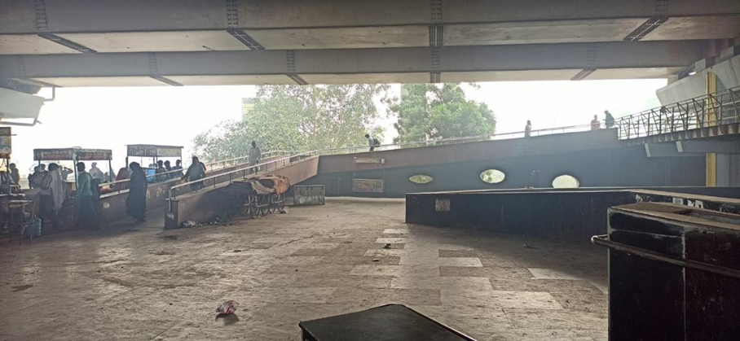

Lack of maintenance, Lighting & Legibility at grade level.

The intersection consists of cloverleafs and separate slip lanes on all directions where it has been observed a continuous trend of crashes at merging and diverging spots. Additionally, crashes are also observed at the centre of the slip lane majorly involving two wheelers’ fatalities. One of the key reasons for this is high speed movement of vehicles while merging, diverging and turning resulting in crashes leading to fatalities and serious injuries in both night & day hours.

To address these pressing issues the road crashes at Mukarba Chowk should be investigated on the spot for better understanding of causes and remedial measures. Meanwhile at the existing infrastructure, WRI India has suggested six key measures, i.e., Geometrical correction, Signage, Speed calming measures, Lighting, CCTV surveillance & road marking to improve the safety & security of the intersection at three levels as marked on the conceptual drawings submitted to PWD & Transport department.

* Geometrical correction: Adjusting the physical layout of roads to improve safety by aligning the traffic lanes, removing the residual spaces, providing adequate infrastructure to curb spill over activities & dedicated space for NMT users.
* Signage: The use of visual information, such as road signs, to communicate important messages such as cautionary, wayfinding, informatorily, speed limits & other hazard warning and guide all road users navigating through the infrastructure.
* Speed calming measures: Strategies implemented to reduce vehicle speeds, enhancing road safety by minimizing the risk and severity of crashes.
* Lighting: Adequate illumination of roadways & pedestrian pathways to enhance visibility, ensuring safer conditions for driving and pedestrian activities, particularly during low-light or night-time.
* CCTV surveillance: The use of closed-circuit television cameras to monitor and record activities at intersections or along roadways, aiding in traffic management, law enforcement, and enhancing overall safety and security.
* Road marking: The application of painted lines, symbols, or patterns on road surfaces to convey information, regulate traffic flow, and improve safety by defining lanes, crosswalks, merging & diverging and other crucial elements of the road infrastructure.

The above-mentioned recommendations have been identified on the conceptual plans below for all the three levels.

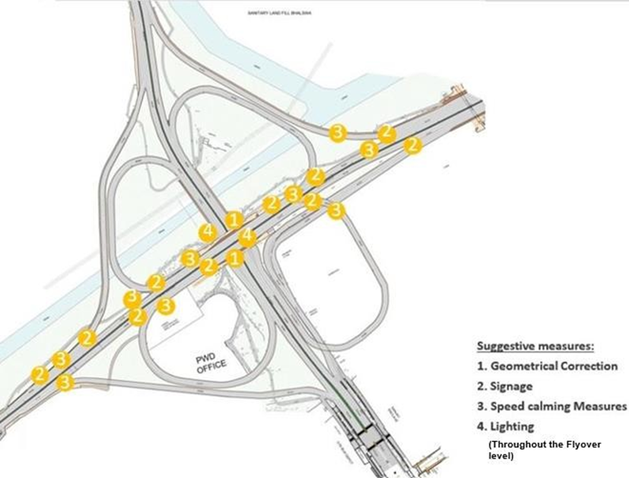

Figure 1‑1: Suggested measures at flyover level

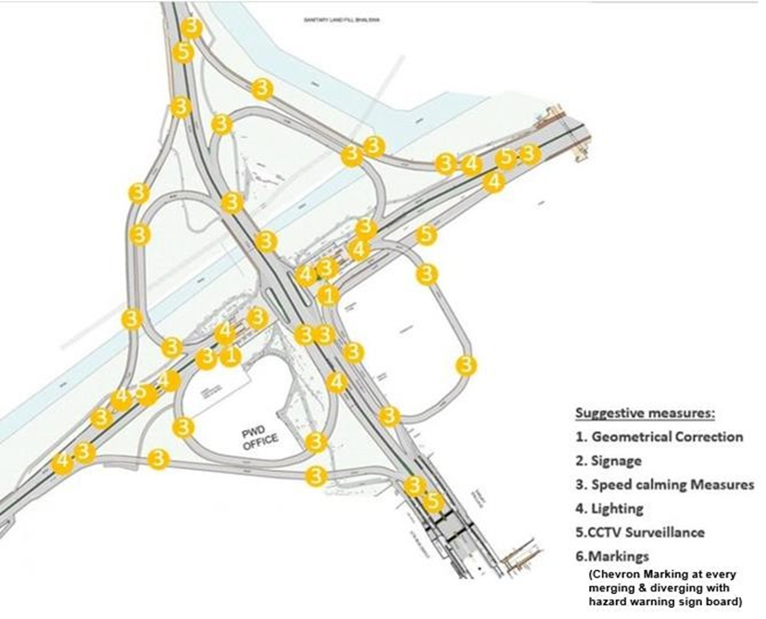

Figure 1‑2:Suggested measures at ground level

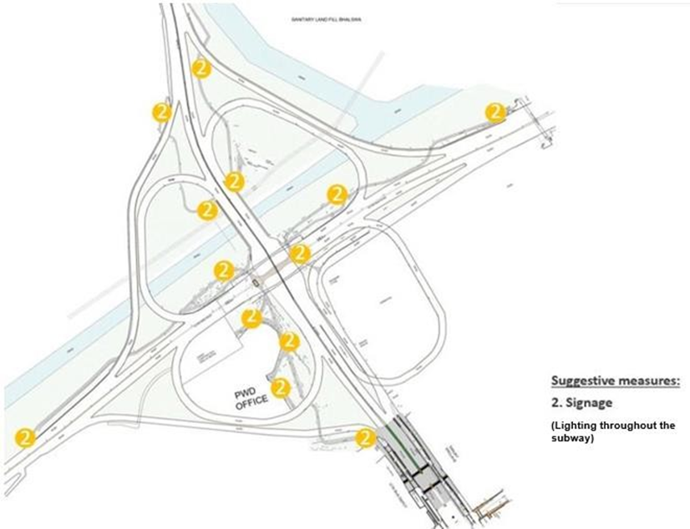

Figure 1‑3: Suggested measures at subway level

1. More bus shelters needed to cater the footfall.
2. Infrastructure for NMV and pedestrians should be designed below the metro line (to connect the village and the foot over bridge). DMRC to provide measures for traffic management in work zones as per IRC-SP-55 for overall safety for the proposed metro line.
3. Footpath improvement, and kerb/ edge repair works need to be done streamlining autos, buses and private vehicle movement and parking. Providing table-top crossings for speed calming and pedestrians.
4. Pathways leading to subway level need to be regulated; safety and lighting needs to be worked out; parking should be restricted for uninterrupted paths for cyclists.
5. Lift not functional, regular maintenance to be done along with maintenance of access ramp to maximise the usage of the foot over bridge.
6. Increase the legibility & Safety & security of the walking & cycling infrastructure by providing adequate lighting, increase the visibility by cleaning the vegetation along the island.
7. Core area demarcation missing: Flexible bollards, Hazard markers, Solar Road studs are required.
8. Speed calming measures, such as speed tables, need to be provided for reducing the speed. Clear the vegetation near the island to maximize the visibility.
9. Height restriction by using gantry for heavy vehicles. Lighting/Safety/Signages. Speed calming measures clear the vegetation to maximize the visibility.

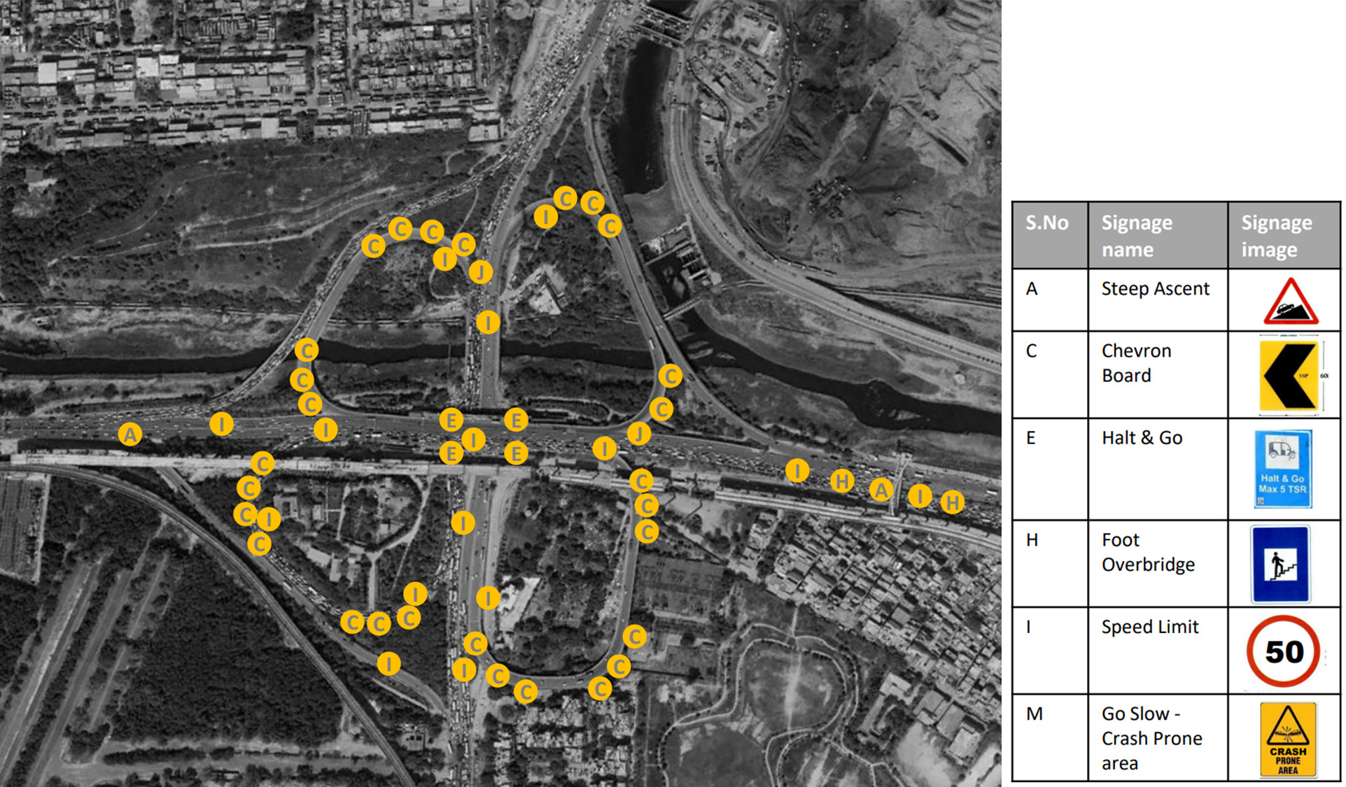

## : Azadpur Junction

### : General description of the site:

Azadpur Junction (Latitude 28° 42 '36.33"N; Longitude 77° 10' 33.96"E) is a signalised four-arm intersection. It acts as a major point for passengers coming from the north Delhi to west and central Delhi side. There is a high number of pedestrian footfall due to commercial activities near junctions. This area is served by the red and yellow metro lines, and the nearest metro stations are Azadpur metro station and Adarsh Nagar metro station. Proposed magenta metro line is under construction by Delhi Metro Rail Corporation. The intersecting roads are Grand Trunk Road and Mahatma Gandhi Road.

### : Existing land use

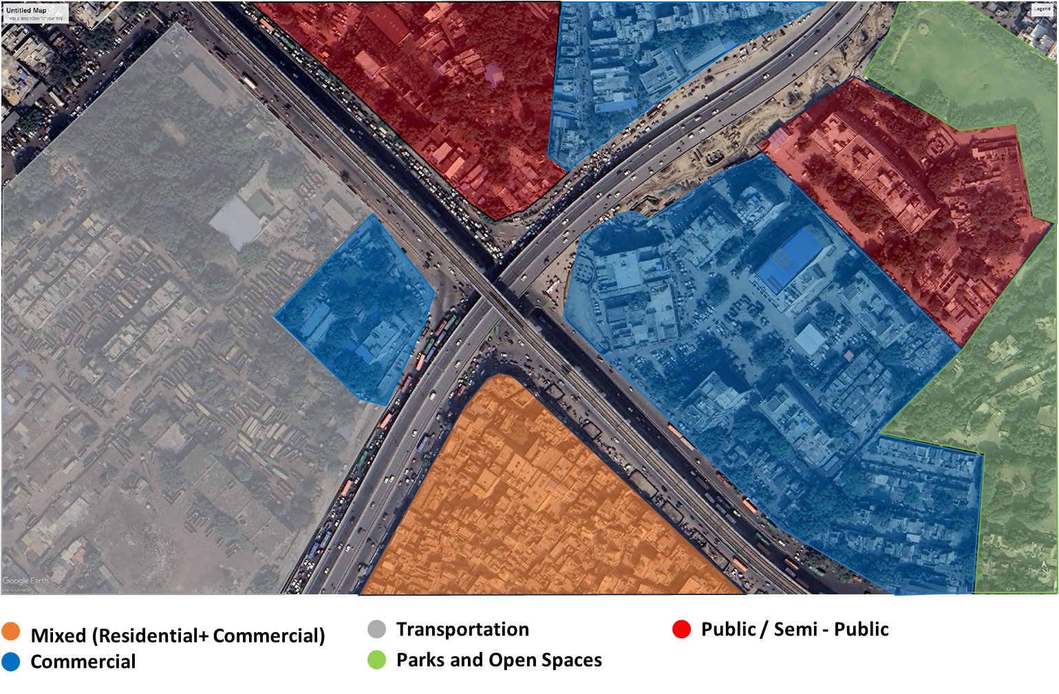

### : Land use evolution

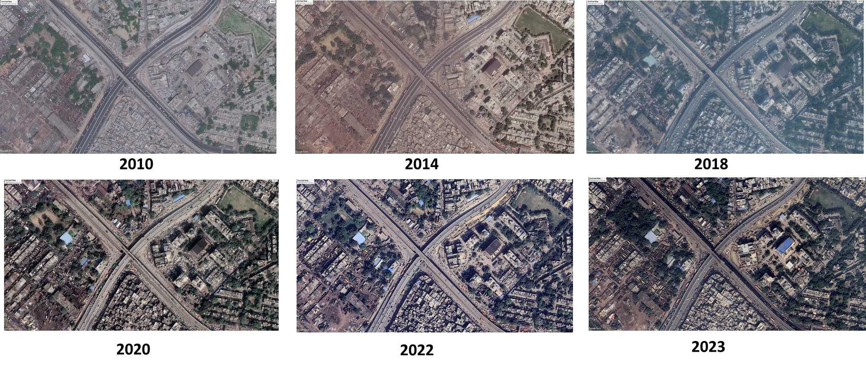

### : Existing scenario

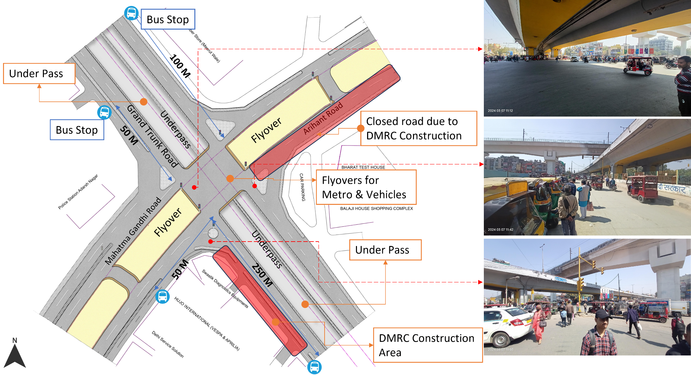

### : Traffic volume count

**Morning peak hour: 09:30 – 10:30 = 15857**

Figure 4: Traffic volume count: Azadpur Junction

**Hourly Traffic Flow**

Figure 5: Hourly traffic flow: Azadpur Junction

**Mode wise traffic distribution**

Figure 6: Mode wise hourly traffic distribution: Azadpur Junction

### : Peak hour traffic flow

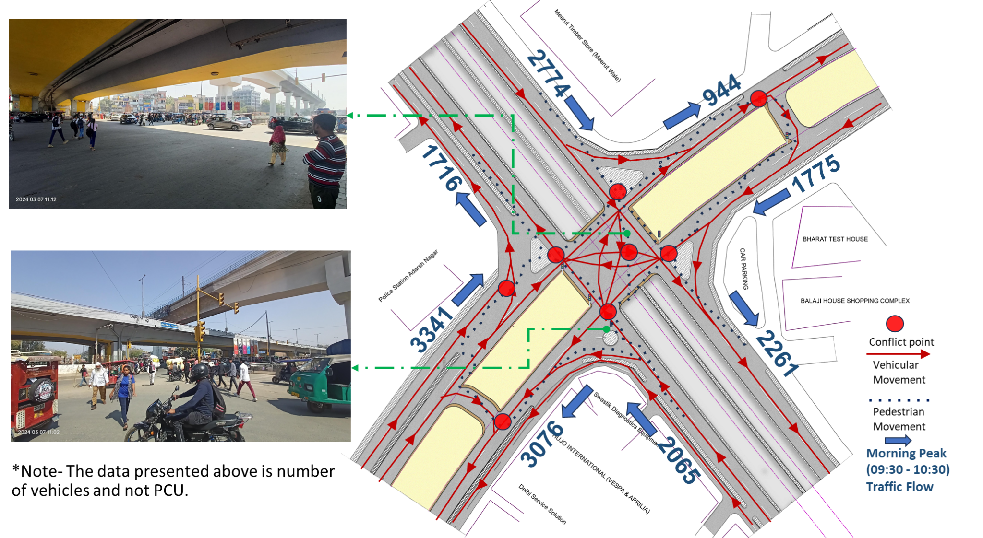

### : Issues identified

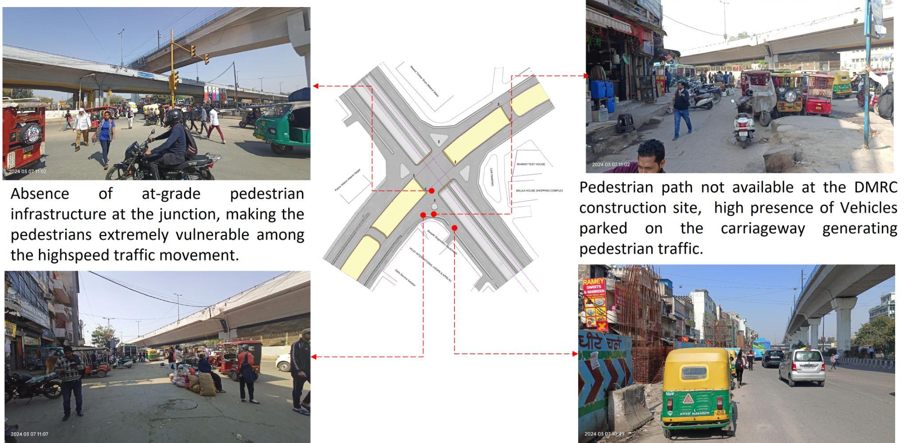

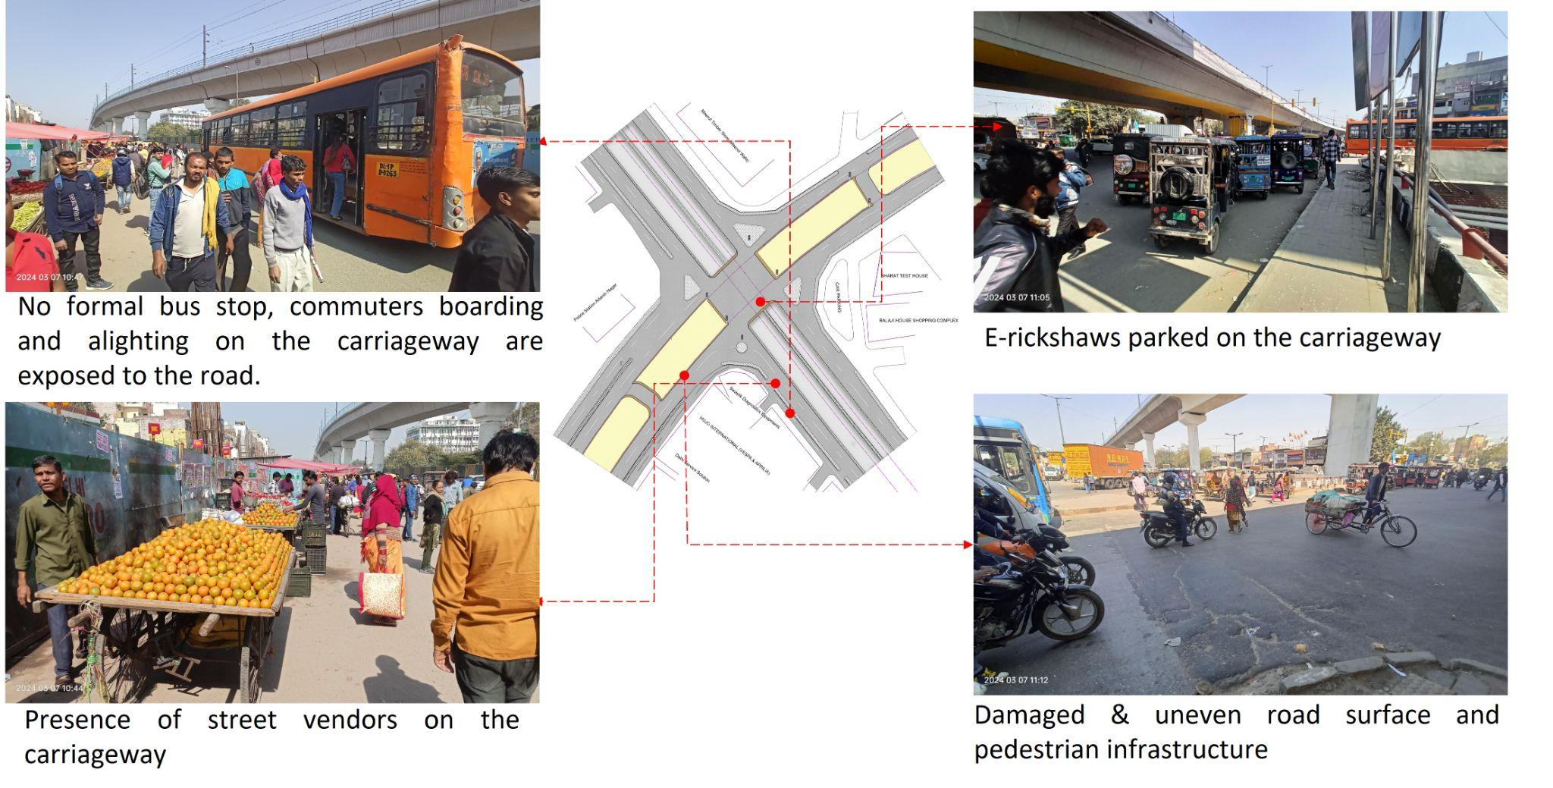

1. Absence of at-grade pedestrian infrastructure at the junction, making the pedestrians extremely vulnerable among the high-speed traffic movement.
2. Lack of pedestrian paths at the Delhi Metro Rail Corporation (DMRC) construction, should be provided as per IRC SP 55.
3. Vehicles parked on the road are causing traffic congestion by obstructing the flow of traffic
4. Absence of bus stops at junctions due to construction by DMRC. DMRC should provide the temporary bus stops as per IRC 55.
5. Absence of safety measures on construction site.
6. Damaged & uneven road surface, raising the chances of accidents and injuries for vehicles and pedestrians.
7. Absence of kerb ramp and tactile flooring for differently abled users.
8. Absence of road markings, signages and speed control measures at the intersection.
9. Absence of delineators and reflectors on the median and carriageway edges.
10. Absence of chevron marking and hazard markers or flexible markers at bull noses.
11. Absence of segregated cycle tracks on arterial roads.

### : Proposed design

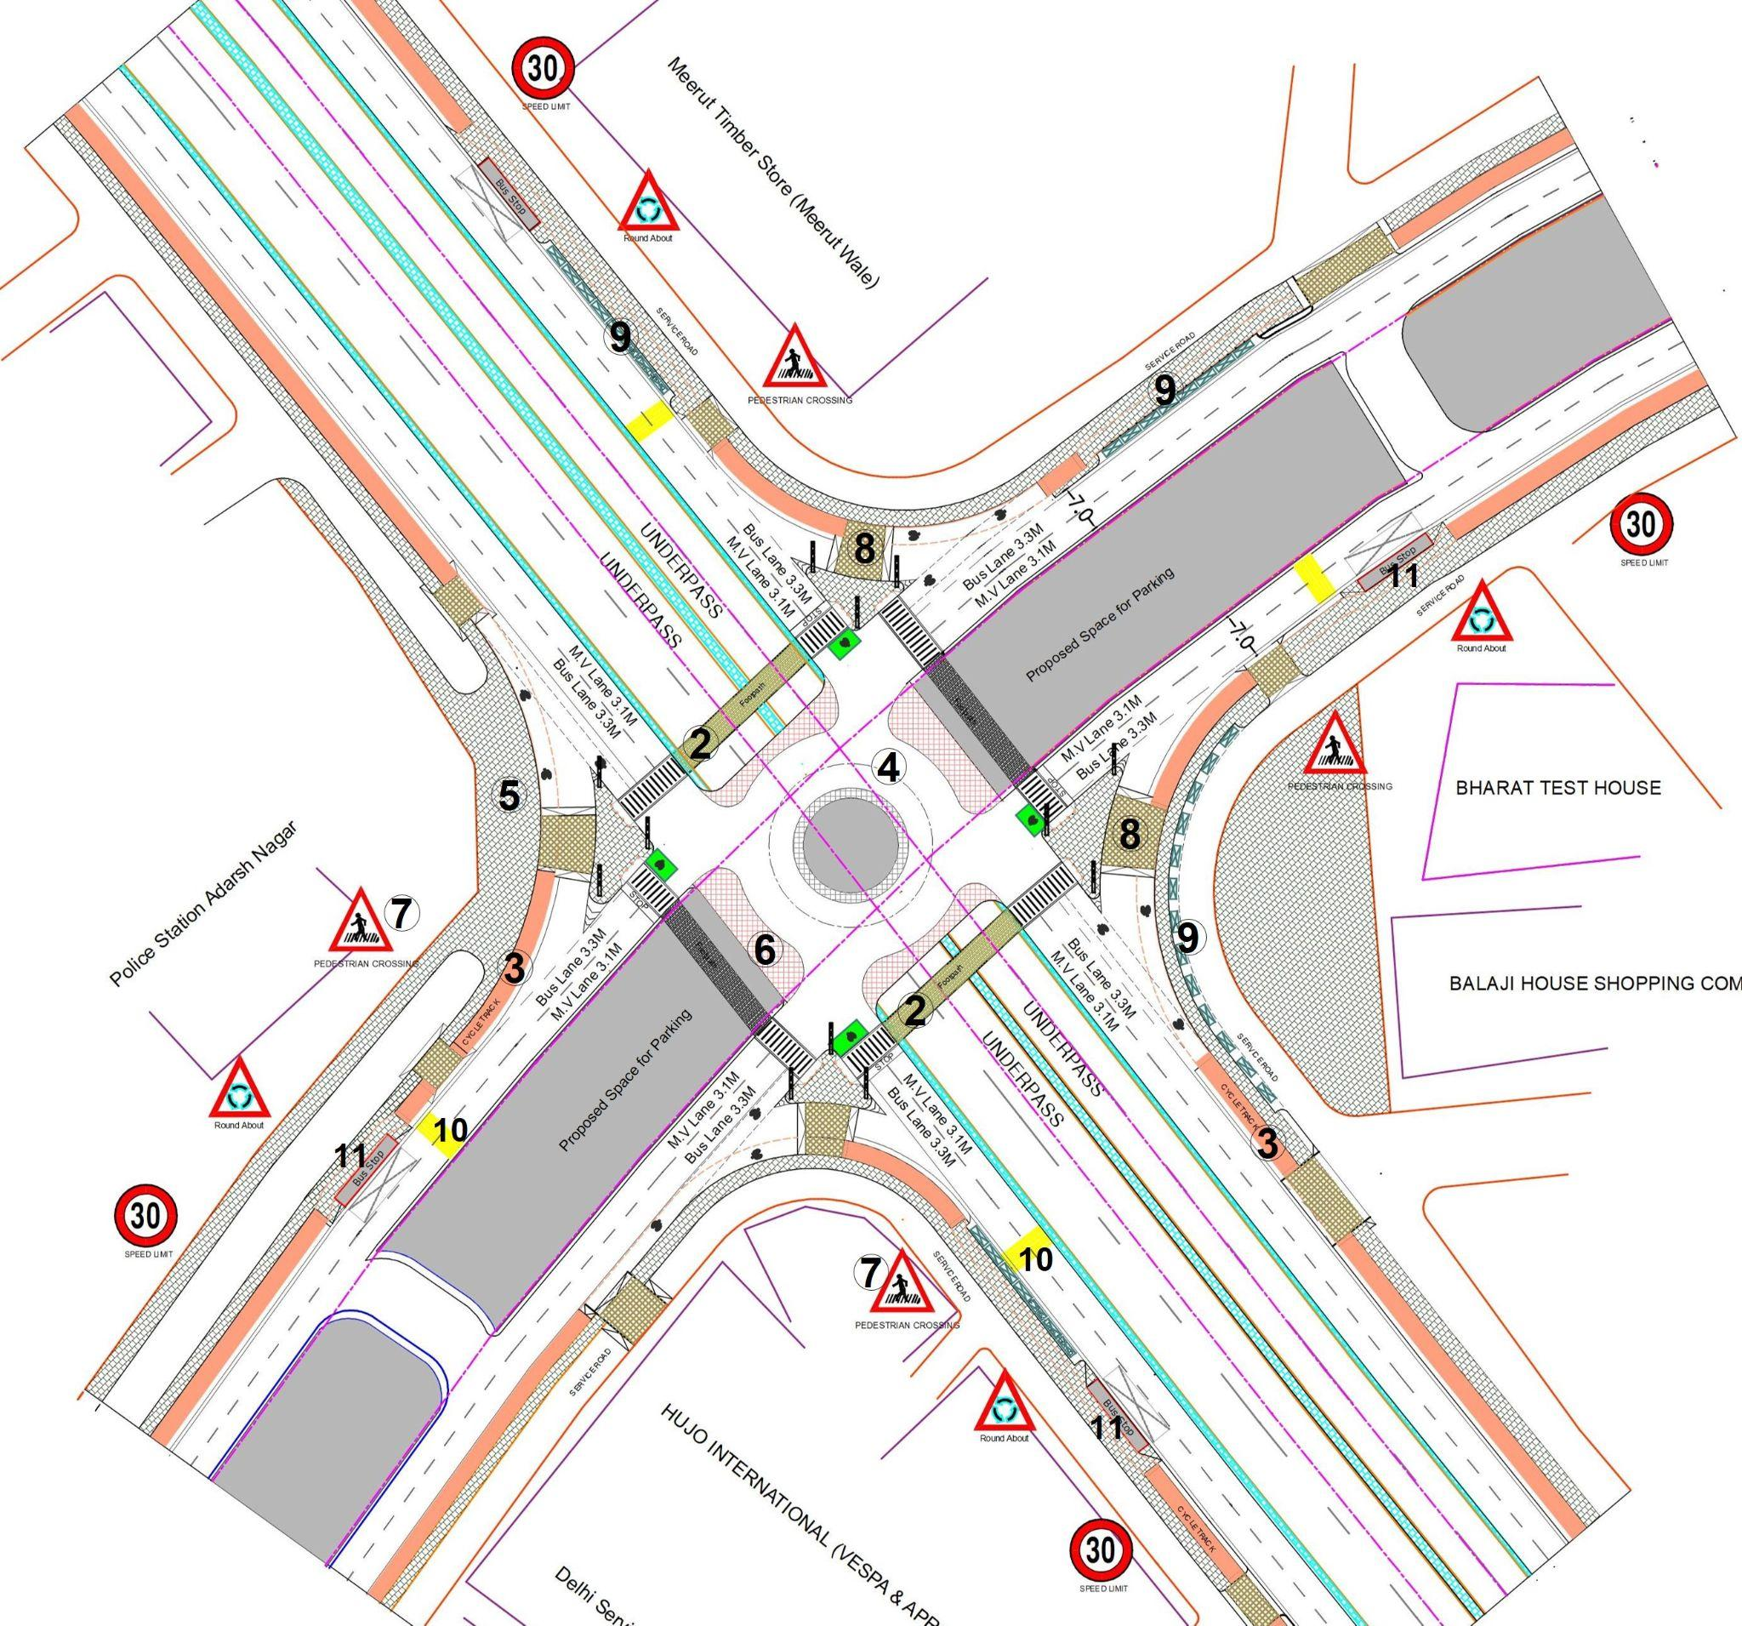

**Design Interventions:**

1. The junction is redesigned for the speed of 30 km/hr to ensure the safety of road users.
2. Proposed at-grade pedestrian crossing over vehicular underpass to increase the accessibility and safety for pedestrians.
3. Dedicated 2.5m wide cycle track to separate the motor traffic and the cyclists (as per Indian Road Congress (IRC): 11-2015).
4. Redesigned the geometry of the junction and proposed a roundabout to decrease the conflict area.
5. Provision of pedestrian infrastructure with tactile flooring as per IRC: 103-2022.
6. Provision of cobbled stone texture on surface to prevent speeding at junction.
7. Installation of signages - Speed Limit, stop sign, pedestrian crossing and other necessary signages.
8. Corrected turning radius, road width and proposed raised crossing on free left turn.
9. Provision of segregated e-rickshaw bays at junctions to reduce congestion.
10. Provision of rumble strips to slow down the through traffic (as per IRC code 99-2018, Pg 10).
11. Proposed new bus stops near the junction (30m-50m) on each approaching road to reduce the pedestrian crossing movement.
12. Demarcation of road markings (properly painted as per standards IRC:35-2015).

### Summary budget estimates

| **S.No** | **Component** | **Details** | **Notes** | **Rate (per sq.m)** | **Cost (INR)** | **Cost (INR, crores)** |
| --- | --- | --- | --- | --- | --- | --- |
| **A** | **CIVIL WORK** |  |  |  |  |  |
| A.1 | Footpath (Primary, Secondary including other Flooring area) | 2m to 3m wide segregated footpath with tactile pavers | Providing and laying of footpath 2m to 3m wide, including earthwork and base layer - PCC, GSB and finishing material. | 3006 | 10,165,562 | 1.017 |
| A.2 | Raised Crossing | Raised crossing with 80mm thick pavers and DQ stone surface | Providing and laying Raised crossing with 80 mm thick pavers blocks, and DQ stone including Earth work and Base layers- PCC (M15), RCC (M30 Design mix) & GSB etc. | 3763 | 1,283,293 | 0.128 |
| A.3 | Cycle Infrastructure | 2.5m wide segregated cycle track | Providing and laying cycle track (2.5mt wide segregated) including Earth work and Base layers- PCC (M15), RCC (M40 Design mix) & GSB etc. also thermoplastic paint for marking and cycle symbol and spring post etc | 3711 | 4,687,588 | 0.469 |
| A.4 | CC Items (Kerbs, Pipe, etc) | Kerb stones, Bollards, Kerb Channels etc. | Providing and fixing Kerbs, Bollards, and Kerb Channel etc. in CC. |  | 1,657,171 | 0.166 |
| A.5 | Signages | Mandatory, Cautionary and Informatorily Sign Boards of different sizes | Providing and fixing Signage Mandatory, Cautionary and informatorily sign board including all the fixing and labours etc. |  | 96,731 | 0.010 |
| A.6 | Marking | Thermoplastic Paint Marking (Edge lines, Centre Line, Lane Marking, Hazard Marking, Chevron, Zebra Crossing, Bar Marking, etc) | Providing and applying road marking strips (retro- reflective) of specified shade/ colour using hot thermoplastic material for road marking. | 748 | 433,724 | 0.043 |
| A.7 | Special Zones | Provision of Sitting Bollards, CC Benches, GRC Jali, Pergola, Dustbin etc. | Miscellaneous items- Provision of Sitting Bollards, CC Benches, GRC Jali, Pergola, Dustbin etc. complete items- including foundation and fixing etc. |  | 143,470 | 0.014 |
| A.8 | Brick Work |  | Brick work with common burnt clay F.P.S. (non-modular) bricks of class designation 7.5 in foundation and plinth in: Cement mortar 1:4 (1 cement : 4 coarse sand) | 7370.65/CUM | 442,239 | 0.044 |
| A.9 | Steel Reinforcement for RCC work |  | Steel reinforcement (in per kg) for R.C.C. work including straightening, cutting, bending, placing in position and binding all complete up to plinth level. Thermo-Mechanically Treated bars of grade Fe-500D or more | 107.85/kg | 64,710 | 0.006 |
| A.10 | Pavement Surface Dressing | Pavement of Bitumen layer on existing road surface | Surface dressing on old surface with hot bitumen of grade VG - 10 | 175.10 / sq.m | 1,674,656 | 0.167 |
| A.11 | Safety Management Equipment (as per design requirement) | Provision of Delineator Post, Spring Post, Cat eye/studs etc. | Miscellaneous items for Safety Management Equipment (as per design requirement) -Provision of Delineator Post, Spring Post, Cat eye/studs etc.- including foundation and fixing etc. |  | 160,776 | 0.016 |
| A.12 | Bus Shelter | 10.5mX2.5m Bus Shelter (Stainless Steel Structure) |  |  | 7,200,000 | 0.720 |
| A.13 | Pedestrian Bridge | 24.5mX3.5m Footbridge (Stainless Steel Structure) | Providing and Fixing Stainless steel Foot over bridge (24.5mx3.5m) including earthwork, foundation and base layer etc. |  | 8,000,000 | 0.800 |
|  | **SUBTOTAL CIVIL WORK (A)** |  |  |  | **36,009,920** | 3.601 |
| **B** | Drainage, Irrigation & Plumbing | (Drainage items based on design proposal) | Drainage, Irrigation & Plumbing work @ 20% of the cost of Civil work | 20% | **7,201,984** | 0.720 |
| **C** | Electrical Work | (Light poles, junction box, other electrical works proposed based on design proposal) | Electrical work @25% of the cost of Civil work | 25% | **9,002,480** | 0.900 |
| **D** | Horticulture Work | (Landscape items based on design proposal) | Horticulture work @ 15% of the cost of Civil work | 15% | **5,401,488** | 0.540 |
| **E** | Dismantling / Demolition | -- | Dismantling work @ 15% of the cost of Civil work | 15% | **5,401,488** | 0.540 |
| **F** | Work Zone Safety & Management | -- | Work zone Management @ 5% of the cost of Civil work | 5% | **1,800,496** | 0.180 |
| **PART 1** | **SUBTOTAL PART 1 (A+B+C+D+E+F)** |  |  |  | **64,817,855** | 6.482 |
| **G** | Design Services & Support | -- | Design Consultancy (Preparation of Drawings, BOQ support, Work Zone plan, Site Supervision, Community Engagement & Liaison, Change Management @ 2% - 8% of the cost of Civil work. | **2%** | **1,296,357** | 0.130 |
| **H** | Survey Cost | -- | Survey Cost (Total Station Survey, underground services, tree demarcation, girths , level differences, steps etc @ ( 80,000 per junction - 250m on each arm ) | 80000 | **80,000** | 0.008 |
| **PART 2** | **SUBTOTAL PART 2 ( PART 1 + G +H)** |  |  |  | **66,194,213** | 6.619 |
| **J** | Contingencies '2.5% | -- | Contingencies (@2.5% ) |  | **1,654,855** | 0.165 |
| **I** | GST('@18%) | -- | GST @18% |  | **12,212,832** | 1.221 |
| **FINAL** | **GRAND TOTAL (PART 2 + J + I)** |  |  |  | **80,061,900** | 8.006 |

Notes

1. This is a preliminary estimate. Final costing to be evaluated & approved by road owning agency.
2. DSR 2023 has been followed for all rates. Market Rate and Costing from part PWD projects has been included for certain items.
3. Cost of Drainage, Irrigation, Plumbing has been calculated at 20% of the civil work cost.
4. Cost of Electrical Work can be calculated at 20% - 25 % of the civil work cost.
5. Cost of Horticulture has been calculated at 15% of the civil work cost.
6. Cost of Dismantling has been calculated at 15% of the civil work cost.
7. Cost of Work Zone Management has been calculated at 5% of the civil work cost.
8. Cost for Design Support can range from 2% - 8%, and can vary from site to site. This should include Technical Assistance on drawings, 3D supports, Site Supervision, Change management.
9. Bus Shelter has been calculated at 18 L per shelter; can be changed as per design specific cost.
10. In case of new items specific to design, please add relevant rows in detail budget estimation and include the same in the budget summary under relevant head.

### : Detailed budget estimates

| **S. No** | **Component** | **Material Description** | **Item No. (DSR 2023 / Market Rate)** | **Unit** | **Depth (m)** | **Qty** | **Unit Rate** | **Amount** |
| --- | --- | --- | --- | --- | --- | --- | --- | --- |
| 1 | Footpath (Primary, Secondary including other Flooring area) |  |  |  |  |  |  |  |
| 1.1 | Excavation | Earth work in excavation by mechanical means (Hydraulic excavator)/ manual means over areas (exceeding 30 cm in depth, 1.5 m in width as well as 10 sqm on plan) including getting out and disposal of excavated earth lead up to 50 m and lift up to 1.5 m, as directed by Engineer-in charge. | 2.6.1 | cum | 0.85 | 3382 | 177.5 | 510259.25 |
| 1.2 | Construction of granular sub-base | Construction of granular sub-base by providing close graded Material conforming to specifications, mixing in a mechanical mix plant at OMC, carriage of mixed material by tippers to work site, for all leads & lifts, spreading in uniform layers of specified thickness with motor grader on prepared surface and compacting with vibratory power roller to achieve the desired density, complete as per specifications and directions of Engineer-in-Charge. With material conforming to Grade-II (size range 53 mm to 0.075 mm) having CBR Value-25 | 16.78.2, pg no. 258 | cum | 0.15 | 3382 | 2924.85 | 1483776.405 |
| 1.3 | Providing and laying in position cement concrete (M15) | Providing and laying in position cement concrete of specified grade excluding the cost of centering and shuttering - All work up to plinth level: 1:2:4 (1 Cement: 2 coarse sand (zone-III) derived from natural sources: 4 graded stone aggregate 40 mm nominal size derived from natural sources) | 4.1.4, pg no. 103 | cum | 0.1 | 3382 | 7780.3 | 2631297.46 |
| 1.4 | Tactile - Warner (300 x 300 x 9.8 mm) (20% of total tactile quantity) | Providing and laying tactile tile (for vision impaired persons as per standards) of size 300x300x9.8 mm having with water absorption less than 0.5% and conforming to IS:15622 of approved make in all colours and shades in for outdoor floors such as footpath, court yard, multi modals location etc., laid on 20 mm thick base of cement mortar 1:4 (1 cement : 4 coarse sand) in all shapes & patterns including grouting the joints with white cement mixed with matching pigments etc. complete as per direction of Engineer-in-Charge. | 16.90, pg no. 261 | sqm |  | 59.2 | 2017.6 | 119441.92 |
| 1.5 | Tactile - Guiding (300 x 300 x 9.8mm) (80% of total tactile quantity) | Providing and laying tactile tile (for vision impaired persons as per standards) of size 300x300x9.8 mm having with water absorption less than 0.5% and conforming to IS:15622 of approved make in all colours and shades in for outdoor floors such as footpath, court yard, multi modals location etc., laid on 20 mm thick base of cement mortar 1:4 (1 cement : 4 coarse sand) in all shapes & patterns including grouting the joints with white cement mixed with matching pigments etc. complete as per direction of Engineer-in-Charge. | 16.90, pg no. 261 | sqm |  | 296 | 2017.6 | 597209.6 |
| 1.6 | Flamed Finish Granite (approved size & colour) (18mm thick) | Providing and laying flamed finish Granite stone flooring in required design and patterns, in linear as well as curvilinear portions of the building all complete as per the architectural drawings with 18 mm thick stone slab over 20 mm (average) thick base of cement mortar 1:4 (1 cement : 4 coarse sand) laid and jointed with cement slurry and pointing with white cement slurry admixed with pigment of matching shade including rubbing, curing and polishing etc. all complete as specified and as directed by the Engineer-in-Charge :Flamed finish granite stone slab Jet Black, Cherry Red, Elite  Brown, Cat Eye or equivalent. | 11.55 pg no 198 | sqm |  | 547 | 3186.7 | 1743124.9 |
| 1.7 | Polished Granite | Providing and laying Polished Granite stone flooring in required design and patterns, in linear as well as curvilinear portions of the building all complete as per the architectural drawings with 18 mm thick stone slab over 20 mm (average) thick base of cement mortar 1:4 (1 cement : 4 coarse sand) laid and jointed with cement slurry and pointing with white cement slurry admixed with pigment of matching shade including rubbing, curing and polishing etc. all complete as specified and as directed by the Engineer-in-Charge.  Polished Granite stone slab colour of Black, Cherry/Ruby Red or equivalent | 11.56.1, Pg no 198 | sqm |  |  | 4481.3 | 0 |
| 1.8 | Interlocking Paver Blocks (approved size & color) (60mm thick) | Providing and laying factory made chamfered edge Cement Concrete paver blocks in footpath, parks, lawns, driveways or light traffic parking etc, of required strength, thickness & size/ shape, made by table vibratory method using PU mould, laid in required colour & pattern over 50 mm thick compacted bed of sand, compacting and proper embedding/laying of interlocking paver blocks into the sand bedding layer through vibratory compaction by using plate vibrator, filling the joints with sand and cutting of paver blocks as per required size and pattern, finishing and sweeping extra sand. complete all as per direction of Engineer-in-Charge : 60 mm thick cement concrete paver block of M-35 grade with  approved colour, design & pattern. | 16.91.1, pg no. 261 | sqm | 0.6 | 2186 | 1045.65 | 2285790.9 |
| 1.9 | Glass Mosaic (20mm x 20mm x 4mm) | Providing and fixing Glass mosaic tiles on finished plain wall surface of size 20 mm x 20 mm x 4 mm in all colour, design, fixing in customised design as per direction of Engineer-in- Charge. The glass mosaic tiles to be fixed on the wall surface with the help of approved adhesive applied at the rate of 2.5 kg per sqm and grouting of the same. The rate is inclusive of all operation, material and required pattern approved by Engineer-in-Charge: | 11.53 pg no 197 | sqm |  |  | 3891.15 | 0 |
| 1.10 | Crazy Marble Stone (18 mm thick) | Crazy marble stone flooring, including filling the gaps with light shade pigment with white cement marble powder mixture (3 parts of white cement: 1 part of marble powder) by weight in proportion of 4:7 (4 cement marble powder mix : 7 white, black or white and black marble chips of sizes from 1 mm to 4 mm nominal size by volume), with under layer 25 mm thick cement concrete 1:2:4 (1 cement: 2 coarse sand: 4 graded stone aggregate 12.5 mm nominal size), including rubbing, polishing and cement slurry etc. complete :  18 mm thick crazy marble stone white, black or as specified | As per NIT DAV Pedestrianisation | sqm |  |  | 948.85 | 0 |
| 1.11 | Crazy Vitrified Tiles (100x100x16mm) | Providing and laying matt finish vitrified tile of size 100x100x16mm having water absorption less than 0.5% and conforming to IS: 15622 of approved make in all colours and shades in outdoor floors such as footpath, court yard multi models etc., laid on 20mm thick base of cement mortar 1:4 (1 cement: 4 coarse sand) in all shapes & patterns including grouting the joints with white cement mixed with matching pigments etc. complete as direction of Engineer-in-Charge. | As per NIT DAV Pedestrianization | sqm |  |  | 842.95 | 0 |
| 1.12 | Delhi Quartzite (MUZ) (10x10x7.50) | Providing and fixing 10x10x7.50 cm Granite stone block hand cut and chisel dressed on top, for paving in floors, drains etc. laid over 20 mm thick base mortar 1:4 (1 cement : 4 coarse sand) with joints 10 mm wide filled with same mortar including ruled pointing etc. complete as per direction of engineer-in-charge. | 16.92 pg no 261 | sqm |  | 363 | 2189.15 | 794661.45 |
| 1.13 | EPDM Flooring | Providing and fixing 36 MM thick Ethylene Propylene Diene Monomer (EPDM) [30 MM SBR (Styrene- Butadiene or Styrene-butadiene Rubber) & 6 MM EPDM] safety FLOORING with the help of BASF Glue 18 adhesive for children play area complete all as per manufacturer's specification and direction of Engineer- in-charge. | As per AR (Market Rate) | Sqm |  | 0 | 3746.2 | 0 |
|  | SUB TOTAL |  |  |  |  |  |  | 10165561.89 |

| **2** | **Raised Crossing** | **Material Description** | **Item No. (DSR 2023 / Market Rate)** | **Unit** | **Depth (m)** | **Qty** | **Unit Rate** | **Amount** |
| --- | --- | --- | --- | --- | --- | --- | --- | --- |
| 2.1 | Excavation | Earth work in excavation by mechanical means (Hydraulic excavator)/ manual means over areas (exceeding 30 cm in depth, 1.5 m in width as well as 10 sqm on plan) including getting out and disposal of excavated earth lead upto 50 m and lift upto 1.5 m, as directed by Engineer-in charge. | 2.6.1 | cum | 0.325 | 341 | 177.5 | 19671.4375 |
| 2.2 | Construction of granular sub-base | Construction of granular sub-base by providing close graded Material conforming to specifications, mixing in a mechanical mix plant at OMC, carriage of mixed material by tippers to work site, for all leads & lifts, spreading in uniform layers of specified thickness with motor grader on prepared surface and compacting with vibratory power roller to achieve the desired density, complete as per specifications and directions of Engineer-in-Charge. With material conforming to Grade-II (size range 53 mm to 0.075 mm ) having CBR Value-25 | 16.78.2, pg no. 258 | cum | 0.1 | 341 | 2924.85 | 99737.385 |
| 2.3 | Providing and laying in position cement concrete (M15) | Providing and laying in position cement concrete of specified grade excluding the cost of centering and shuttering - All work up to plinth level :1:2:4 (1 Cement : 2 coarse sand (zone-III) derived from natural sources : 4 graded stone aggregate 40 mm nominal size derived from natural sources) | 4.1.4, pg no. 103 | cum | 0.1 | 341 | 7780.3 | 265308.23 |
| 2.4 | Providing and laying in position cement concrete (M25, Design Mix) | Providing and laying in position ready mixed or site batched design mix cement concrete for plain cement concrete work; using coarse aggregate and fine aggregate derived from natural sources, Portland Pozzolana/Ordinary Portland /Portland Slag cement, admixtures in recommended proportions as per IS: 9103 to accelerate / retard setting of concrete, to improve durability and workability without impairing strength; including pumping of concrete to site of laying, curing, carriage for all leads; but excluding the cost of centering, shuttering and finishing as per direction of the engineer-in-charge; for the following grades of concrete.  Note: Extra cement up to 10% of the minimum specified cement content in design mix shall be payable separately. In case the cement content in design mix is more than 110% of the minimum specified cement content, the contractor shall have discretion to either re-design the mix or bear the cost of extra cement.  Concrete of M25 grade with minimum cement content of 300 kg /cum | 4.20.1.4, page 108 | cum | 0.125 | 341 | 9439.05 | 402339.5063 |
| 2.4 | Interlocking Paver Block (Red & White of approved size) 80mm thick | Providing and laying factory made chamfered edge Cement Concrete paver blocks in footpath, parks, lawns, drive ways or light traffic parking etc, of required strength, thickness & size/ shape, made by table vibratory method using PU mould, laid in required colour & pattern over 50 mm thick compacted bed of sand, compacting and proper embedding/laying of inter locking paver blocks into the sand bedding layer through vibratory compaction by using plate vibrator, filling the joints with sand and cutting of paver blocks as per required size and pattern, finishing and sweeping extra sand. complete all as per direction of Engineer-in-Charge: 80 mm thick C.C. paver block of M-35 grade with approved colour design and pattern | 16.91.2, pg no. 261 | sqm |  | 228 | 1091.5 | 248862 |
| 2.5 | Delhi Quartzite 10x10x7.50 | Providing and fixing 10x10x7.50 cm Granite stone block hand cut and chisel dressed on top, for paving in floors, drains etc. laid over 20 mm thick base mortar 1:4 (1 cement: 4 coarse sand) with joints 10 mm wide filled with same mortar including ruled pointing etc. complete as per direction of engineer-in-charge. | 16.92 pg no 261 | sqm |  | 113 | 2189.15 | 247373.95 |
|  | SUB TOTAL |  |  |  |  |  |  | 1283292.509 |

| **3** | **Cycle Infrastructure** | **Material Description** | **Item No. (DSR 2023 / Market Rate)** | **Unit** | **Depth (m)** | **Qty** | **Unit Rate** | **Amount** |
| --- | --- | --- | --- | --- | --- | --- | --- | --- |
| 3.1 | Excavation | Earth work in excavation by mechanical means (Hydraulic excavator)/ manual means over areas (exceeding 30 cm in depth, 1.5 m in width as well as 10 sqm on plan) including getting out and disposal of excavated earth lead up to 50 m and lift up to 1.5 m, as directed by Engineer-in charge. | 2.6.1 | cum | 0.4 | 1263 | 177.5 | 89673 |
| 3.2 | Construction of granular sub-base | Construction of granular sub-base by providing close graded Material conforming to specifications, mixing in a mechanical mix plant at OMC, carriage of mixed material by tippers to work site, for all leads & lifts, spreading in uniform layers of specified thickness with motor grader on prepared surface and compacting with vibratory power roller to achieve the desired density, complete as per specifications and directions of Engineer-in-Charge. With material conforming to Grade-II (size range 53 mm to 0.075 mm) having CBR Value-25 | 16.78.2, pg no. 258 | cum | 0.15 | 1263 | 2924.85 | 554112.8325 |
| 3.3 | Providing and laying in position cement concrete (M15) | Providing and laying in position cement concrete of specified grade excluding the cost of centering and shuttering - All work up to plinth level: 1:2:4 (1 Cement: 2 coarse sand (zone-III) derived from natural sources : 4 graded stone aggregate 40 mm nominal size derived from natural sources) | 4.1.4, pg no. 103 | cum | 0.1 | 1263 | 7780.3 | 982651.89 |
| 3.4 | Providing and laying in position cement concrete (M40, Design Mix) | Providing and laying in position ready mixed or site batched design mix cement concrete for reinforced cement concrete work; using coarse aggregate and fine aggregate derived from natural sources, Portland Pozzolana / Ordinary Portland /Portland Slag cement, admixtures in recommended proportions as per IS: 9103 to accelerate / retard setting of concrete, to improve durability and workability without impairing strength; including pumping of concrete to site of laying, curing, carriage for all leads; but excluding the cost of centering, shuttering, finishing and reinforcement as per direction of the engineer-in-charge; for the following grades of concrete. Note: Extra cement up to 10% of the minimum specified cement content in design mix shall be payable separately. In case the cement content in design mix is more than 110% of the specified minimum cement content, the contractor shall have discretion to either re-design the mix or bear the cost of extra cement:  Concrete of M40 grade with minimum cement content of 390 kg/cum | 5.33.1.4, page 120 | cum | 0.15 | 1263 | 9957.65 | 1886476.793 |
| 3.5 | Thermoplastic Paint Marking (Cycle Track - Grey Color; Cycle Box (Green); Cycle Lane, Edge Marking) | Providing and applying 2.5 mm thick road marking strips (retro- reflective) of specified shade/ colour using hot thermoplastic material by fully/ semi-automatic thermoplastic paint applicator machine fitted with profile shoe, glass beads dispenser, propane tank heater and profile shoe heater, driven by experienced operator on road surface including cost of material, labour, T&P, cleaning the road surface of all dirt, seals, oil, grease and foreign material etc. complete as per direction of Engineer-in-charge and accordance with applicable specifications. | 16.62, pg no. 257 | sq.m |  | 1512 | 747.8 | 1130673.6 |
| 3.6 | Cycle Symbol (On green box) | Providing and applying cycle symbol using thermoplastic paint as per IRC 35:2018 in cycle box at location specified | Market Rate | No.s |  | 40 | 1100 | 44000 |
| 3.7 | Spring Post (80mm dia 750mm high Plastic) | Providing and applying Plastic spring post 80mm dia 750mm high at location specified | Market Rate | No.s |  | 250 | 350 | 87500 |
|  | SUB TOTAL |  |  |  |  |  |  | 4687588.115 |

| **4** | **CC Items (Kerbs, Pipe, etc)** | **Material Description** | **Item No. (DSR 2023 / Market Rate)** | **Unit** | **Depth (m)** | **Qty** | **Unit Rate** | **Amount** |
| --- | --- | --- | --- | --- | --- | --- | --- | --- |
| 4.1 | Excavation | Earth work in excavation by mechanical means (Hydraulic excavator)/ manual means over areas (exceeding 30 cm in depth, 1.5 m in width as well as 10 sqm on plan) including getting out and disposal of excavated earth lead upto 50 m and lift upto 1.5 m, as directed by Engineer-in charge. | 2.6.1 | cum | 0.45 | 951.3 | 177.5 | 75985.0875 |
| 4.2 | Construction of granular sub-base | Construction of granular sub-base by providing close graded Material conforming to specifications, mixing in a mechanical mix plant at OMC, carriage of mixed material by tippers to work site, for all leads & lifts, spreading in uniform layers of specified thickness with motor grader on prepared surface and compacting with vibratory power roller to achieve the desired density, complete as per specifications and directions of Engineer-in-Charge. With material conforming to Grade-II (size range 53 mm to 0.075 mm) having CBR Value-25 | 16.78.2, pg no. 258 | cum | 0.1 | 951.3 | 2924.85 | 278240.9805 |
| 4.3 | Dotted kerb stone of approved pattern of M-25 grade cement concrete (0.15x3xL) | Providing and laying at or near ground level factory made kerb stone of M-25 grade cement concrete in position to the required line, level and curvature, jointed with cement mortar 1:3 (1 cement: 3 coarse sand), including making joints with or without grooves (thickness of joints except at sharp curve shall not to more than 5 mm), including making drainage opening wherever required complete etc. as per direction of Engineer In-charge (length of finished kerb edging shall be measured to calculate volume for payment). (Precast C.C. kerb stone shall be approved by Engineer-in-charge) | 16.69, pg no. 313 | cum | 0.1 | 951.3 | 10117.6 | 962487.288 |
| 4.4 | Bollards (600mm 120mm dia)  (Preferred size: 950mm high 150mm dia) | Precasting and placing in position 125 mm dia Bollards 600 mm high of required shape including providing M.S. Pipe Sleeve 50 mm dia 300 mm long in the Bollard and M.S. Pipes 40 mm dia and 450mm long with 150x150x6mm M.S. plate welded at bottom and embedded 150mm in cement concrete 1:3:6 (1 Cement : 3 coarse sand (zone-III) derived from natural sources : 6 graded stone aggregate 20 mm nominal size derived from natural sources), including necessary excavation of size 250x250x450mm deep for the same in bitumen/concrete pavement at specified spacing | 4.9, pg no. 106 | No.s |  | 150 | 929.8 | 139470 |
| 4.5 | Kerb Channel (L*0.3) | Providing, laying and making kerb channel 30 cm wide and 50 mm thick with cement concrete 1:3:6 (1 cement: 3 coarse sands:6 graded stone aggregate 20 mm nominal size) over 75 mm bed of dry brick ballast 40 mm nominal size, well rammed and consolidated and grouted with fine sand, including finishing the top smooth etc. complete and as per direction of Engineer-in-charge. | 16.63, pg no. 257 | sqm |  | 360 | 558.3 | 200988 |
|  | SUB TOTAL |  |  |  |  |  |  | 1657171.356 |

| **5** | **Signages** | **Material Description** | **Item No. (DSR 2023 / Market Rate)** | **Unit** | **Depth (m)** | **Qty** | **Unit Rate** | **Amount** |
| --- | --- | --- | --- | --- | --- | --- | --- | --- |
| 5.1 | Mandatory sign boards of equilateral triangular shape having each side of 900 mm with support length of 3650 mm on arterial - sub arterial roads | Manufacturing, supplying and fixing retro reflective sign boards made up of 2 mm thick aluminium sheet, face to be fully covered with high intensity encapsulated type heat activated retro reflective sheeting conforming to type - IV of ASTM-D 4956-01 in blue and silver white or other colour combination including subject matter, message (bi-lingual), symbols and borders etc. as per IRC ; 67:2001, pasted on substrate by an adhesive backing which shall be activated by applying heat and pressure conforming to class -2 of ASTM-D-4956-01 and fixing the same with suitable sized aluminium alloy rivets @ 20 cm c/c to back support frame of M.S. angle iron of size 25x25x3 mm along with theft resistant measures, mounted and fixed with 2 Nos. M.S. angles of size 35x35x5 mm to a vertical post made up to M.S. Tee section ISMT 50x50x6 mm welded with base plate of size 100x100x5 mm at the bottom end and including making holes in pipes, angles flats, providing & fixing M.S. message plate of required size, steel work to be painted with two or more coats of synthetic enamel paint of required shade and of approved brand & manufacture over priming coat of zinc chromate yellow primer (vertical MS-Tee support to be painted in black and white colours).Backside of aluminium sheet to be painted with two or more coats of epoxy paint over and including appropriate priming coat including all leads and lifts etc. complete as per drawing , specification and direction of Engineer-in-charge.:  Mandatory/ Regulatory sign boards of 900 mm diameter with support length of 3750 mm | 16.59.1 | No.s |  | 4 | 7183.35 | 28733.4 |
| 5.2 | Cautionary / warning sign boards of equilateral triangular shape having each side of 900 mm with support length of 3650 mm on arterial - sub arterial roads | Manufacturing, supplying and fixing retro reflective sign boards made up of 2 mm thick aluminium sheet, face to be fully covered with high intensity encapsulated type heat activated retro reflective sheeting conforming to type - IV of ASTM-D 4956-01 in blue and silver white or other colour combination including subject matter, message (bi-lingual), symbols and borders etc. as per IRC ; 67:2001, pasted on substrate by an adhesive backing which shall be activated by applying heat and pressure conforming to class -2 of ASTM-D-4956-01 and fixing the same with suitable sized aluminium alloy rivets @ 20 cm c/c to back support frame of M.S. angle iron of size 25x25x3 mm along with theft resistant measures, mounted and fixed with 2 Nos. M.S. angles of size 35x35x5 mm to a vertical post made up to M.S. Tee section ISMT 50x50x6 mm welded with base plate of size 100x100x5 mm at the bottom end and including making holes in pipes, angles flats, providing & fixing M.S. message plate of required size, steel work to be painted with two or more coats of synthetic enamel paint of required shade and of approved brand & manufacture over priming coat of zinc chromate yellow primer (vertical MS-Tee support to be painted in black and white colours).Backside of aluminium sheet to be painted with two or more coats of epoxy paint over and including appropriate priming coat including all leads and lifts etc. complete as per drawing , specification and direction of Engineer-in-charge.:: Cautionary /warning sign boards of equilateral triangular shape having each side of 900 mm with support length of 3650 mm | 16.59.2 | No.s |  | 8 | 5559.75 | 44478 |
| 5.3 | Informatory sign boards of equilateral triangular shape having each side of 900 mm with support length of 3650 mm on arterial - sub arterial roads | Manufacturing, supplying and fixing retro reflective overhead signage boards made up of 2 mm thick aluminium sheet, face to be fully covered with high intensity and encapsulated lens type heat activated retro reflective sheeting conforming to type - III of ASTM-D-4956-01 as approved by Engineer-in-charge, letters, borders etc. as per IRC : 67-2001 in silver white with blue colour background and with high intensity grade, pasted on substrate by pressure sensitive adhesive backing which shall be activated by applying pressure conforming to class II of ASTM-D-4956-01 and fixing the same to the plate of structural framework by means of suitable sized aluminium alloys, rivets or bolts & nuts @ 300 mm centre to centre all along the periphery as well as in two vertical rows along with theft resistant measures, including the cost of painting with two or more coats of epoxy paint in grey colour on the back side of aluminium sheet including appropriate priming coat. The rate includes the cost of rounding off the corners, lowering down the structural framework from the gantry, fixing and erecting the same in position all complete as per drawings, specification and direction of the engineer-in-charge. (Structural framework including M.S. plate to be provided separately. Rectangular area of the sheet only shall be measured for payment).  Overhead informatory road signage | 16.60.1 | No.s |  | 4 | 5879.9 | 23519.6 |
| 5.4 | Mandatory sign boards of equilateral triangular shape having each side of 600 mm or lower with support length of 3650 mm on distributary roads (MARKET RATE) | Manufacturing, supplying and fixing retro reflective sign boards made up of 2 mm thick aluminium sheet, face to be fully covered with high intensity encapsulated type heat activated retro reflective sheeting conforming to type - IV of ASTM-D 4956-01 in blue and silver white or other colour combination including subject matter, message (bi-lingual), symbols and borders etc. as per IRC ; 67:2001, pasted on substrate by an adhesive backing which shall be activated by applying heat and pressure conforming to class -2 of ASTM-D-4956-01 and fixing the same with suitable sized aluminium alloy rivets @ 20 cm c/c to back support frame of M.S. angle iron of size 25x25x3 mm along with theft resistant measures, mounted and fixed with 2 Nos. M.S. angles of size 35x35x5 mm to a vertical post made up to M.S. Tee section ISMT 50x50x6 mm welded with base plate of size 100x100x5 mm at the bottom end and including making holes in pipes, angles flats, providing & fixing M.S. message plate of required size, steel work to be painted with two or more coats of synthetic enamel paint of required shade and of approved brand & manufacture over priming coat of zinc chromate yellow primer (vertical MS-Tee support to be painted in black and white colours).Backside of aluminium sheet to be painted with two or more coats of epoxy paint over and including appropriate priming coat including all leads and lifts etc. complete as per drawing , specification and direction of Engineer-in-charge.:  Mandatory/ Regulatory sign boards of 900 mm diameter with support length of 3750 mm | 16.59.1 (Market Rate) | No.s |  |  | 7183.35 | 0 |
| 5.5 | Cautionary / Warning sign boards of equilateral triangular shape having each side of 600 mm or lower with support length of 3650 mm on distributary roads (MARKET RATE) | Manufacturing, supplying and fixing retro reflective sign boards made up of 2 mm thick aluminium sheet, face to be fully covered with high intensity encapsulated type heat activated retro reflective sheeting conforming to type - IV of ASTM-D 4956-01 in blue and silver white or other colour combination including subject matter, message (bi-lingual), symbols and borders etc. as per IRC ; 67:2001, pasted on substrate by an adhesive backing which shall be activated by applying heat and pressure conforming to class -2 of ASTM-D-4956-01 and fixing the same with suitable sized aluminium alloy rivets @ 20 cm c/c to back support frame of M.S. angle iron of size 25x25x3 mm along with theft resistant measures, mounted and fixed with 2 Nos. M.S. angles of size 35x35x5 mm to a vertical post made up to M.S. Tee section ISMT 50x50x6 mm welded with base plate of size 100x100x5 mm at the bottom end and including making holes in pipes, angles flats, providing & fixing M.S. message plate of required size, steel work to be painted with two or more coats of synthetic enamel paint of required shade and of approved brand & manufacture over priming coat of zinc chromate yellow primer (vertical MS-Tee support to be painted in black and white colours).Backside of aluminium sheet to be painted with two or more coats of epoxy paint over and including appropriate priming coat including all leads and lifts etc. complete as per drawing , specification and direction of Engineer-in-charge.:: Cautionary /warning sign boards of equilateral triangular shape having each side of 900 mm with support length of 3650 mm | 16.59.2 (Market Rate) | No.s |  |  | 5550.75 | 0 |
| 5.6 | Informatory sign boards of equilateral triangular shape having each side of 600 mm or lower with support length of 3650 mm on distributary roads (MARKET RATE) | Manufacturing, supplying and fixing retro reflective overhead signage boards made up of 2 mm thick aluminium sheet, face to be fully covered with high intensity and encapsulated lens type heat activated retro reflective sheeting conforming to type - III of ASTM-D-4956-01 as approved by Engineer-in-charge, letters, borders etc. as per IRC : 67-2001 in silver white with blue colour back ground and with high intensity grade, pasted on substrate by pressure sensitive adhesive backing which shall be activated by applying pressure conforming to class II of ASTM-D-4956-01 and fixing the same to the plate of structural frame work by means of suitable sized aluminium alloys, rivets or bolts & nuts @ 300 mm centre to centre all along the periphery as well as in two vertical rows along with theft resistant measures, including the cost of painting with two or more coats of epoxy paint in grey colour on the back side of aluminium sheet including appropriate priming coat. The rate includes the cost of rounding off the corners, lowering down the structural frame work from the gantry, fixing and erecting the same in position all complete as per drawings, specification and direction of the engineer-in-charge. (Structural frame work including M.S. plate to be provided separately. Rectangular area of the sheet only shall be measured for payment). Overhead informatory road signage | 16.60.1 (Market Rate) | No.s |  |  | 5879.9 | 0 |
| 5.7 | Informatory sign - Road Signages, Road Names | Providing, installing and fixing with necessary clamps etc. retro-reflective Single Sided shoulder / gantry / cantilever mounted signboards comprising of customized modular PU Epoxy Coated. MS Tube frame work, aluminium composite panel (ACP) (both side of frame) mill finished or PVDF coated or as specified as base board, micro prismatic retro-reflective sheet and electro- cut coloured overlay film. The horizontal and vertical members of the MS frame module shall be made of MS tube 50x50x3.6mm thick as per approved drawing and each panel shall be braced diagonally (one way only) with same section. The aluminium composite panel (ACP) shall have a thickness of 4mm which including 0.5 mm thick skin of aluminium on both sides. The ACP shall be routed, folded and fixed on the MS frame with VHB tape 24mm wide and 2.3 mm thick provided throughout the length and breadth of the frame including riveting at the right-angle face of the frame with pop riveting or with self-taping SS screws 5mm dia spaced not more than 300mm centre to centre on both side of frame ensuring that no riveting is seen on either face of the frame. On the front face of the ACP, micro prismatic retro- reflective sheet conforming to Type-XI of ASTM: D 4956-09 shall be pressure fixed as background sheet (In white colour) which will be digitally printed matter, border & symbol etc with 15 years warranty and having clear film for UV protection (the reflective value should be as per IRC 67 when tested) of approved make and colour to create a desired road sign and information message. The rear side of the MS frame shall be covered with balancing ACP sheet of the same description as mentioned above and shall be fixed in similar manner as described above. The edges of the board shall be covered all-round with powder coated die cast extruded aluminium channel of required colour and shade of size 68x12x2mm. The channel shall be fixed using two rows of double sided VHB tape of above description. The channel shall further be secured by pop rivets having SS screws of 5mm dia at junctions and corners. The rate shall include all materials, labour, equipment, fabrication, transportation, erection, installation and incidental charges all complete as per direction of the Engineer-in- Charge. Only front area of the board shall be measured for payment. (All Structural steel work shall be paid separately under the relevant agreement item, except MS tube frame work and fixing arrangement with clamps for the sign boards with are included in this item). | As per AR (Market Rate) | Sq.m |  |  | 16686.2 | 0 |
|  | SUB TOTAL |  |  |  |  |  |  | 96731 |

|  |  |  |  |  |  |  |  |  |
| --- | --- | --- | --- | --- | --- | --- | --- | --- |
| **6** | **Marking** | **Material Description** | **Item No. (DSR 2023 / Market Rate)** | **Unit** | **Depth (m)** | **Qty** | **Unit Rate** | **Amount** |
| 6.1 | Thermoplastic Paint Marking (Edge lines, Centre Line, Lane Marking, Hazard Marking, Chevron, Zebra Crossing, Bar Marking, etc) | Providing and applying 2.5 mm thick road marking strips (retro- reflective) of specified shade/ colour using hot thermoplastic material by fully/ semi-automatic thermoplastic paint applicator machine fitted with profile shoe, glass beads dispenser, propane tank heater and profile shoe heater, driven by experienced operator on road surface including cost of material, labour, T&P, cleaning the road surface of all dirt, seals, oil, grease and foreign material etc. complete as per direction of Engineer-in-charge and accordance with applicable specifications. | 16.62, pg no. 257 | sq.m |  | 580 | 747.8 | 433724 |
| 6.2 | Epoxy paint (concrete bollards, kerbs)  (Reference: For Segment Length 250m - Qty =150sq.m) | Finishing with Epoxy paint (two or more coats) at all locations prepared and applied as per manufacturer’s specifications including appropriate priming coat, preparation of surface, etc. complete:  On concrete work | 13.52, pg no. 221 | sqm |  |  | 235.15 | 0 |
| 6.3 | Synthetic Enamel Paint | Painting with synthetic enamel paint of approved brand and manufacture of required colour to give an even shade: Two or more coats on new work over an under coat of suitable shade with ordinary paint of approved brand and manufacture | 13.62.1, pg no. 222 | sqm |  |  | 226.25 | 0 |
|  | SUB TOTAL |  |  |  |  |  |  | 433724 |

| **7** | **Special Zones** | **Material Description** | **Item No. (DSR 2023 / Market Rate)** | **Unit** | **Depth (m)** | **Qty** | **Unit Rate** | **Amount** |
| --- | --- | --- | --- | --- | --- | --- | --- | --- |
| 7.1 | Seating Bollards (450mm dia, 400mm high) | Providing & Fixing Position precast reinforced cement concrete cylindrical bollard cum stool of size 400mm top dia, 300mm bottom dia, 475mm overall height, 150mm stem height and concrete grade M-30 as per approved design/drawing. The bollard shall be fixed in C.C. block mix 1:2:4 (1 Cement: 2 coarse sands: 4 graded stone aggregate 20mm nominal size) 300 mm dia and 150 mm deep including earth work in excavation, painting etc. complete as per direction and instruction of Engineer-in-Charge. | As per AR (Market Rate) | No |  | 20 | 4258.98 | 85179.6 |
| 7.2 | Benches (CC benches) | Providing and placing of precast RCC benches (chair bench with back Rest) using m-30 grade of concrete consisting of 2 no. L-shaped base support of thickness 100 mm having Back height 1000mm, front height 450mm and Base width 620mm having 5 No. of RCC planks 1500x100x50 mm and one number plank of size 1500x200x50mm in the approved colour and shade. The minimum weight of MS reinforcement bar in the base support will be 3.40 kg having 4 nos. 8mm dia M.S. Bar distributed alone the section and periphery of the legs with sufficient No. of 4mm dia MS stirrups. Each base support will have 3 nos. 12mm dia (2 Nos. 40mm and one number 65 mm long) galvanized coupling nuts welded suitably to the main reinforcement at appropriate locations so as to receive bolts for fixing of seats of concrete planks on base support and 3 holes to received carriage bolts for fixing back rest planks. The minimum weight of MS reinforcement bar in the plank of 200mm wide will be 4.4kg and of 100mm wide 2.90kg. All the RCC planks will have 2 holes of 14mm dia at appropriate location, so as to receive 12mm dia galvanized bolts for fixing on the base support. One of the planks of size 1500x100x50mm shall be engraved in the centre at the back with letter PWD, 2 plank of size 1500x100x50mm will be bolted to coupling nuts provided in the base support on both sides with 2 numbers of 12mm dia and 65mm long galvanized steel CSR bolt and one Eva washer for each bolt to form a seat 3 planks of size 1500x100x50mm will be bolted to coupling nuts provided in both the base support to form back rest with 6nos. (Two nos. in each plank) half threaded carriage bolts and nuts of size 165mm long and 8mm dia with Eva and steel washers. The holes visible at the back side of the bench will be sealed with cement mortar after assembling sides edges of all the planks shall be painted with acrylic base paint of approved colour and shade and front portion of seating and back rest planks shall be polished to given glossy finish complete as per direction of Engineer-in-charge. | As per AR (Market Rate) | No |  | 10 | 5829 | 58290 |
| 7.3 | GRC Jali | Providing and fixing Uni-Stone make or equivalent Glass Reinforced Concrete (G.R.C.) Screens casted with Spray Mix concrete design in approved size, Patten, thickness of 50mm on the outer Boarder & 25-30mm for internal member and shade. The Screens should be made from 53 grade White Portland Cement manufactured by JK Cement or Birla White, White Quartz fine graded sieved silica Sand, Alkali Resistant Glass Fiber Manufactured by NEG Japan, Owen Corning Saint Gobain or equivalent, Super Plasticizers manufactured by Karochem or equivalent, polymers manufactured by Nova Polychem or equivalent and U.V. resistant Synthetic inorganic pigments should be used for pigmentation manufactured by Phenochem industries or equivalent. The Screens casting shall take place with layering methodology using Direct Power Spray machines. The GRC Screens flexural strength average L.O.P. should be above or equivalent to 6 N/mm2 & M.O.R. Should be above or equivalent to 15 N/mm2 for tests done on 28 days cured samples. The fixing of Screens should be done using Dry fixing method onto structural support members i.e., R.C.C., Brick work, MS Framework. SS/MS Galvanized Clamps & Pins fasteners to be used of Worth, Hilti & Fischer or equivalent. All cast in Socket to be Epoxy primer Coated. Electrodes to be used of Advani, Mangalam, Esab or Victor brand or equivalent, all as per manufacturer's specification and direction of Engineer- in-charge. Vendor shall submit shop drawings of same, the drawings to be duly approved from Engineer-in- charge at site. | As per AR (Market Rate) | Sqm |  | 0 | 8190.85 | 0 |
| 7.4 | EPDM Flooring | Providing and fixing 36 MM thick Ethylene Propylene Diene Monomer (EPDM) [30 MM SBR (Styrene- Butadiene or Styrene-butadiene Rubber) & 6 MM EPDM] safety FLOORING with the help of BASF Glue 18 adhesive for children play area complete all as per manufacturer's specification and direction of Engineer- in-charge. | As per AR (Market Rate) | Sqm |  | 0 | 3746.2 | 0 |
| 7.5 | Exposed Brick Masonry (Seater with exp including putty, plaster, earth work, including foundation with steel for RCC etc) | Brick work with common burnt clay selected F.P.S. (non-modular) bricks of class designation 7.5 in exposed brick work including making horizontal and vertical grooves 10 mm wide 12 mm deep complete in cement mortar 1:6 (1 cement: 6 coarse sand):  Above plinth level up to floor V level | 6.26.2, pg no. 129 | cum |  | 0 | 9439.75 | 0 |
| 7.6 | Street Art Wall (wall putty) | Providing and applying plaster of paris putty of 2 mm thickness over plastered surface to prepare the surface even and smooth complete. | 13.26, pg no. 218 | Sqm |  |  | 262.7 | 0 |
| 7.7 | Street Art Wall (exterior paint, etc) | Finishing walls with Premium Acrylic Smooth exterior paint with Silicone additives of required shade: New work (Two or more coats applied @ 1.43 ltr/10 sqm over and including priming coat of exterior primer applied @ 0.90 litre/10 sqm) | 13.47.1, pg. no. 220 | Sq.m |  |  | 171.1 | 0 |
| 7.8 | Metal Pergola | Steel work in built up tubular (round, square or rectangular hollow tubes etc.) trusses etc., including cutting, hoisting, fixing in position and applying a priming coat of approved steel primer, including welding and bolted with special shaped washers etc. complete.  Hot finished welded type tubes | As per AR (Market Rate) | kg |  |  | 90.25 | 0 |
| 7.9 | Polycarbonate sheet |  | As per AR (Market Rate) | Sq.m |  |  | 1300 | 0 |
| 7.10 | CNC metal cut column / marker |  | As per AR (Market Rate) | sq.m |  |  | 3000 | 0 |
| 7.11 | Play / Gym Equipment | Providing designing and fixing play equipment as per size, shape and materials per design. All complete as per direction and approval of engineer-in-charge regarding material, shape of equipment, colour on metal, fixing of equipment etc (the cement concrete and excavation work shall be paid separately) | As per AR (Market Rate) | lump sum |  |  | 40000 | 0 |
| 7.12 | Dustbin |  | As per AR (Market Rate) | No |  |  | 10000 | 0 |
| 7.13 | Sculpture |  | As per AR (Market Rate) | lump sum |  |  |  | 0 |
|  | SUB TOTAL |  |  |  |  |  |  | 143469.6 |

|  |  |  |  |  |  |  |  |  |
| --- | --- | --- | --- | --- | --- | --- | --- | --- |
| **8** | **Brick Work** | **Material Description** | **Item No. (DSR 2023 / Market Rate)** | **Unit** | **Depth (m)** | **Qty** | **Unit Rate** | **Amount** |
| 8.1 | Brick Work (1 cum for 1m) | Brick work with common burnt clay F.P.S. (non modular) bricks of class designation 7.5 in superstructure above plinth level up to floor V level in all shapes and sizes in : | 6.1.1 pg no. 127 | cum | 0.1 | 600 | 7370.65 | 442239 |
|  | SUB TOTAL |  |  |  |  |  |  | 442239 |

|  |  |  |  |  |  |  |  |  |
| --- | --- | --- | --- | --- | --- | --- | --- | --- |
| **9** | **Steel Reinforcement for RCC work** | **Material Description** | **Item No. (DSR 2023 / Market Rate)** | **Unit** | **Depth (m)** | **Qty** | **Unit Rate** | **Amount** |
| 9.1 | Thermo-Mechanically Treated bars of grade Fe-500D or more | Steel reinforcement for R.C.C. work including straightening, cutting, bending, placing in position and binding all complete up to plinth level.: | 5.22.6, pg no. | kg |  | 600 | 107.85 | 64710 |
|  | SUB TOTAL |  |  |  |  |  |  | 64710 |

|  |  |  |  |  |  |  |  |  |
| --- | --- | --- | --- | --- | --- | --- | --- | --- |
| **10** | **Pavement Surface Dressing** | **Material Description** | **Item No. (DSR 2023 / Market Rate)** | **Unit** | **Depth (m)** | **Qty** | **Unit Rate** | **Amount** |
| 10.1 | Bituminous- Top Layer | Surface dressing on old surface with hot bitumen of grade VG - 10 of approved quality using 1.95 kg of bitumen per sqm with 1.50 cum of stone chippings 11.2 mm nominal size per 100 sqm of road surface, including consolidation with road roller of 6 to 8 tonne capacity, etc. complete. | 16.27 Page 249 | sqm |  | 9564 | 175.1 | 1674656.4 |
|  | SUB TOTAL |  |  |  |  |  |  | 1674656.4 |

|  |  |  |  |  |  |  |  |  |
| --- | --- | --- | --- | --- | --- | --- | --- | --- |
| **11** | **Safety Management Equipment (as per design requirement)** | **Material Description** | **Item No. (DSR 2023 / Market Rate)** | **Unit** | **Depth (m)** | **Qty** | **Unit Rate** | **Amount** |
| 11.1 | Delineator | Providing and fixing post delineators made of ABS round body fitted with 2 nos 100 mm dia high reflective reflectors and mounted on MS pipe of 65 mm dia duly powder coated anti-rust and anti-theft steel to be installed as per direction of Engineer-in-charge | 16.65, Page 257 | No |  | 24 | 904.2 | 21700.8 |
| 11.2 | Spring Post (80mm dia 750mm high Plastic) | Providing and applying Plastic spring post 80mm dia 750mm high at location specified | As per AR (Market Rate) | No |  | 250 | 350 | 87500 |
| 11.3 | Road Studs/Cat eye | Providing and fixing Glow studs of size 100 x 20 mm made of heavy duty body shall be moulded ASA (Acrylic styrene Acryloretrite ) or HIP (High impact polystyrene) or ABS having electronically welded micro- prismatic lens with abrasion resistant coating as approved by Engineer in charge. The glow stud shall support a load of 13635 kg tested in accordance with ASTM D4280. The slope of the retro- reflective surface shall be 35 (+/- 5) degrees to base .The reflective panels on both sides with at least 12 cm of reflective area up each side. The luminance intensity should be as per the specification and shall be tested as described in ASTM I: 809 as recommended in BS: 873 part 4 : 1973. The studs shall be fixed to the Road surface using the adhesive conforming to IS, as per procedure recommended by the manufacturer complete and as per direction of Engineer-in-charge. | 16.50, Pg no. 253 | No |  | 250 | 206.3 | 51575 |
|  | SUB TOTAL |  |  |  |  |  |  | 160775.8 |

|  |  |  |  |  |  |  |  |  |
| --- | --- | --- | --- | --- | --- | --- | --- | --- |
| **12** | **Bus Stops** | **Material Description** | **Item No. (DSR 2023 / Market Rate)** | **Unit** | **Depth (m)** | **Qty** | **Unit Rate** | **Amount** |
| 12.1 | Bus Shelter (10.5mX2.5m) | Stainless Steel Structure | As per AR (Market Rate) | No |  | 4 | 1800000 | 7200000 |
|  | SUB TOTAL |  |  |  |  |  |  | 7200000 |

|  |  |  |  |  |  |  |  |  |
| --- | --- | --- | --- | --- | --- | --- | --- | --- |
| **13** | **New Item 01 : Pedestrian Bridges (to be added in Summary Sheet)** | **Material Description** | **Item No. (DSR 2023 / Market Rate)** | **Unit** | **Depth (m)** | **Qty** | **Unit Rate** | **Amount** |
| 13.1 | Steel Structure footbridge for pedestrians over the VUP | Stainless Steel Structure | As per AR (Market Rate) | No |  | 2 | 4000000 | 8000000 |
|  | SUB TOTAL |  |  |  |  |  |  | 8000000 |

## 

## : Kingsway Camp

### : General description of the site

Kingsway Camp Chowk (Latitude: 28° 41 '55.75"N , Longitude: 77° 12' 16.77"E) is a four arm signalised Junction. The Intersecting Roads are Mahatma Gandhi Road (Arterial Road) and Surjit Singh Road (Collector Road).

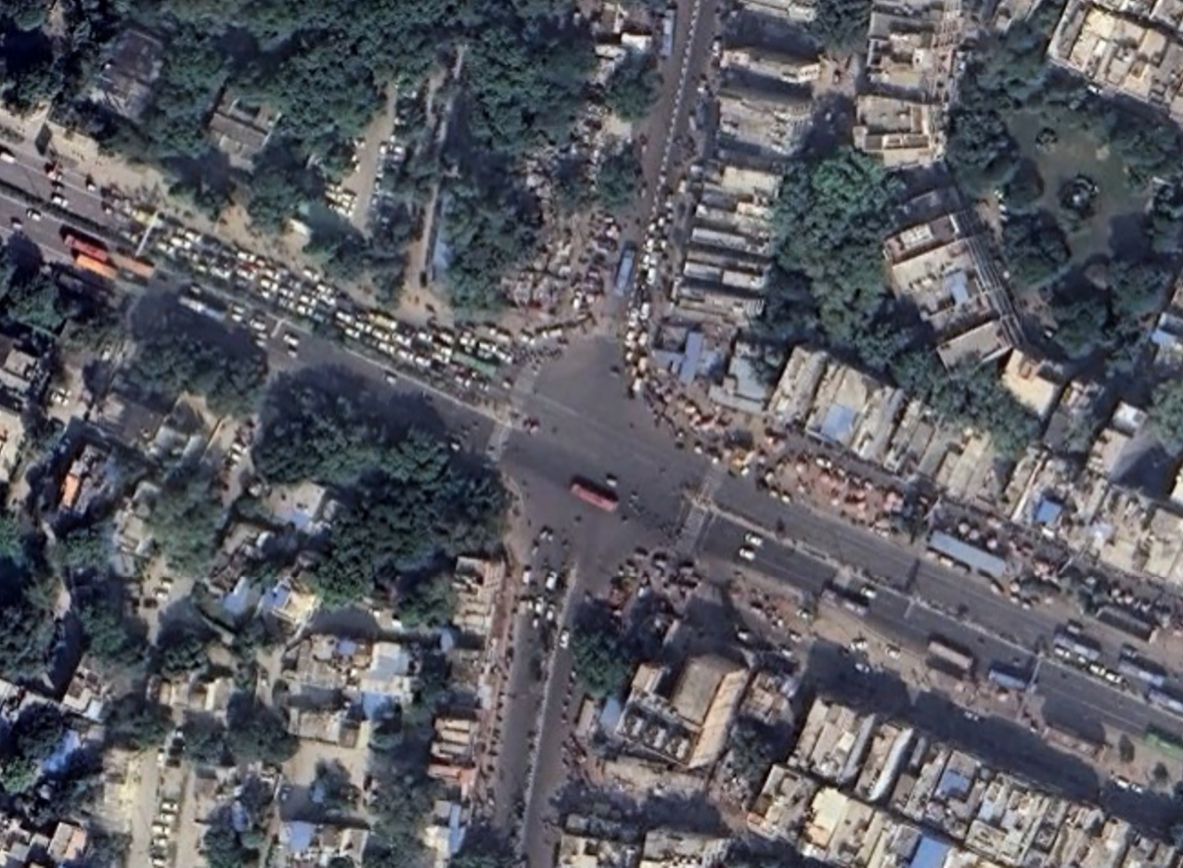

### : Existing land use

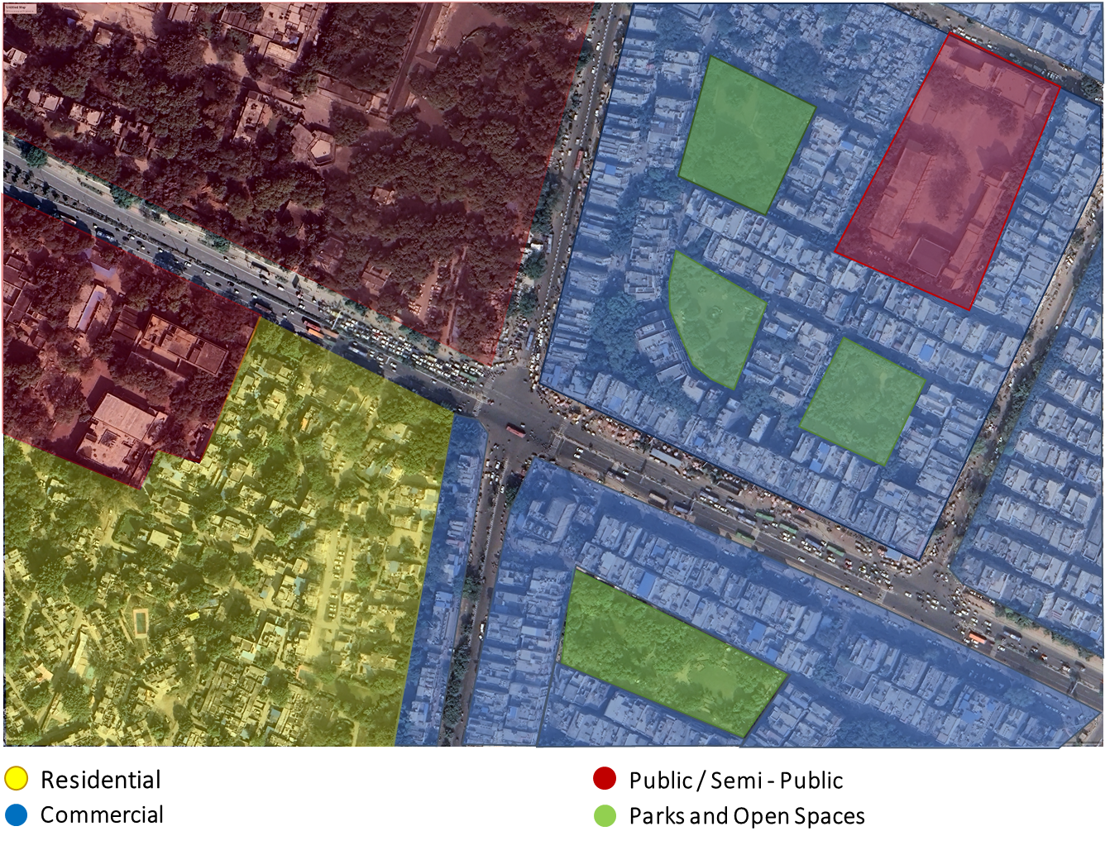

### : Land use evolution

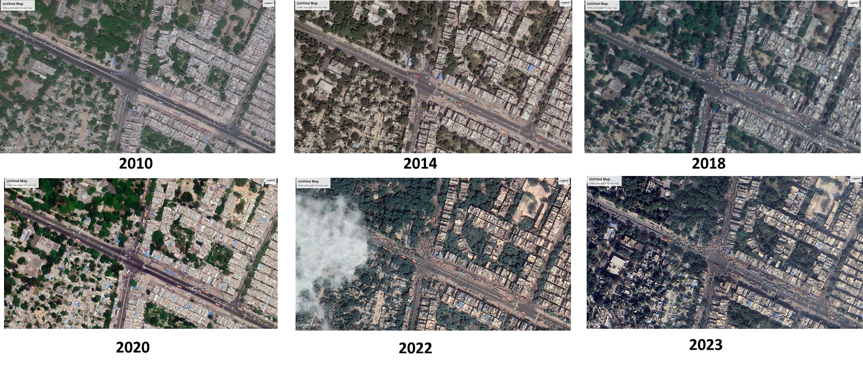

### : Existing scenario

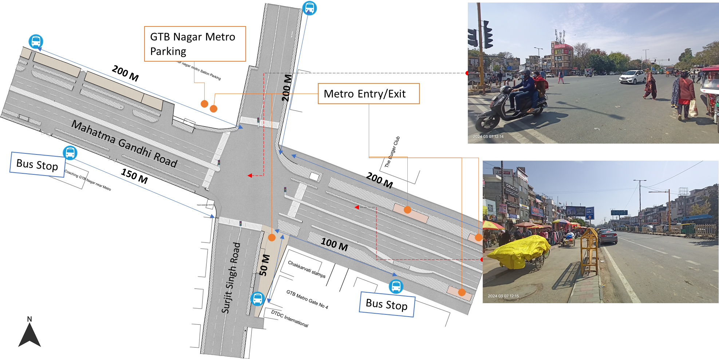

### : Traffic volume count

**Morning peak hour: 09:00-10:00 = 8422**

Figure 7: Traffic volume count: Kingsway camp

Note: NMT include pedestrians and cyclists and 3-wheelers include autos and e-rickshaws

*Note: 3 hours data (combined from all directions)

Figure 8: Hourly traffic flow: Kinsgway camp

Figure 9: Mode wise traffic flow: Kingsway camp

### : Peak hour traffic flow

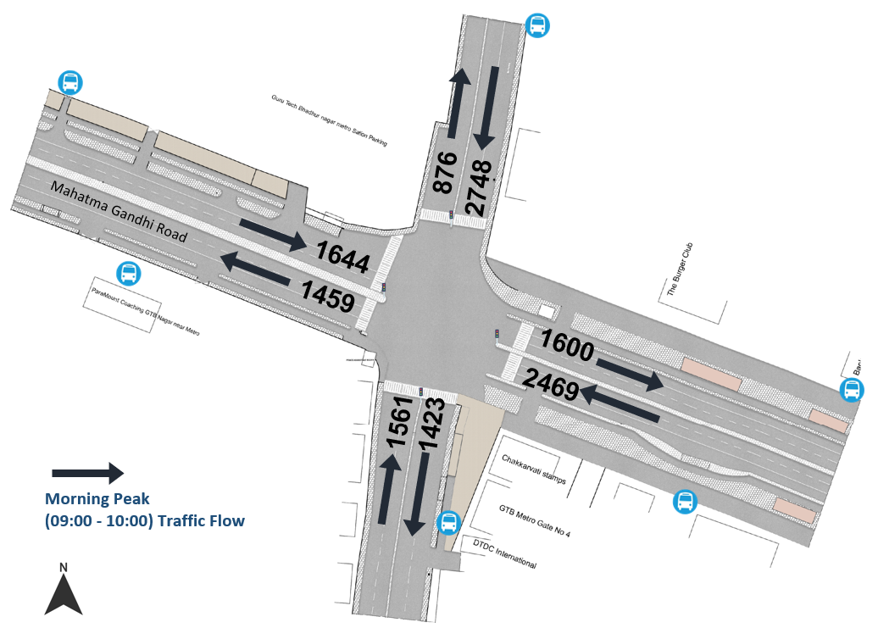

### : Conflict Points

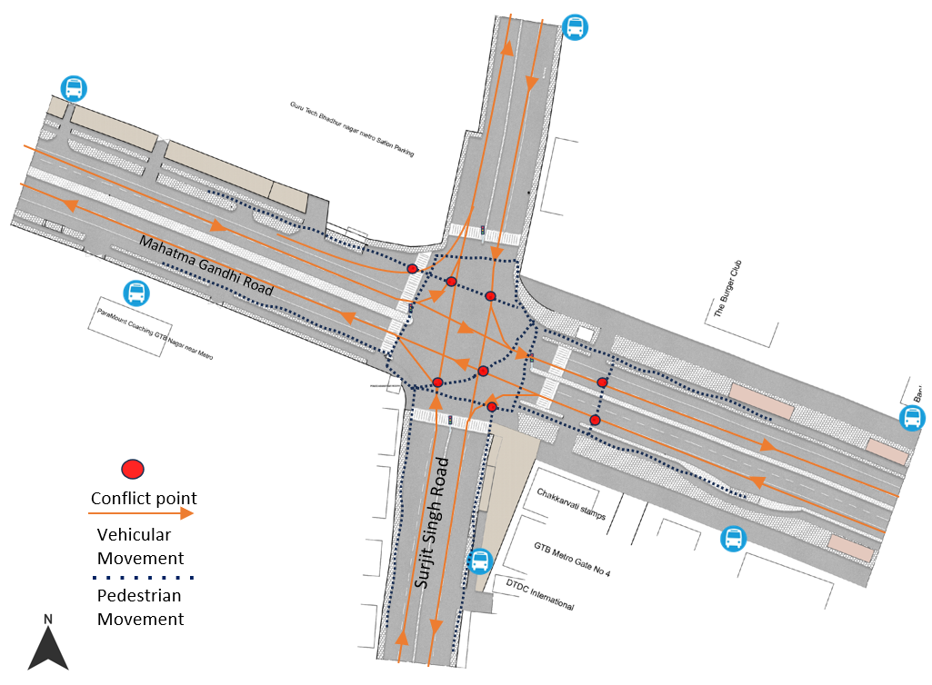

### : Issues identified

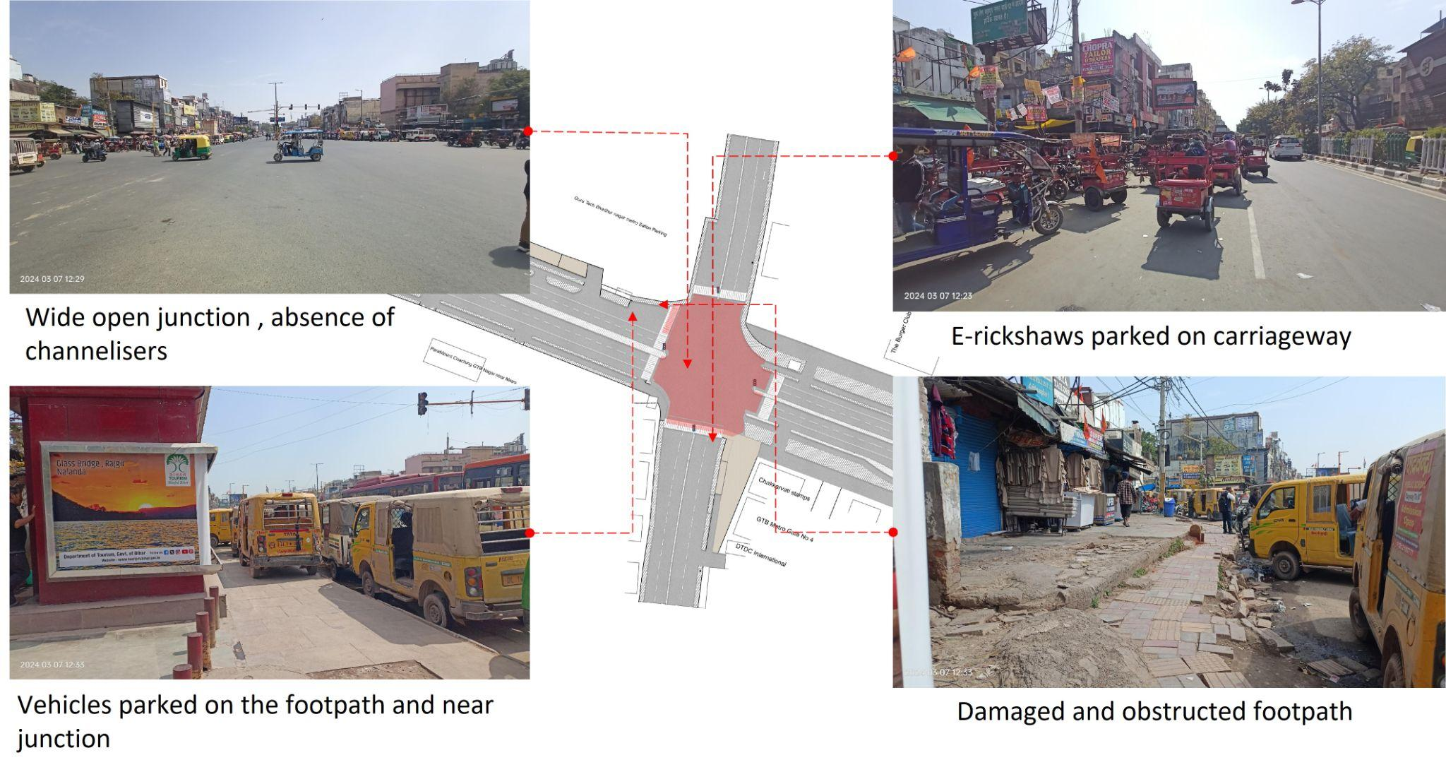

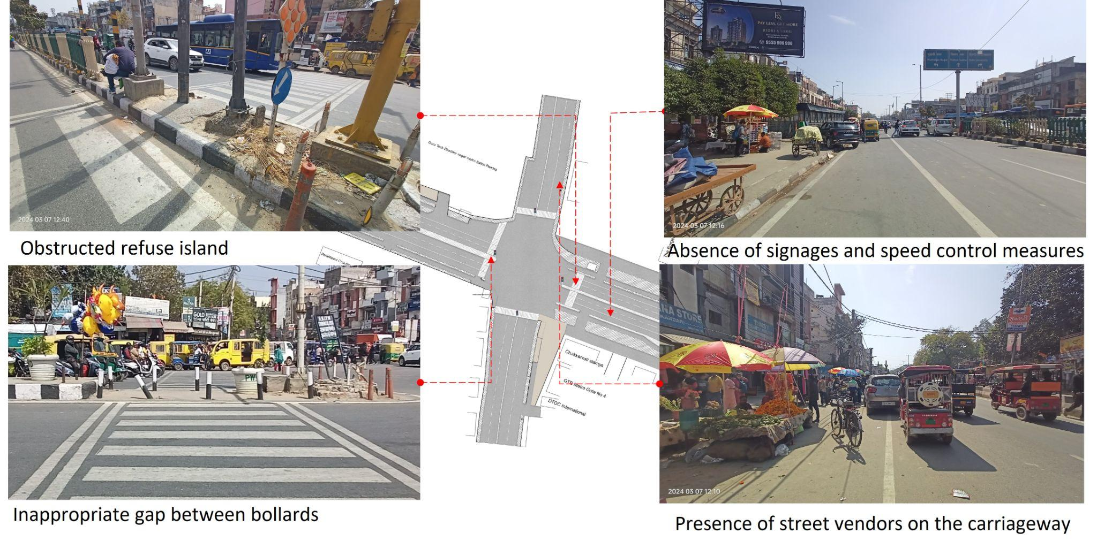

1. Unorganised parking of Gramin Sewa (shared taxi) and e-rickshaws near junctions.
2. Wide open resulting in conflicts, no channelizers.
3. Damaged and obstructed footpath, presence of street vendors and e-rickshaws.
4. Absence of kerb ramp and tactile flooring for differently abled users.
5. Absence of traffic calming near the junction.
6. Absence of signages and speed control measures at the intersection.
7. Absence of delineators and reflectors on the median and carriageway edges.

### : Proposed design

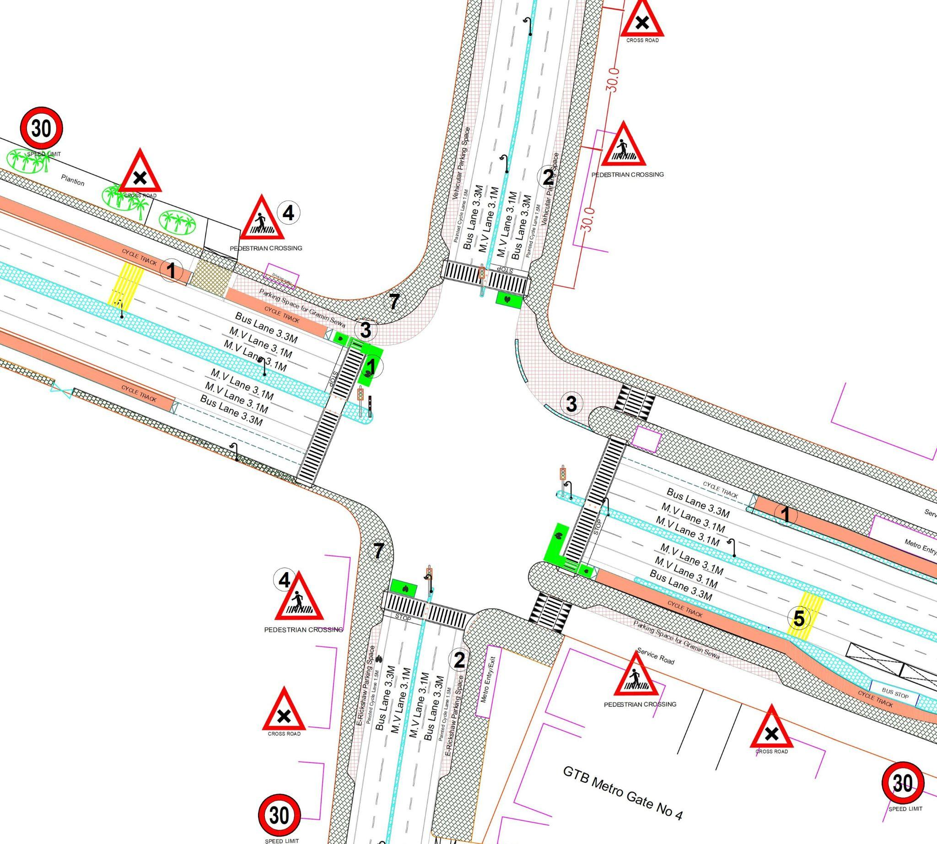

**Design Interventions:**

1. Dedicated 2.5m wide cycle track on arterial road and 1.8m painted cycle lane on collector road with cycle box marking to separate the motor traffic and the cyclists (as per IRC: 11-2015)
2. Provision of dedicated parking space for e-rickshaws, and vehicles
3. Provision of segregated gramin sewa parking space with cobbled stone texture to reduced conflict area at junction
4. Installation of signages - Speed Limit, stop sign, pedestrian crossing and other necessary Signages.
5. Provision of rumble strip to slow down the through traffic(as per IRC code 99-2018, Pg 10)
6. Demarcation of road markings (properly painted as per standards IRC:35-2015).
7. Provision of pedestrian infrastructure with tactile flooring as per IRC: 103-2022.

### Summary budget estimates

| **S.No** | **Component** | **Details** | **Notes** | **Rate (per sq.m)** | **Cost (INR)** | **Cost (INR, crores)** |
| --- | --- | --- | --- | --- | --- | --- |
| **A** | **CIVIL WORK** |  |  |  |  |  |
| A.1 | Footpath (Primary, Secondary including other Flooring area) | 2m to 3m wide segregated footpath with tactile pavers | Providing and laying of footpath 2m to 3m wide, including earthwork and base layer - PCC, GSB and finishing material. | 2365 | 9,225,842 | 0.923 |
| A.2 | Raised Crossing | Raised crossing with 80mm thick pavers and DQ stone surface | Providing and laying Raised crossing with 80 mm thick pavers blocks, and DQ stone including Earth work and Base layers- PCC (M15), RCC (M30 Design mix) & GSB etc. | 3816 | 553,310 | 0.055 |
| A.3 | Cycle Infrastructure | 2.5m wide segregated cycle track | Providing and laying cycle track (2.5mt wide segregated) including Earth work and Base layers- PCC (M15), RCC (M40 Design mix) & GSB etc. also thermoplastic paint for marking and cycle symbol and spring post etc | 5223 | 4,194,393 | 0.419 |
| A.4 | CC Items (Kerbs, Pipe, etc) | Kerb stones, Bollards, Kerb Channels etc. | Providing and fixing Kerbs, Bollards, and Kerb Channel etc. in CC. |  | 1,169,334 | 0.117 |
| A.5 | Signages | Mandatory, Cautionary and Informatory Sign Boards of different sizes | Providing and fixing Signage Mandatory, Cautionary and informatory sign board including all the fixing and labours etc. |  | 96,731 | 0.010 |
| A.6 | Marking | Thermoplastic Paint Marking (Edge lines, Centre Line, Lane Marking, Hazard Marking, Chevron, Zebra Crossing, Bar Marking, etc) | Providing and applying road marking strips (retro- reflective) of specified shade/ colour using hot thermoplastic material for road marking. | 748 | 574,310 | 0.057 |
| A.7 | Special Zones | Provision of Sitting Bollards, CC Benches, GRC Jali, Pergola, Dustbin etc. | Miscellaneous items- Provision of Sitting Bollards, CC Benches, GRC Jali, Pergola, Dustbin etc. complete items- including foundation and fixing etc. |  | 143,470 | 0.014 |
| A.8 | Brick Work |  | Brick work with common burnt clay F.P.S. (non-modular) bricks of class designation 7.5 in foundation and plinth in: Cement mortar 1:4 (1 cement: 4 coarse sand) | 7370.65/CUM | 294,826 | 0.029 |
| A.9 | Steel Reinforcement for RCC work |  | Steel reinforcement (in per kg) for R.C.C. work including straightening, cutting, bending, placing in position and binding all complete up to plinth level. Thermo-Mechanically Treated bars of grade Fe-500D or more | 107.85/kg | 43,140 | 0.004 |
| A.10 | Pavement Surface Dressing | Pavement of Bitumen layer on existing road surface | Surface dressing on old surface with hot bitumen of grade VG - 10 | 175.10 / sq.m | 227,630 | 0.023 |
| A.11 | Safety Management Equipment (as per design requirement) | Provision of Delineator Post, Spring Post, Cat eye/studs etc. | Miscellaneous items for Safety Management Equipment ( as per design requirement) -Provision of Delineator Post, Spring Post, Cat eye/studs etc.- including foundation and fixing etc. |  | 97,961 | 0.010 |
|  | **SUBTOTAL CIVIL WORK (A)** |  |  |  | **16,620,948** | 1.662 |
| **B** | Drainage, Irrigation & Plumbing | (Drainage items based on design proposal) | Drainage, Irrigation & Plumbing work @ 20% of the cost of Civil work | 20% | **3,324,190** | 0.332 |
| **C** | Electrical Work | (Light poles, junction box, other electrical works proposed based on design proposal) | Electrical work @25% of the cost of Civil work | 25% | **4,155,237** | 0.416 |
| **D** | Horticulture Work | (Landscape items based on design proposal) | Horticulture work @ 15% of the cost of Civil work | 15% | **2,493,142** | 0.249 |
| **E** | Dismantling / Demolition | -- | Dismantling work @ 15% of the cost of Civil work | 15% | **2,493,142** | 0.249 |
| **F** | Work Zone Safety & Management | -- | Work zone Management @ 5% of the cost of Civil work | 5% | **831,047** | 0.083 |
| **PART 1** | **SUBTOTAL PART 1 (A+B+C+D+E+F)** |  |  |  | **29,917,707** | 2.992 |
| **G** | Design Services & Support | -- | Design Consultancy (Preparation of Drawings, BOQ support, Work Zone plan, Site Supervision, Community Engagement & Liaison, Change Management @ 2% - 8% of the cost of Civil work. | **2%** | **598,354** | 0.060 |
| **H** | Survey Cost | -- | Survey Cost (Total Station Survey, underground services, tree demarcation, girths, level differences, steps etc @ (80,000 per junction - 250m on each arm) | 80000 | **80,000** | 0.008 |
| **PART 2** | **SUBTOTAL PART 2 (PART 1 + G +H)** |  |  |  | **30,596,061** | 3.060 |
| **J** | Contingencies '2.5% | -- | Contingencies (@2.5%) |  | **764,902** | 0.076 |
| **I** | GST ('@18%) | -- | GST @18% |  | **5,644,973** | 0.564 |
| **FINAL** | **GRAND TOTAL (PART 2 + J + I)** |  |  |  | **37,005,936** | 3.701 |

**Notes:**

1. This is a preliminary estimate. Final costing to be evaluated & approved by road owning agency
2. DSR 2023 has been followed for all rates. Market Rate and Costing from part PWD projects has been included for certain items
3. Cost of Drainage, Irrigation, Plumbing has been calculated at 20% of the civil work cost
4. Cost of Electrical Work can be calculated at 20% - 25 % of the civil work cost
5. Cost of Horticulture has been calculated at 15% of the civil work cost
6. Cost of Dismantling has been calculated at 15% of the civil work cost
7. Cost of Work Zone Management has been calculated at 5% of the civil work cost
8. Cost for Design Support can range from 2% - 8%, and can vary from site to site. This should include Technical Assistance on drawings, 3D supports, Site Supervision, Change management
9. Bus Shelter has been calculated at 18 L per shelter; can be changed as per design specific cost
10. In case of new items specific to design, please add relevant rows in detail budget estimation and include the same in the budget summary under relevant head

### : Detailed budget estimates

| **S. No** | **Component** | **Material Description** | **Item No. (DSR 2023 / Market Rate)** | **Unit** | **Depth (m)** | **Qty** | **Unit Rate** | **Amount** |
| --- | --- | --- | --- | --- | --- | --- | --- | --- |
| **1** | **Footpath (Primary, Secondary including other Flooring area)** |  |  |  |  |  |  |  |
| 1.1 | Excavation | Earth work in excavation by mechanical means (Hydraulic excavator)/ manual means over areas (exceeding 30 cm in depth, 1.5 m in width as well as 10 sqm on plan) including getting out and disposal of excavated earth lead up to 50 m and lift up to 1.5 m, as directed by Engineer-in charge. | 2.6.1 | cum | 0.85 | 3901 | 177.5 | 588563.375 |
| 1.2 | Construction of granular sub-base | Construction of granular sub-base by providing close graded Material conforming to specifications, mixing in a mechanical mix plant at OMC, carriage of mixed material by tippers to work site, for all leads & lifts, spreading in uniform layers of specified thickness with motor grader on prepared surface and compacting with vibratory power roller to achieve the desired density, complete as per specifications and directions of Engineer-in-Charge. With material conforming to Grade-II (size range 53 mm to 0.075 mm) having CBR Value-25 | 16.78.2, pg no. 258 | cum | 0.15 | 3901 | 2924.85 | 1711475.978 |
| 1.3 | Providing and laying in position cement concrete (M15) | Providing and laying in position cement concrete of specified grade excluding the cost of centering and shuttering - All work up to plinth level:1:2:4 (1 Cement : 2 coarse sand (zone-III) derived from natural sources : 4 graded stone aggregate 40 mm nominal size derived from natural sources) | 4.1.4, pg no. 103 | cum | 0.1 | 3901 | 7780.3 | 3035095.03 |
| 1.4 | Tactile - Warner (300 x 300 x 9.8 mm ) (20% of total tactile quantity) | Providing and laying tactile tile (for vision impaired persons as per standards) of size 300x300x9.8 mm having with water absorption less than 0.5% and conforming to IS:15622 of approved make in all colours and shades in for outdoor floors such as footpath, court yard, multi modals location etc., laid on 20 mm thick base of cement mortar 1:4 (1 cement : 4 coarse sand) in all shapes & patterns including grouting the joints with white cement mixed with matching pigments etc. complete as per direction of Engineer-in-Charge. | 16.90, pg no. 261 | sqm |  | 17 | 2017.6 | 34299.2 |
| 1.5 | Tactile - Guiding (300 x 300 x 9.8mm ) (80% of total tactile quantity) | Providing and laying tactile tile (for vision impaired persons as per standards) of size 300x300x9.8 mm having with water absorption less than 0.5% and conforming to IS:15622 of approved make in all colours and shades in for outdoor floors such as footpath, court yard, multi modals location etc., laid on 20 mm thick base of cement mortar 1:4 (1 cement : 4 coarse sand) in all shapes & patterns including grouting the joints with white cement mixed with matching pigments etc. complete as per direction of Engineer-in-Charge. | 16.90, pg no. 261 | sqm |  | 468 | 2017.6 | 944236.8 |
| 1.6 | Flamed Finish Granite (approved size & color) (18mm thick) | Providing and laying flamed finish Granite stone flooring in required design and patterns, in linear as well as curvilinear portions of the building all complete as per the architectural drawings with 18 mm thick stone slab over 20 mm (average) thick base of cement mortar 1:4 (1 cement : 4 coarse sand) laid and jointed with cement slurry and pointing with white cement slurry admixed with pigment of matching shade including rubbing, curing and polishing etc. all complete as specified and as directed by the Engineer-in-Charge :Flamed finish granite stone slab Jet Black, Cherry Red, Elite  Brown, Cat Eye or equivalent. | 11.55 pg no 198 | sqm |  |  | 3186.7 | 0 |
| 1.7 | Polished Granite | Providing and laying Polished Granite stone flooring in required design and patterns, in linear as well as curvilinear portions of the building all complete as per the architectural drawings with 18 mm thick stone slab over 20 mm (average) thick base of cement mortar 1:4 (1 cement : 4 coarse sand) laid and jointed with cement slurry and pointing with white cement slurry admixed with pigment of matching shade including rubbing, curing and polishing etc. all complete as specified and as directed by the Engineer-in-Charge.  Polished Granite stone slab colour of Black, Cherry/Ruby Red or equivalent | 11.56.1, Pg no 198 | sqm |  |  | 4481.3 | 0 |
| 1.8 | Interlocking Paver Blocks (approved size & color) (60mm thick) | Providing and laying factory made chamfered edge Cement Concrete paver blocks in footpath, parks, lawns, drive ways or light traffic parking etc, of required strength, thickness & size/ shape, made by table vibratory method using PU mould, laid in required colour & pattern over 50 mm thick compacted bed of sand, compacting and proper embedding/laying of inter locking paver blocks into the sand bedding layer through vibratory compaction by using plate vibrator, filling the joints with sand and cutting of paver blocks as per required size and pattern, finishing and sweeping extra sand. complete all as per direction of Engineer-in-Charge : 60 mm thick cement concrete paver block of M-35 grade with  approved colour, design & pattern. | 16.91.1, pg no. 261 | sqm | 0.6 | 547 | 1045.65 | 571970.55 |
| 1.9 | Glass Mosaic (20mm x 20mm x 4mm ) | Providing and fixing Glass mossaic tiles on finished plain wall surface of size 20 mm x 20 mm x 4 mm in all colour, design , fixing in customize design as per direction of Engineer-in- Charge. The glass mosaic tiles to be fixed on the wall surface with the help of approved adhesive applied at the rate of 2.5 kg per sqm and grouting of the same. The rate is inclusive of all operation, material and required pattern approved by Engineer-in-Charge: | 11.53 pg no 197 | sqm |  |  | 3891.15 | 0 |
| 1.10 | Crazy Marble Stone (18 mm thick) | Crazy marble stone flooring, including filling the gaps with light shade pigment with white cement marble powder mixture (3 parts of white cement: 1 part of marble powder) by weight in proportion of 4:7 (4 cement marble powder mix : 7 white, black or white and black marble chips of sizes from 1 mm to 4 mm nominal size by volume), with under layer 25 mm thick cement concrete 1:2:4 (1 cement: 2 coarse sand: 4 graded stone aggregate 12.5 mm nominal size), including rubbing, polishing and cement slurry etc. complete :  18 mm thick crazy marble stone white, black or as specified | As per NIT DAV Pedestrianization | sqm |  |  | 948.85 | 0 |
| 1.11 | Crazy Vitrified Tiles (100x100x16mm) | Providing and laying matt finished vitrified tile of size 100x100x16mm having water absorption less than 0.5% and conforming to IS: 15622 of approved make in all colours and shades in outdoor floors such as footpath, court yard multi models etc., laid on 20mm thick base of cement mortar 1:4 (1cement: 4 coarse sand) in all shapes & patterns including grouting the joints with white cement mixed with matching pigments etc. complete as direction of Engineer-in-Charge. | As per NIT DAV Pedestrianization | sqm |  |  | 842.95 | 0 |
| 1.12 | Delhi Quartzite (MUZ) (10x10x7.50) | Providing and fixing 10x10x7.50 cm Granite stone block hand cut and chisel dressed on top, for paving in floors, drains etc. laid over 20 mm thick base mortar 1:4 (1 cement : 4 coarse sand) with joints 10 mm wide filled with same mortar including ruled pointing etc. complete as per direction of engineer-in-charge. | 16.92 pg no 261 | sqm |  | 1069 | 2189.15 | 2340201.35 |
| 1.13 | EPDM Flooring | Providing and fixing 36 MM thick Ethylene Propylene Diene Monomer (EPDM) [30 MM SBR (Styrene- Butadiene or Styrene-butadiene Rubber) & 6 MM EPDM] safety FLOORING with the help of BASF Glue 18 adhesive for children play area complete all as per manufacturer's specification and direction of Engineer- in-charge. | As per AR (Market Rate) | Sqm |  | 0 | 3746.2 | 0 |
|  | SUB TOTAL |  |  |  |  |  |  | 9225842.283 |

| **2** | **Raised Crossing** | **Material Description** | **Item No. (DSR 2023 / Market Rate)** | **Unit** | **Depth (m)** | **Qty** | **Unit Rate** | **Amount** |
| --- | --- | --- | --- | --- | --- | --- | --- | --- |
| 2.1 | Excavation | Earth work in excavation by mechanical means (Hydraulic excavator)/ manual means over areas (exceeding 30 cm in depth, 1.5 m in width as well as 10 sqm on plan) including getting out and disposal of excavated earth lead upto 50 m and lift upto 1.5 m, as directed by Engineer-incharge. | 2.6.1 | cum | 0.325 | 145 | 177.5 | 8364.6875 |
| 2.2 | Construction of granular sub-base | Construction of granular sub-base by providing close graded Material conforming to specifications, mixing in a mechanical mix plant at OMC, carriage of mixed material by tippers to work site, for all leads & lifts, spreading in uniform layers of specified thickness with motor grader on prepared surface and compacting with vibratory power roller to achieve the desired density, complete as per specifications and directions of Engineer-in-Charge. With material conforming to Grade-II (size range 53 mm to 0.075 mm) having CBR Value-25 | 16.78.2, pg no. 258 | cum | 0.1 | 145 | 2924.85 | 42410.325 |
| 2.3 | Providing and laying in position cement concrete (M15) | Providing and laying in position cement concrete of specified grade excluding the cost of centering and shuttering - All work up to plinth level: 1:2:4 (1 Cement: 2 coarse sand (zone-III) derived from natural sources: 4 graded stone aggregate 40 mm nominal size derived from natural sources) | 4.1.4, pg no. 103 | cum | 0.1 | 145 | 7780.3 | 112814.35 |
| 2.4 | Providing and laying in position cement concrete (M25, Design Mix) | Providing and laying in position ready mixed or site batched design mix cement concrete for plain cement concrete work; using coarse aggregate and fine aggregate derived from natural sources, Portland Pozzolana/Ordinary Portland /Portland Slag cement, admixtures in recommended proportions as per IS: 9103 to accelerate / retard setting of concrete, to improve durability and workability without impairing strength; including pumping of concrete to site of laying, curing, carriage for all leads; but excluding the cost of centering, shuttering and finishing as per direction of the engineer-in-charge; for the following grades of concrete.  Note: Extra cement up to 10% of the minimum specified cement content in design mix shall be payable separately. In case the cement content in design mix is more than 110% of the minimum specified cement content, the contractor shall have discretion to either re-design the mix or bear the cost of extra cement.  Concrete of M25 grade with minimum cement content of 300 kg /cum | 4.20.1.4, page 108 | cum | 0.125 | 145 | 9439.05 | 171082.7813 |
| 2.4 | Interlocking Paver Block (Red & White of approved size) 80mm thick | Providing and laying factory made chamfered edge Cement Concrete paver blocks in footpath, parks, lawns, drive ways or light traffic parking etc, of required strength, thickness & size/ shape, made by table vibratory method using PU mould, laid in required colour & pattern over 50 mm thick compacted bed of sand, compacting and proper embedding/laying of inter locking paver blocks into the sand bedding layer through vibratory compaction by using plate vibrator, filling the joints with sand and cutting of paver blocks as per required size and pattern, finishing and sweeping extra sand. complete all as per direction of Engineer-in-Charge: 80 mm thick C.C. paver block of M-35 grade with approved colour design and pattern | 16.91.2, pg no. 261 | sqm |  | 90 | 1091.5 | 98235 |
| 2.5 | Delhi Quartzite 10x10x7.50 | Providing and fixing 10x10x7.50 cm Granite stone block hand cut and chisel dressed on top, for paving in floors, drains etc. laid over 20 mm thick base mortar 1:4 (1 cement: 4 coarse sand) with joints 10 mm wide filled with same mortar including ruled pointing etc. complete as per direction of engineer-in-charge. | 16.92 pg no 261 | sqm |  | 55 | 2189.15 | 120403.25 |
|  | SUB TOTAL |  |  |  |  |  |  | 553310.3938 |

| **3** | **Cycle Infrastructure** | **Material Description** | **Item No. (DSR 2023 / Market Rate)** | **Unit** | **Depth (m)** | **Qty** | **Unit Rate** | **Amount** |
| --- | --- | --- | --- | --- | --- | --- | --- | --- |
| 3.1 | Excavation | Earth work in excavation by mechanical means (Hydraulic excavator)/ manual means over areas (exceeding 30 cm in depth, 1.5 m in width as well as 10 sqm on plan) including getting out and disposal of excavated earth lead upto 50 m and lift upto 1.5 m, as directed by Engineer-in charge. | 2.6.1 | cum | 0.4 | 803 | 177.5 | 57013 |
| 3.2 | Construction of granular sub-base | Construction of granular sub-base by providing close graded Material conforming to specifications, mixing in a mechanical mix plant at OMC, carriage of mixed material by tippers to work site, for all leads & lifts, spreading in uniform layers of specified thickness with motor grader on prepared surface and compacting with vibratory power roller to achieve the desired density, complete as per specifications and directions of Engineer-in-Charge. With material conforming to Grade-II (size range 53 mm to 0.075 mm) having CBR Value-25 | 16.78.2, pg no. 258 | cum | 0.15 | 803 | 2924.85 | 352298.1825 |
| 3.3 | Providing and laying in position cement concrete (M15) | Providing and laying in position cement concrete of specified grade excluding the cost of centering and shuttering - All work up to plinth level: 1:2:4 (1 Cement: 2 coarse sand (zone-III) derived from natural sources: 4 graded stone aggregate 40 mm nominal size derived from natural sources) | 4.1.4, pg no. 103 | cum | 0.1 | 803 | 7780.3 | 624758.09 |
| 3.4 | Providing and laying in position cement concrete (M40, Design Mix) | Providing and laying in position ready mixed or site batched design mix cement concrete for reinforced cement concrete work; using coarse aggregate and fine aggregate derived from natural sources, Portland Pozzolana / Ordinary Portland /Portland Slag cement, admixtures in recommended proportions as per IS: 9103 to accelerate / retard setting of concrete, to improve durability and workability without impairing strength; including pumping of concrete to site of laying, curing, carriage for all leads; but excluding the cost of centering, shuttering, finishing and reinforcement as per direction of the engineer-in-charge; for the following grades of concrete. Note: Extra cement up to 10% of the minimum specified cement content in design mix shall be payable separately. In case the cement content in design mix is more than 110% of the specified minimum cement content, the contractor shall have discretion to either re-design the mix or bear the cost of extra cement:  Concrete of M40 grade with minimum cement content of 390 kg/cum | 5.33.1.4, page 120 | cum | 0.15 | 803 | 9957.65 | 1199398.943 |
| 3.5 | Thermoplastic Paint Marking (Cycle Track - Grey Color; Cycle Box (Green); Cycle Lane, Edge Marking) | Providing and applying 2.5 mm thick road marking strips (retro- reflective) of specified shade/ colour using hot thermoplastic material by fully/ semi-automatic thermoplastic paint applicator machine fitted with profile shoe, glass beads dispenser, propane tank heater and profile shoe heater, driven by experienced operator on road surface including cost of material, labour, T&P, cleaning the road surface of all dirt, seals, oil, grease and foreign material etc. complete as per direction of Engineer-in-charge and accordance with applicable specifications. | 16.62, pg no. 257 | sq.m |  | 2534 | 747.8 | 1894925.2 |
| 3.6 | Cycle Symbol (On green box) | Providing and applying cycle symbol using thermoplastic paint as per IRC 35:2018 in cycle box at location specified | Market Rate | No.s |  | 60 | 1100 | 66000 |
| 3.7 | Spring Post (80mm dia 750mm high Plastic) | Providing and applying Plastic spring post 80mm dia 750mm high at location specified | Market Rate | No.s |  | 500 | 350 | 175000 |
|  | SUB TOTAL |  |  |  |  |  |  | 4194393.415 |

| **4** | **CC Items (Kerbs, Pipe, etc)** | **Material Description** | **Item No. (DSR 2023 / Market Rate)** | **Unit** | **Depth (m)** | **Qty** | **Unit Rate** | **Amount** |
| --- | --- | --- | --- | --- | --- | --- | --- | --- |
| 4.1 | Excavation | Earth work in excavation by mechanical means (Hydraulic excavator)/ manual means over areas (exceeding 30 cm in depth, 1.5 m in width as well as 10 sqm on plan) including getting out and disposal of excavated earth lead up to 50 m and lift up to 1.5 m, as directed by Engineer-in charge. | 2.6.1 | cum | 0.45 | 619 | 177.5 | 49442.625 |
| 4.2 | Construction of granular sub-base | Construction of granular sub-base by providing close graded Material conforming to specifications, mixing in a mechanical mix plant at OMC, carriage of mixed material by tippers to work site, for all leads & lifts, spreading in uniform layers of specified thickness with motor grader on prepared surface and compacting with vibratory power roller to achieve the desired density, complete as per specifications and directions of Engineer-in-Charge. With material conforming to Grade-II (size range 53 mm to 0.075 mm) having CBR Value-25 | 16.78.2, pg no. 258 | cum | 0.1 | 619 | 2924.85 | 181048.215 |
| 4.3 | Dotted kerb stone of approved pattern of M-25 grade cement concrete ( 0.15x3xL ) | Providing and laying at or near ground level factory made kerb stone of M-25 grade cement concrete in position to the required line, level and curvature, jointed with cement mortar 1:3 (1 cement: 3 coarse sand), including making joints with or without grooves (thickness of joints except at sharp curve shall not to more than 5 mm), including making drainage opening wherever required complete etc. as per direction of Engineering-charge (length of finished kerb edging shall be measured to calculate volume for payment). (Precast C.C. kerb stone shall be approved by Engineer-in-charge) | 16.69, pg no. 313 | cum | 0.1 | 619 | 10117.6 | 626279.44 |
| 4.4 | Bollards (600mm 120mm dia)  (Preferred size: 950mm high 150mm dia) | Precasting and placing in position 125 mm dia Bollards 600 mm high of required shape including providing M.S. Pipe Sleeve 50 mm dia 300 mm long in the Bollard and M.S. Pipes 40 mm dia and 450mm long with 150x150x6mm M.S. plate welded at bottom and embedded 150mm in cement concrete 1:3:6 (1 Cement : 3 coarse sand (zone-III) derived from natural sources : 6 graded stone aggregate 20 mm nominal size derived from natural sources), including necessary excavation of size 250x250x450mm deep for the same in bitumen/concrete pavement at specified spacing | 4.9, pg no. 106 | No.s |  | 120 | 929.8 | 111576 |
| 4.5 | Kerb Channel (L*0.3) | Providing, laying and making kerb channel 30 cm wide and 50 mm thick with cement concrete 1:3:6 (1 cement: 3 coarse sands:6 graded stone aggregate 20 mm nominal size) over 75 mm bed of dry brick ballast 40 mm nominal size, well rammed and consolidated and grouted with fine sand, including finishing the top smooth etc. complete and as per direction of Engineer-in-charge. | 16.63, pg no. 257 | sqm |  | 360 | 558.3 | 200988 |
|  | SUB TOTAL |  |  |  |  |  |  | 1169334.28 |

| **5** | **Signages** | **Material Description** | **Item No. (DSR 2023 / Market Rate)** | **Unit** | **Depth (m)** | **Qty** | **Unit Rate** | **Amount** |
| --- | --- | --- | --- | --- | --- | --- | --- | --- |
| 5.1 | Mandatory sign boards of equilateral triangular shape having each side of 900 mm with support length of 3650 mm on arterial - sub arterial roads | Manufacturing, supplying and fixing retro reflective sign boards made up of 2 mm thick aluminium sheet, face to be fully covered with high intensity encapsulated type heat activated retro reflective sheeting conforming to type - IV of ASTM-D 4956-01 in blue and silver white or other colour combination including subject matter, message (bi-lingual), symbols and borders etc. as per IRC ; 67:2001, pasted on substrate by an adhesive backing which shall be activated by applying heat and pressure conforming to class -2 of ASTM-D-4956-01 and fixing the same with suitable sized aluminium alloy rivets @ 20 cm c/c to back support frame of M.S. angle iron of size 25x25x3 mm along with theft resistant measures, mounted and fixed with 2 Nos. M.S. angles of size 35x35x5 mm to a vertical post made up to M.S. Tee section ISMT 50x50x6 mm welded with base plate of size 100x100x5 mm at the bottom end and including making holes in pipes, angles flats, providing & fixing M.S. message plate of required size, steel work to be painted with two or more coats of synthetic enamel paint of required shade and of approved brand & manufacture over priming coat of zinc chromate yellow primer (vertical MS-Tee support to be painted in black and white colours).Backside of aluminium sheet to be painted with two or more coats of epoxy paint over and including appropriate priming coat including all leads and lifts etc. complete as per drawing , specification and direction of Engineer-in-charge.:  Mandatory/ Regulatory sign boards of 900 mm diameter with support length of 3750 mm | 16.59.1 | No.s |  | 4 | 7183.35 | 28733.4 |
| 5.2 | Cautionary / warning sign boards of equilateral triangular shape having each side of 900 mm with support length of 3650 mm on arterial - sub arterial roads | Manufacturing, supplying and fixing retro reflective sign boards made up of 2 mm thick aluminium sheet, face to be fully covered with high intensity encapsulated type heat activated retro reflective sheeting conforming to type - IV of ASTM-D 4956-01 in blue and silver white or other colour combination including subject matter, message (bi-lingual), symbols and borders etc. as per IRC ; 67:2001, pasted on substrate by an adhesive backing which shall be activated by applying heat and pressure conforming to class -2 of ASTM-D-4956-01 and fixing the same with suitable sized aluminium alloy rivets @ 20 cm c/c to back support frame of M.S. angle iron of size 25x25x3 mm along with theft resistant measures, mounted and fixed with 2 Nos. M.S. angles of size 35x35x5 mm to a vertical post made up to M.S. Tee section ISMT 50x50x6 mm welded with base plate of size 100x100x5 mm at the bottom end and including making holes in pipes, angles flats, providing & fixing M.S. message plate of required size, steel work to be painted with two or more coats of synthetic enamel paint of required shade and of approved brand & manufacture over priming coat of zinc chromate yellow primer (vertical MS-Tee support to be painted in black and white colours).Backside of aluminium sheet to be painted with two or more coats of epoxy paint over and including appropriate priming coat including all leads and lifts etc. complete as per drawing , specification and direction of Engineer-in-charge.:: Cautionary /warning sign boards of equilateral triangular shape having each side of 900 mm with support length of 3650 mm | 16.59.2 | No.s |  | 8 | 5559.75 | 44478 |
| 5.3 | Informatory sign boards of equilateral triangular shape having each side of 900 mm with support length of 3650 mm on arterial - sub arterial roads | Manufacturing, supplying and fixing retro reflective overhead signage boards made up of 2 mm thick aluminium sheet, face to be fully covered with high intensity and encapsulated lens type heat activated retro reflective sheeting conforming to type - III of ASTM-D-4956-01 as approved by Engineer-in-charge, letters, borders etc. as per IRC : 67-2001 in silver white with blue colour back ground and with high intensity grade, pasted on substrate by pressure sensitive adhesive backing which shall be activated by applying pressure conforming to class II of ASTM-D-4956-01 and fixing the same to the plate of structural frame work by means of suitable sized aluminium alloys, rivets or bolts & nuts @ 300 mm centre to centre all along the periphery as well as in two vertical rows along with theft resistant measures, including the cost of painting with two or more coats of epoxy paint in grey colour on the back side of aluminium sheet including appropriate priming coat. The rate includes the cost of rounding off the corners, lowering down the structural frame work from the gantry, fixing and erecting the same in position all complete as per drawings, specification and direction of the engineer-in-charge. (Structural frame work including M.S. plate to be provided separately. Rectangular area of the sheet only shall be measured for payment).  Overhead informatory road signage | 16.60.1 | No.s |  | 4 | 5879.9 | 23519.6 |
| 5.4 | Mandatory sign boards of equilateral triangular shape having each side of 600 mm or lower with support length of 3650 mm on distributary roads (MARKET RATE) | Manufacturing, supplying and fixing retro reflective sign boards made up of 2 mm thick aluminium sheet, face to be fully covered with high intensity encapsulated type heat activated retro reflective sheeting conforming to type - IV of ASTM-D 4956-01 in blue and silver white or other colour combination including subject matter, message (bi-lingual), symbols and borders etc. as per IRC ; 67:2001, pasted on substrate by an adhesive backing which shall be activated by applying heat and pressure conforming to class -2 of ASTM-D-4956-01 and fixing the same with suitable sized aluminium alloy rivets @ 20 cm c/c to back support frame of M.S. angle iron of size 25x25x3 mm along with theft resistant measures, mounted and fixed with 2 Nos. M.S. angles of size 35x35x5 mm to a vertical post made up to M.S. Tee section ISMT 50x50x6 mm welded with base plate of size 100x100x5 mm at the bottom end and including making holes in pipes, angles flats, providing & fixing M.S. message plate of required size, steel work to be painted with two or more coats of synthetic enamel paint of required shade and of approved brand & manufacture over priming coat of zinc chromate yellow primer (vertical MS-Tee support to be painted in black and white colours).Backside of aluminium sheet to be painted with two or more coats of epoxy paint over and including appropriate priming coat including all leads and lifts etc. complete as per drawing , specification and direction of Engineer-in-charge.:  Mandatory/ Regulatory sign boards of 900 mm diameter with support length of 3750 mm | 16.59.1 (Market Rate) | No.s |  |  | 7183.35 | 0 |
| 5.5 | Cautionary / Warning sign boards of equilateral triangular shape having each side of 600 mm or lower with support length of 3650 mm on distributary roads (MARKET RATE) | Manufacturing, supplying and fixing retro reflective sign boards made up of 2 mm thick aluminium sheet, face to be fully covered with high intensity encapsulated type heat activated retro reflective sheeting conforming to type - IV of ASTM-D 4956-01 in blue and silver white or other colour combination including subject matter, message (bi-lingual), symbols and borders etc. as per IRC ; 67:2001, pasted on substrate by an adhesive backing which shall be activated by applying heat and pressure conforming to class -2 of ASTM-D-4956-01 and fixing the same with suitable sized aluminium alloy rivets @ 20 cm c/c to back support frame of M.S. angle iron of size 25x25x3 mm along with theft resistant measures, mounted and fixed with 2 Nos. M.S. angles of size 35x35x5 mm to a vertical post made up to M.S. Tee section ISMT 50x50x6 mm welded with base plate of size 100x100x5 mm at the bottom end and including making holes in pipes, angles flats, providing & fixing M.S. message plate of required size, steel work to be painted with two or more coats of synthetic enamel paint of required shade and of approved brand & manufacture over priming coat of zinc chromate yellow primer (vertical MS-Tee support to be painted in black and white colours).Backside of aluminium sheet to be painted with two or more coats of epoxy paint over and including appropriate priming coat including all leads and lifts etc. complete as per drawing , specification and direction of Engineer-in-charge.:: Cautionary /warning sign boards of equilateral triangular shape having each side of 900 mm with support length of 3650 mm | 16.59.2 (Market Rate) | No.s |  |  | 5550.75 | 0 |
| 5.6 | Informatory sign boards of equilateral triangular shape having each side of 600 mm or lower with support length of 3650 mm on distributary roads (MARKET RATE) | Manufacturing, supplying and fixing retro reflective overhead signage boards made up of 2 mm thick aluminium sheet, face to be fully covered with high intensity and encapsulated lens type heat activated retro reflective sheeting conforming to type - III of ASTM-D-4956-01 as approved by Engineer-in-charge, letters, borders etc. as per IRC : 67-2001 in silver white with blue colour back ground and with high intensity grade, pasted on substrate by pressure sensitive adhesive backing which shall be activated by applying pressure conforming to class II of ASTM-D-4956-01 and fixing the same to the plate of structural frame work by means of suitable sized aluminium alloys, rivets or bolts & nuts @ 300 mm centre to centre all along the periphery as well as in two vertical rows along with theft resistant measures, including the cost of painting with two or more coats of epoxy paint in grey colour on the back side of aluminium sheet including appropriate priming coat. The rate includes the cost of rounding off the corners, lowering down the structural frame work from the gantry, fixing and erecting the same in position all complete as per drawings, specification and direction of the engineer-in-charge. (Structural frame work including M.S. plate to be provided separately. Rectangular area of the sheet only shall be measured for payment).  Overhead informatory road signage | 16.60.1 (Market Rate) | No.s |  |  | 5879.9 | 0 |
| 5.7 | Informatory sign - Road Signages, Road Names | Providing, installing and fixing with necessary clamps etc. retro-reflective Single Sided shoulder / gantry / cantilever mounted signboards comprising of customized modular PU Epoxy Coated. MS Tube frame work, aluminium composite panel (ACP) (both side of frame) mill finished or PVDF coated or as specified as base board, micro prismatic retro-reflective sheet and electro- cut coloured overlay film. The horizontal and vertical members of the MS frame module shall be made of MS tube 50x50x3.6mm thick as per approved drawing and each panel shall be braced diagonally (one way only) with same section. The aluminium composite panel (ACP) shall have a thickness of 4mm which including 0.5 mm thick skin of aluminium on both sides. The ACP shall be routed, folded and fixed on the MS frame with VHB tape 24mm wide and 2.3 mm thick provided throughout the length and breadth of the frame including riveting at the right-angle face of the frame with pop riveting or with self-taping SS screws 5mm dia spaced not more than 300mm centre to centre on both side of frame ensuring that no riveting is seen on either face of the frame. On the front face of the ACP, micro prismatic retro- reflective sheet conforming to Type-XI of ASTM: D 4956-09 shall be pressure fixed as background sheet (In white colour) which will be digitally printed matter, border & symbol etc with 15 years warranty and having clear film for UV protection (the reflective value should be as per IRC 67 when tested) of approved make and colour to create a desired road sign and information message. The rear side of the MS frame shall be covered with balancing ACP sheet of the same description as mentioned above and shall be fixed in similar manner as described above. The edges of the board shall be covered all-round with powder coated die cast extruded aluminium channel of required colour and shade of size 68x12x2mm.  The channel shall be fixed using two rows of double sided VHB tape of above description. The channel shall further be secured by pop rivets having SS screws of 5mm dia at junctions and corners. The rate shall include all materials, labour, equipment, fabrication, transportation, erection, installation and incidental charges all complete as per direction of the Engineer-in- Charge. Only front area of the board shall be measured for payment. (All Structural steel work shall be paid separately under the relevant agreement item, except MS tube frame work and fixing arrangement with clamps for the sign boards with are included in this item). | As per AR (Market Rate) | Sq.m |  |  | 16686.2 | 0 |
|  | SUB TOTAL |  |  |  |  |  |  | 96731 |

| **6** | **Marking** | **Material Description** | **Item No. (DSR 2023 / Market Rate)** | **Unit** | **Depth (m)** | **Qty** | **Unit Rate** | **Amount** |
| --- | --- | --- | --- | --- | --- | --- | --- | --- |
| 6.1 | Thermoplastic Paint Marking (Edge lines, Centre Line, Lane Marking, Hazard Marking, Chevron, Zebra Crossing, Bar Marking, etc) | Providing and applying 2.5 mm thick road marking strips (retro- reflective) of specified shade/ colour using hot thermoplastic material by fully/ semi-automatic thermoplastic paint applicator machine fitted with profile shoe, glass beads dispenser, propane tank heater and profile shoe heater, driven by experienced operator on road surface including cost of material, labour, T&P, cleaning the road surface of all dirt, seals, oil, grease and foreign material etc. complete as per direction of Engineer-in-charge and accordance with applicable specifications. | 16.62, pg no. 257 | sq.m |  | 768 | 747.8 | 574310.4 |
| 6.2 | Epoxy paint (concrete bollards, kerbs)  (Reference: For Segment Length 250m - Qty =150sq.m) | Finishing with Epoxy paint (two or more coats) at all locations prepared and applied as per manufacturer’s specifications including appropriate priming coat, preparation of surface, etc. complete: On concrete work | 13.52, pg no. 221 | sqm |  |  | 235.15 | 0 |
| 6.3 | Synthetic Enamel Paint | Painting with synthetic enamel paint of approved brand and manufacture of required colour to give an even shade: Two or more coats on new work over an under coat of suitable shade with ordinary paint of approved brand and manufacture | 13.62.1, pg no. 222 | sqm |  |  | 226.25 | 0 |
|  | SUB TOTAL |  |  |  |  |  |  | 574310.4 |

| **7** | **Special Zones** | **Material Description** | **Item No. (DSR 2023 / Market Rate)** | **Unit** | **Depth (m)** | **Qty** | **Unit Rate** | **Amount** |
| --- | --- | --- | --- | --- | --- | --- | --- | --- |
| 7.1 | Seating Bollards (450mm dia, 400mm high) | Providing & Fixing Position precast reinforced cement concrete cylindrical bollard cum stool of size 400mm top dia, 300mm bottom dia, 475mm overall height, 150mm stem height and concrete grade M-30 as per approved design/drawing. The bollard shall be fixed in C.C. block mix 1:2:4 (1 Cement: 2 coarse sands: 4 graded stone aggregate 20mm nominal size) 300 mm dia and 150 mm deep including earth work in excavation, painting etc. complete as per direction and instruction of Engineer-in-Charge. | As per AR (Market Rate) | No |  | 20 | 4258.98 | 85179.6 |
| 7.2 | Benches (CC benches) | Providing and placing of precast RCC benches (chair bench with back Rest) using m-30 grade of concrete consisting of 2 no. L-shaped base support of thickness 100 mm having Back height 1000mm, front height 450mm and Base width 620mm having 5 No. of RCC planks 1500x100x50 mm and one number plank of size 1500x200x50mm in the approved colour and shade. The minimum weight of MS reinforcement bar in the base support will be 3.40 kg having 4 nos. 8mm dia M.S. Bar distributed alone the section and periphery of the legs with sufficient No. of 4mm dia MS stirrups. Each base support will have 3 nos. 12mm dia (2 Nos. 40mm and one number 65 mm long) galvanized coupling nuts welded suitably to the main reinforcement at appropriate locations so as to receive bolts for fixing of seats of concrete planks on base support and 3 holes to received carriage bolts for fixing back rest planks. The minimum weight of MS reinforcement bar in the plank of 200mm wide will be 4.4kg and of 100mm wide 2.90kg. All the RCC planks will have 2 holes of 14mm dia at appropriate location, so as to receive 12mm dia galvanized bolts for fixing on the base support. One of the planks of size 1500x100x50mm shall be engraved in the centre at the back with letter PWD, 2 plank of size 1500x100x50mm will be bolted to coupling nuts provided in the base support on both sides with 2 numbers of 12mm dia and 65mm long galvanized steel CSR bolt and one Eva washer for each bolt to form a seat 3 planks of size 1500x100x50mm will be bolted to coupling nuts provided in both the base support to form back rest with 6nos. (Two nos. in each planks) half threaded carriage bolts and nuts of size 165mm long and 8mm dia with Eva and steel washers. The holes visible at the back side of the bench will be sealed with cement mortar after assembling sides edges of all the planks shall be painted with acrylic base paint of approved colour and shade and front portion of seating and back rest planks shall be polished to given glossy finish complete as per direction of Engineer-in-charge | As per AR (Market Rate) | No |  | 10 | 5829 | 58290 |
| 7.3 | GRC Jali | Providing and fixing Uni-Stone make or equivalent Glass Reinforced Concrete (G.R.C.) Screens casted with Spray Mix concrete design in approved size, Patten, thickness of 50mm on the outer Boarder & 25-30mm for internal member and shade. The Screens should be made from 53 grade White Portland Cement manufactured by JK Cement or Birla White, White Quartz fine graded sieved silica Sand, Alkali Resistant Glass Fiber Manufactured by NEG Japan, Owen Corning Saint Gobain or equivalent, Super Plasticizers manufactured by Karochem or equivalent, polymers manufactured by Nova Polychem or equivalent and U.V. resistant Synthetic inorganic pigments should be used for pigmentation manufactured by Phenochem industries or equivalent. The Screens casting shall take place with layering methodology using Direct Power Spray machines. The GRC Screens flexural strength average L.O.P. should be above or equivalent to 6 N/mm2 & M.O.R. Should be above or equivalent to 15 N/mm2 for tests done on 28 days cured samples. The fixing of Screens should be done using Dry fixing method onto structural support members i.e. R.C.C., Brick work, MS Framework. SS/MS Galvanized Clamps & Pins fasteners to be used of Worth, Hilti & Fischer or equivalent. All cast in Socket to be Epoxy primer Coated. Electrodes to be used of Advani, Mangalam, Esab or Victor brand or equivalent, all as per manufacturer's specification and direction of Engineer- in-charge. Vendor shall submit shop drawings of same, the drawings to be duly approved from Engineer-in- charge at site. | As per AR (Market Rate) | Sqm |  | 0 | 8190.85 | 0 |
| 7.4 | EPDM Flooring | Providing and fixing 36 MM thick Ethylene Propylene Diene Monomer (EPDM) [30 MM SBR (Styrene- Butadiene or Styrene-butadiene Rubber) & 6 MM EPDM] safety FLOORING with the help of BASF Glue 18 adhesive for children play area complete all as per manufacturer's specification and direction of Engineer- in-charge. | As per AR (Market Rate) | Sqm |  | 0 | 3746.2 | 0 |
| 7.5 | Exposed Brick Masonry (Seater with exp including putty, plaster, earth work, including foundation with steel for RCC etc) | Brick work with common burnt clay selected F.P.S. (non-modular) bricks of class designation 7.5 in exposed brick work including making horizontal and vertical grooves 10 mm wide 12 mm deep complete in cement mortar 1:6 (1 cement: 6 coarse sand):  Above plinth level up to floor V level | 6.26.2, pg no. 129 | cum |  | 0 | 9439.75 | 0 |
| 7.6 | Street Art Wall (wall putty) | Providing and applying plaster of paris putty of 2 mm thickness over plastered surface to prepare the surface even and smooth complete. | 13.26, pg no. 218 | Sqm |  |  | 262.7 | 0 |
| 7.7 | Street Art Wall (exterior paint, etc) | Finishing walls with Premium Acrylic Smooth exterior paint with Silicone additives of required shade: New work (Two or more coats applied @ 1.43 ltr/10 sqm over and including priming coat of exterior primer applied @ 0.90 litre/10 sqm) | 13.47.1, pg. no. 220 | Sq.m |  |  | 171.1 | 0 |
| 7.8 | Metal Pergola | Steel work in built up tubular (round, square or rectangular hollow tubes etc.) trusses etc., including cutting, hoisting, fixing in position and applying a priming coat of approved steel primer, including welding and bolted with special shaped washers etc. complete.  Hot finished welded type tubes | As per AR (Market Rate) | kg |  |  | 90.25 | 0 |
| 7.9 | Polycarbonate sheet |  | As per AR (Market Rate) | Sq.m |  |  | 1300 | 0 |
| 7.10 | CNC metal cut column / marker |  | As per AR (Market Rate) | sq.m |  |  | 3000 | 0 |
| 7.11 | Play / Gym Equipment | Providing designing and fixing play equipment as per size, shape and material s per design. All complete as per direction and approval of engineer-in-charge regarding material, shape of equipment, colour on metal, fixing of equipment etc(the cement concrete and excavation work shall be paid separately) | As per AR (Market Rate) | lump sum |  |  | 40000 | 0 |
| 7.12 | Dustbin |  | As per AR (Market Rate) | No |  |  | 10000 | 0 |
| 7.13 | Sculpture |  | As per AR (Market Rate) | lump sum |  |  |  | 0 |
|  | SUB TOTAL |  |  |  |  |  |  | 143469.6 |

|  |  |  |  |  |  |  |  |  |
| --- | --- | --- | --- | --- | --- | --- | --- | --- |
| **8** | **Brick Work** | **Material Description** | **Item No. (DSR 2023 / Market Rate)** | **Unit** | **Depth (m)** | **Qty** | **Unit Rate** | **Amount** |
| 8.1 | Brick Work (1 cum for 1m) | Brick work with common burnt clay F.P.S. (non-modular) bricks of class designation 7.5 in superstructure above plinth level up to floor V level in all shapes and sizes in : | 6.1.1 pg no. 127 | cum | 0.1 | 400 | 7370.65 | 294826 |
|  | SUB TOTAL |  |  |  |  |  |  | 294826 |

|  |  |  |  |  |  |  |  |  |
| --- | --- | --- | --- | --- | --- | --- | --- | --- |
| **9** | **Steel Reinforcement for RCC work** | **Material Description** | **Item No. (DSR 2023 / Market Rate)** | **Unit** | **Depth (m)** | **Qty** | **Unit Rate** | **Amount** |
| 9.1 | Thermo-Mechanically Treated bars of grade Fe-500D or more | Steel reinforcement for R.C.C. work including straightening, cutting, bending, placing in position and binding all complete upto plinth level.: | 5.22.6, pg no. | kg |  | 400 | 107.85 | 43140 |
|  | SUB TOTAL |  |  |  |  |  |  | 43140 |

|  |  |  |  |  |  |  |  |  |
| --- | --- | --- | --- | --- | --- | --- | --- | --- |
| **10** | **Pavement Surface Dressing** | **Material Description** | **Item No. (DSR 2023 / Market Rate)** | **Unit** | **Depth (m)** | **Qty** | **Unit Rate** | **Amount** |
| 10.1 | Bituminous- Top Layer | Surface dressing on old surface with hot bitumen of grade VG - 10 of approved quality using 1.95 kg of bitumen per sqm with 1.50 cum of stone chippings 11.2 mm nominal size per 100 sqm of road surface, including  consolidation with road roller of 6 to 8 tonne capacity, etc. complete. | 16.27 Page 249 | sqm |  | 1300 | 175.1 | 227630 |
|  | SUB TOTAL |  |  |  |  |  |  | 227630 |

|  |  |  |  |  |  |  |  |  |
| --- | --- | --- | --- | --- | --- | --- | --- | --- |
| **11** | **Safety Management Equipment (as per design requirement)** | **Material Description** | **Item No. (DSR 2023 / Market Rate)** | **Unit** | **Depth (m)** | **Qty** | **Unit Rate** | **Amount** |
| 11.1 | Delineator | Providing and fixing post delineators made of ABS round body fitted with 2 nos 100 mm dia high reflective reflectors and mounted on MS pipe of 65 mm dia duly powder coated anti-rust and anti-theft steel to be installed as per direction of Engineer-in-charge | 16.65, Page 257 | No |  | 24 | 904.2 | 21700.8 |
| 11.2 | Spring Post (80mm dia 750mm high Plastic) | Providing and applying Plastic spring post 80mm dia 750mm high at location specified | As per AR (Market Rate) | No |  | 100 | 350 | 35000 |
| 11.3 | Road Studs/Cat eye | Providing and fixing Glow studs of size 100x20 mm made of heavy duty body shall be moulded ASA (Acrylic styrene Acryloretrite ) or HIP (High impact polystyrene) or ABS having electronically welded micro- prismatic lens with abrasion resistant coating as approved by Engineer in charge. The glow stud shall support a load of 13635 kg tested in accordance with ASTM D4280. The slope of retro- reflective surface shall be 35 (+/- 5) degrees to base. The reflective panels on both sides with at least 12 cm of reflective area up each side. The luminance intensity should be as per the specification and shall be tested as described in ASTM I: 809 as recommended in BS: 873 part 4: 1973. The studs shall be fixed to the Road surface using the adhesive conforming to IS, as per procedure recommended by the manufacturer complete and as per direction of Engineer-in-charge. | 16.50, Pg no. 253 | No |  | 200 | 206.3 | 41260 |
|  | SUB TOTAL |  |  |  |  |  |  | 97960.8 |

|  |  |  |  |  |  |  |  |  |
| --- | --- | --- | --- | --- | --- | --- | --- | --- |
| **12** | **Bus Stops** | **Material Description** | **Item No. (DSR 2023 / Market Rate)** | **Unit** | **Depth (m)** | **Qty** | **Unit Rate** | **Amount** |
| 12.1 | Bus Shelter (10.5mX2.5m) | Stainless Steel Structure | As per AR (Market Rate) | No |  | 0 | 1800000 | 0 |
|  | SUB TOTAL |  |  |  |  |  |  | 0 |

|  |  |  |  |  |  |  |  |  |
| --- | --- | --- | --- | --- | --- | --- | --- | --- |
| 13 | New Item 01 : Pedestrian Bridges (to be added in Summary Sheet) | Material Description | Item No. (DSR 2023 / Market Rate) | Unit | Depth (m) | Qty | Unit Rate | Amount |
| 13.1 | Steel Structure footbridge for pedestrians over the VUP | Stainless Steel Structure | As per AR (Market Rate) | No |  | 0 | 4000000 | 0 |
|  | SUB TOTAL |  |  |  |  |  |  | 0 |

## : Safe School Zone: Sachdeva Public School, Rohini

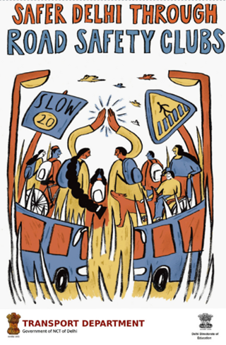The Transport Department is the Lead Agency for Road Safety in Delhi. Safer School Zones was launched as part of High Impact Project in 2022 initiating a focus on school and school travel safety in partnership with HumanQind as the lead partner of the Transportation Research and Injury Prevention Centre (TRIP C) at Indian Institute of Technology, Delhi. Road Safety Clubs were established in all schools by the Directorate of Education in November 2022. As part of the High Impact Project, 11 model school zones, one every district of Delhi. The project has brought all school members including students to discuss and plan long term traffic safety and school accessibility blueprint based on data and collaborative action with District Road Safety Committees.

The road safety club are core teams constituting a representative group of the school community including students and alumni, school staff, parents, and head of school. The primary objective of this club is to promote traffic safety, especially in how users get to and from school.

### : Engagement Timeline

|  |  |  |  |  |  |
| --- | --- | --- | --- | --- | --- |
| **STAGE 1**  **Orientation** | **STAGE 2 Data Collection** | **STAGE 3**  **Design Collaboration** | **STAGE 4 Exhibition** | **STAGE 5 Implementation** | **STAGE 6 Management** |
| Focus the school towards safer commuting to school for all-parents, staff,students, SMC/PTA. | Conduct school accessibility audits and traffic safety assessment for evidence based planning and understanding the school community. | Conduct co-design workshops with students, staff and parents to prepare safe school zone plan, design and management-including circulation and parking. | Organise periodic exhibitions on school zones and road safety with decision makers and the school community. | Involve the government to implement the safe school zone plan. | Enable the Road safety club to manage the school zone and organise talks and interviews with experts. |
| Nov 22 | Dec 22 - Jan 23 | Nov -Dec 22 | July 23 | Current Stage |  |

### General description of the site

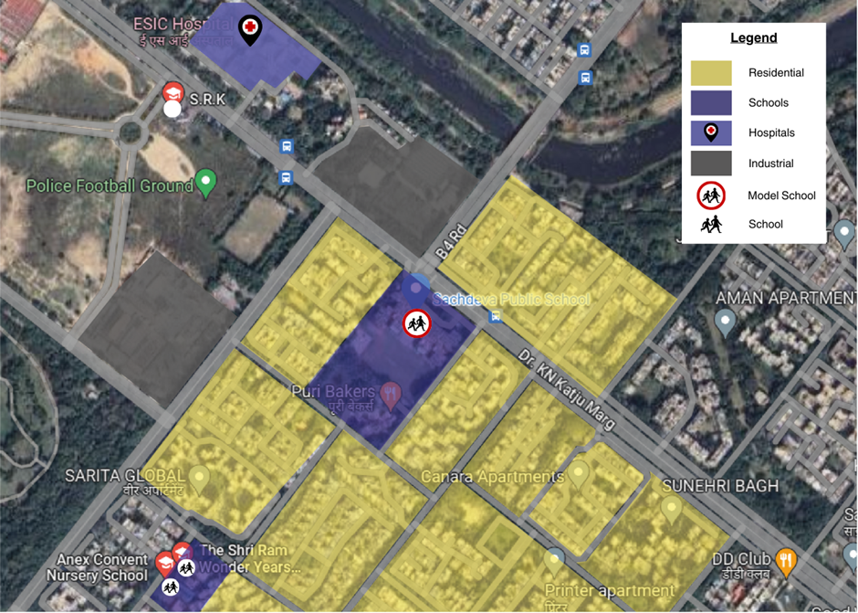

|  |  |  |  |  |  |  |
| --- | --- | --- | --- | --- | --- | --- |
| District | Co-ed | School Shift | Shared Campus | Cluster of Schools | Total No. of Students: | ROW |
| North | Yes | Morning | No | No | 3552 | 7m-44m |

Length of the Intervention (all arms, in metres) : 970 m

Figure 1 - Land Use Map around Sachdeva Public School and School Zone Date (AY 22-23)

Situated at Dr. KN Katju Marg (44 m ROW connecting H.L Parwana Road (23 m ROW) ) and adjacent to an MCD road ( 7m ROW), with , the Sachdeva Public School (SPS) Rohini (120m x 135m block) is the pilot school zone site in the North district (28°43'30.1"N 77°07'42.6"E). The school surroundings are predominantly residential in nature. Within its proximity, there is also a gas station, Tata electrical plant, and an ESIC hospital. The school has a total of 5 gates, out of which only 3 gates are used during the entry and exit hours. SPS Rohini is a co-ed school with a total enrolment of 3552 students from Nursery to XII, as per the academic year 2022-2023. Thus, the children from age 5 to 17 are travelling to and from school. With the observed issues of over speeding and lack of traffic calming devices, the site was identified as a potential crash location as per the ‘Data to Action report 2022-23’. The larger mode of transport observed are vans, private vehicles and walking. Others include cab, Three wheeled Scooter Rickshaw (TSR), cycle etc. The graph below shows the data collected online via road safety clubs.

### : Existing Scenario

As per a travel survey conducted in Dec '22, response from 895 students (25% of total school population) was mapped to understand the travel patterns and socio-economic data relevant to school journeys.

Figure 10: Home to School travel modal distribution: SPS Rohini

Figure 11: School to home travel modal distribution

Source: HumanQind School Travel Survey 22-23)

* Private vehicles and school vans are the most common modes of travel both in the morning and the afternoon.
* Most of the students that responded come to school either by private vehicles, vans or by walking.
* Public transport and cycling are amongst the least used modes.
* Between morning (home to school) and afternoon (school to home) trips there are very few changes that we see in modal share.
* One of the major changes is the decrease in private vehicle use in the afternoon, though this decrease is compensated with an increase in public transport use.

Figure 12: Commute distance to and from school

Source: HumanQind School Travel Survey 22-23

* Most of the students of the school stay within 1 - 2 km of the school (27%).
* 26% of the students stay within 1 km of the school, thus more than half the students are within 2 km of the school,
* A fifth of the student come from distances more than 3 km radius

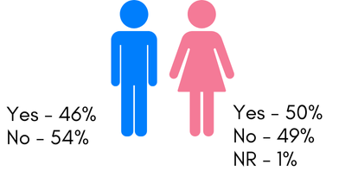

Figure 13: Infrastructure change expected: SPS Rohini

Source: HumanQind School Travel Survey 22-23

* Half of the students (49%) feel unsafe during their trip to school.
* Gender wise distribution of this is also very similar with the male students reporting marginally less fear compared to girls.
* The travel modes in which the students feel the safest are - auto rickshaws (TSR), private vehicles, cabs, walking and public transport (< 30%).
* Vans were reported to be where the students feel the most unsafe with more than 90% of them reporting they feel unsafe while travelling in vans.
* Students travelling by school bus and cycles also feel unsafe while travelling.
* There is very little change in this behaviour between morning and afternoon trips.

**Infrastructure Interventions and its Impact on Social and Emotional Learning**

When asked what infrastructural changes both in the school surroundings and their travel routes will have a positive impact on them. 66% of students preferred no crowding outside the school, 63% suggested traffic lights and safer crossing, 57% suggested a footpath for walking would be beneficial to them. 57% of students opted for comfortable waiting spaces. With that significant students opted for vehicle-free streets and organised entry and exit outside the schools (55%,and 58% respectively). Infrastructure not only provides a change in the environment but also serves a psychological purpose of providing safety and comfort which affects the sense of belonging and emotions around a public space. (Source: HumanQind School Travel Survey 22-23)

**Infrastructure Interventions and Academic Performance**

The students were also surveyed about what are the factors they believe will enhance their learning and academic performance. 52% of students reported last mile walking. 45% of students reported less travel time, and availability of public transportation near school (41%), and less walking time (40%). Long and cumbersome commutes to school can hamper the readiness for learning and the exhaustion of learning. (Source: HumanQind School Travel Survey 22-23).

### : Issues Identified

**Observations on Road Infrastructure:** Due to the traditional vehicle-centric planning approach, the road infrastructure does not promote pedestrian safety and creates an unsafe environment for the vulnerable road users, putting school children at risk. The school is located on an arterial road which is mostly non signalised. Instances of high speeds have been observed. Lack of continuous footpaths, encroachments, no space to cycle safely, traffic calming, signages and marking, and non-functional traffic lights, high conflict of moving vehicles with students is visible. Students walk and cycle between parked vehicles on the carriageway and service lane. The zone lacks pedestrian amenities such as waiting areas & integrated vendor spaces. No drop off and pick-up areas have been assigned. Better lighting and drainage is needed. There is a high foliage of wide trees that occupy ~1m or more space.

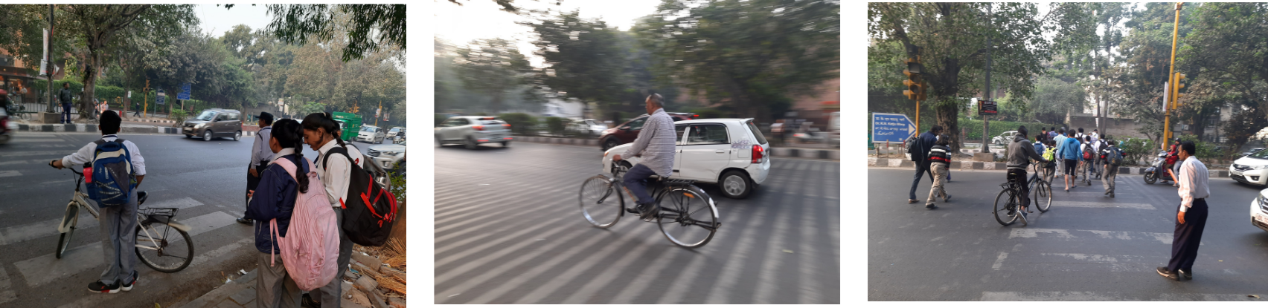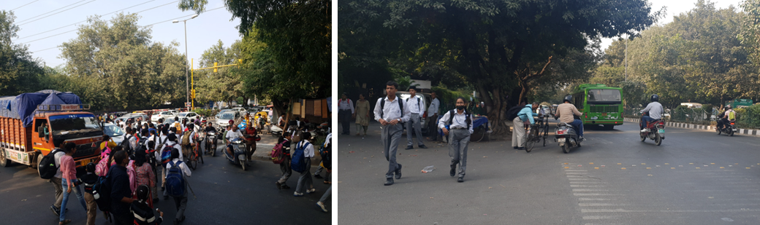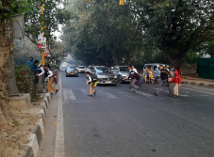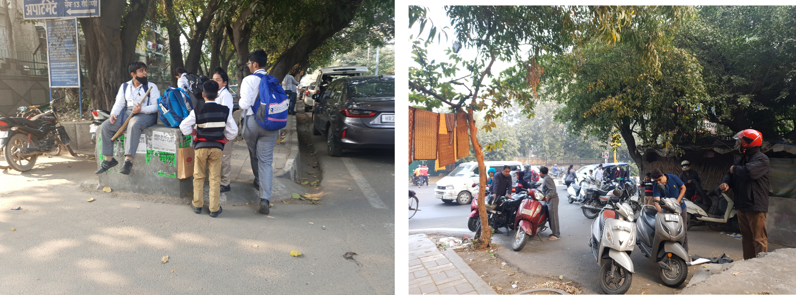  
Site Photographs: Sachdeva Public School

**Type and quality of enforcement:** Unorganised parking, lack of dedicated pick up and drop off zone and traffic management in the school vicinity leads to an uncontrolled environment and circumstances. The school is located at a T intersection which has pedestrian access but cars do not slow down. Over speeding is observed to be a common phenomenon resulting in difficulties for children to cross the road.

**Road users’ behaviour and mobility patterns:** To understand the patterns of movements and conflicts in the school zone, activity mapping was conducted in morning hours (home to school traffic) and exit timing during afternoon (school to home).

### : Activity Map

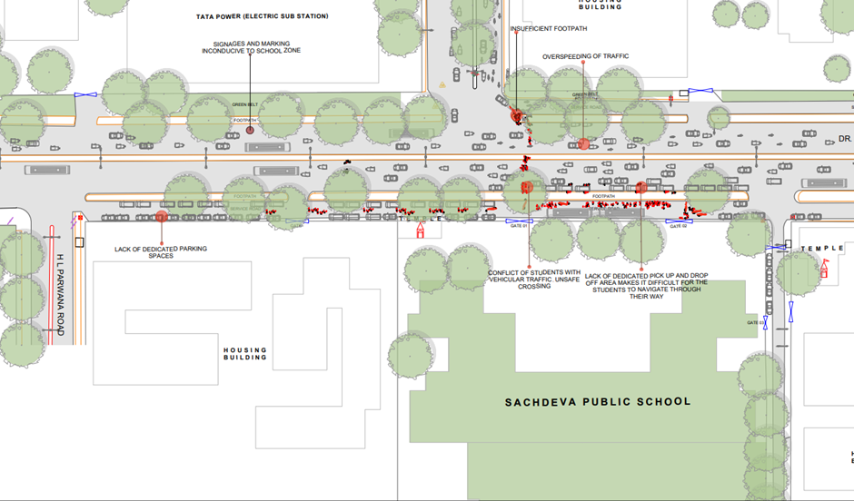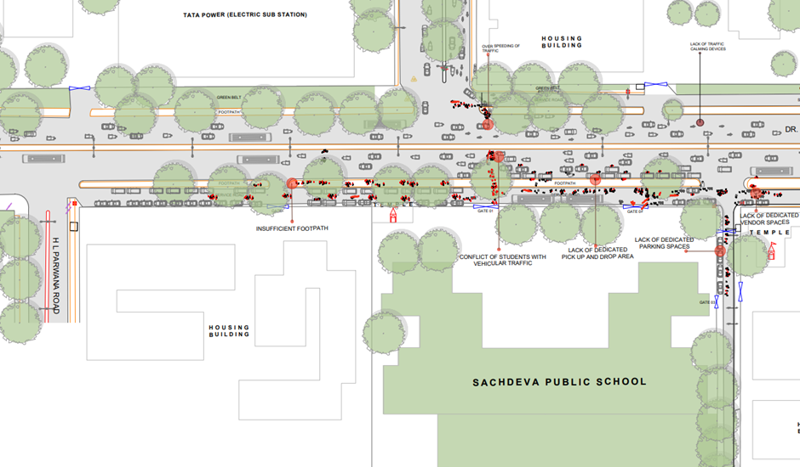

**Figure 5- Activity Mapping : Home to School (U) , Activity Mapping School to Home (D)**

**Key Findings:**

|  |  |
| --- | --- |
| **Morning: Home to School**   * Buses and vans use separate sections of service lanes to offload students near gates. Due to inadequate planning and improper parking, students find it difficult to navigate their way to the school gate. * Private vehicles occupy footpaths and service lanes making it inaccessible to the students and parents who walk to school. Pedestrians and children as young as 5 yrs walk on the carriageway along with high-speed traffic. Teachers mainly park in the minor road towards the market. * Parents pick and drop off students on both sides of the main arterial road due to which students risk unsafe crossings. Parents and caregivers are observed standing due to lack of waiting spaces near the school gate. * High speed and high conflict of motorised and non-motorised vehicles is observed between school traffic and through traffic. | **Afternoon: School to Home**   * The conflict points relatively increase with the increase in general traffic on the road. * The vans and e-rickshaw due to no pick up points are scattered on the carriageway. Students find it difficult to navigate through them. Students have also mentioned that they tend to get late because of overcrowding and congestion at the school gate. * The traffic lights near the school vicinity are non-functional with no traffic calming devices or pedestrian crossing due to which students find it difficult to cross the road. |

### : Proposed Design

The School Zone plan addressed by school road safety clubs is titled ‘Sensitive Abode of Learning’ strictly adheres to IRC guidelines and principles of traffic safety and management around schools. The design takes into consideration some of the specific problems and challenges identified together. Students embrace a slow zone, promote walkability, extend limits to the intersection, propose an integrated plan with public transport and incorporate their visible needs. The proposed design 970m covers length of streets and adheres to 20 km/h or lower in the school zone promoting walkability and designated spaces for parking to avoid conflicts. The area in front of gates including the two intersections of K.N. Katju Marg have been made safer with wide prominent crossings for all road users.

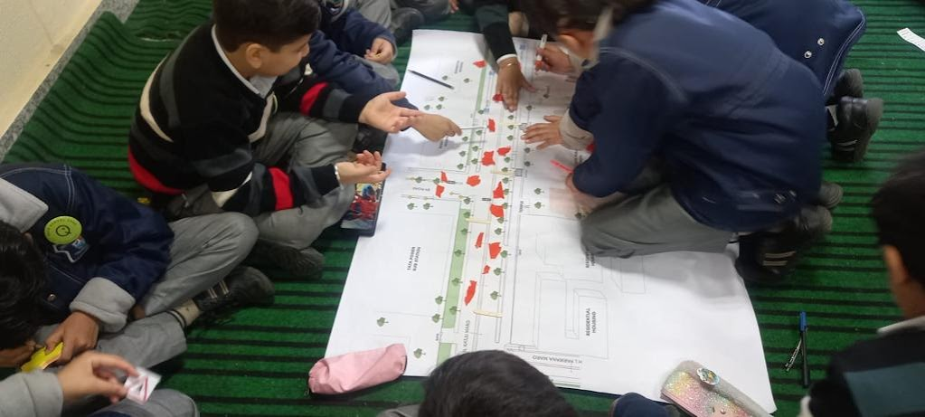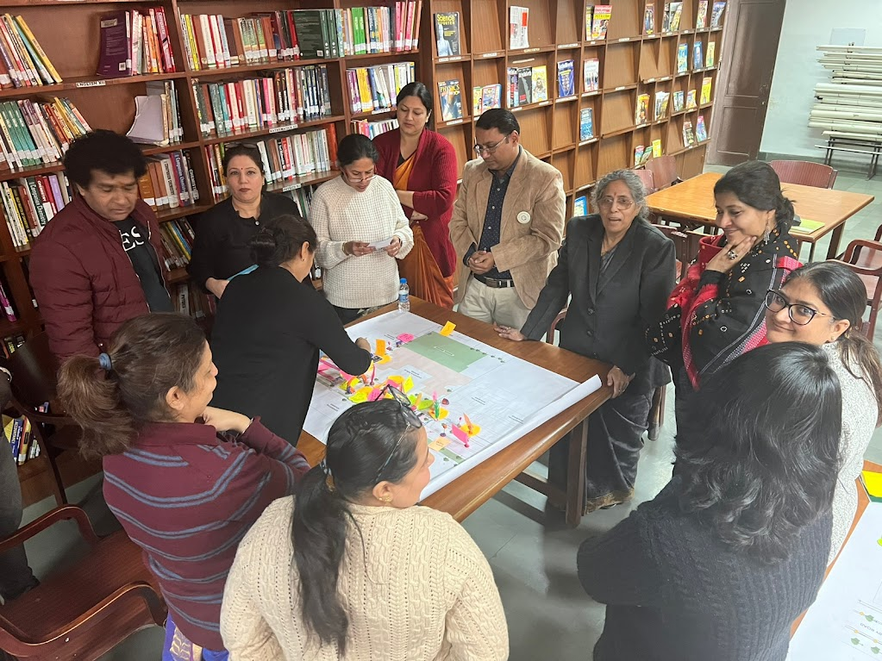

Figure 6 - School Road Safety Club design safety interventions for school zone

**Advantages of the new design**

Designed with students, the proposed design prioritises the needs of the students and vulnerable users and incorporates efficient sharing of streets for all. It includes the following:

* Provision of pedestrian infrastructure as per IRC 103
* Provision of cyclist infrastructure as per IRC 11
* Provision of traffic calming devices
* Provision of Signages and Markings conducive to school zone requirements.
* Provision of waiting areas and dedicated vendor zones
* Better planning of utilities, and street furniture
* Student friendly street elements and details
* Reduction of Conflict Area : Segregated and continuous footpaths have been provided along with texture change and raised crossings at intersections. Cycle tracks have been introduced.
* Safer Junctions - Both the intersections are made safer with provision of pedestrian crossing, signages and markings as per the school zone requirements
* Safe and efficient traffic movement - Provision of dedicated Motorised Vehicle lanes are incorporated with markings and signages to ensure safe and efficient traffic movement.
* Safe and accessible pedestrian movement- Dedicated pedestrian infrastructure all along the school stretch provided with required markings, signages and universal accessibility features.
* Safer speeds - In accordance to Design speed of 20kmph as per IRC 86:2018 and IRC SP 32

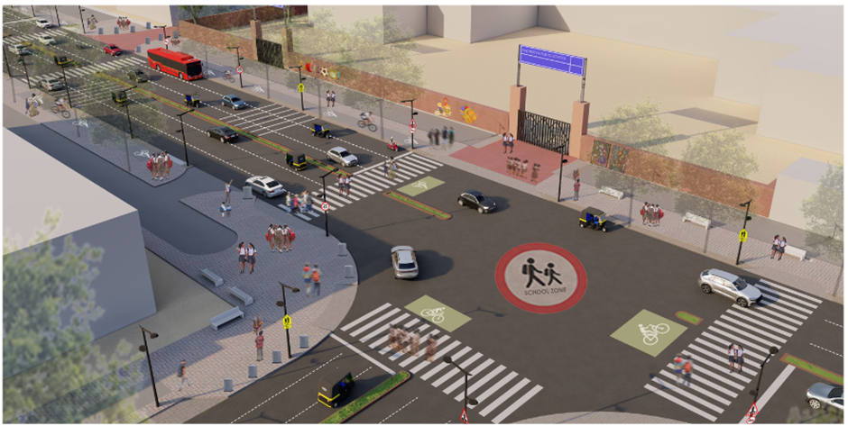

*Figure 7 - Sensitive Abode of Learning - Proposed Render of K N Katju Marg in front of Sachdeva Public School*

**Design Interventions**

The proposal prepared by road safety clubs (Refer Safer Delhi through Road Safety Clubs) is called ‘Sensitive Abode of Learning’ aligning to pedestrian first approach, traffic safety principles, UN Sustainable Development Goals and Ladder of Children Participation. Sensitive Abode of Learning is an area plan connecting 4 schools and the neighbourhood to 950 m of school zone development. The entire plan is in adherence to Indian Road Congress Guidelines. To reduce speeds and conflicts, the school zone has been designed as per 20 km/h or lower speed, promoting walkability, and safe mobility. Continuous footpaths with designated boarding areas and drop off zones have been proposed. With a mix of arterial, collector streets and local streets, each of the ROW are designed as per their street typology. The access function in arterial streets has been proposed via service lanes.

* 2.5m segregated footpaths on both sides
* 2.5m segregated cycle track on both sides
* 1.0 m of Multi-Utility Zone for Services such as lighting and drainage.
* Designated boarding areas and drop off zones near school gates
* Waiting spaces and street furniture integrated
* School specific signage and marking
* Wide Pedestrian Crossings to accommodate school traffic.
* Major intersections have been rationalised.The intersection in front of Gate 1 has been proposed to be signalized and allow turning traffic. With Gate 1, this intersection will function as an arm intersection, allowing smooth movement of school traffic in both directions.
* Table top crossings and texture change on surface has been proposed for minor intersections towards the MCD Road.
* Continuous carriageway (3 lanes each direction on K N Katju Marg) and (two lane each direction on H L Parwana Road and Shahid Captain Dahiya Marg).

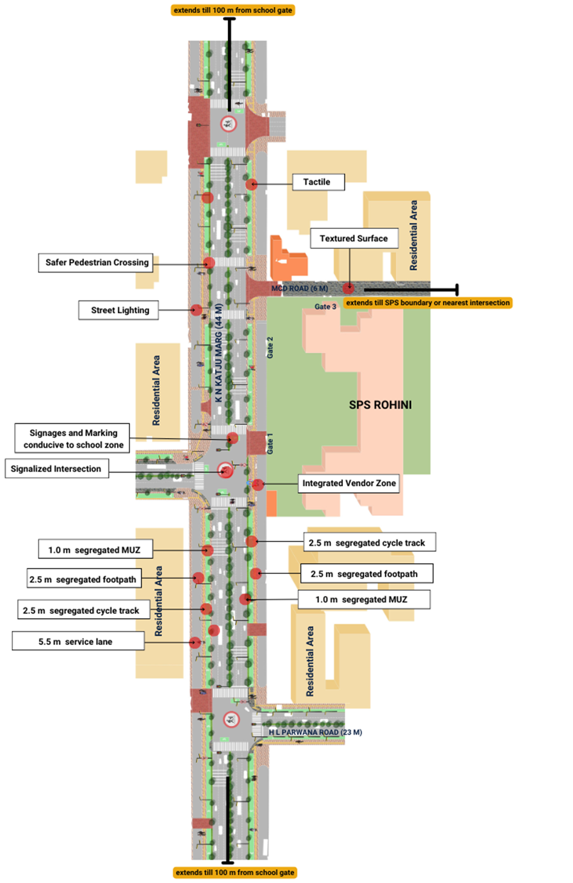

Proposed Design for School Zone Sachdeva Public School, Rohini

### Summary Budget estimate

| **S.No** | **Component** | **Details** | **Notes** | **Rate (per sq.m)** | **Cost (INR)** | **Cost (INR, crores)** |
| --- | --- | --- | --- | --- | --- | --- |
| **A** | **CIVIL WORK** |  |  |  |  |  |
| A.1 | Footpath (Primary, Secondary including other Flooring area) | 2.5m segregated footpath with tactile pavers in both directions | Providing and Laying of footpath 2m to 3m wide, including earthwork and base layer - PCC, GSB and finishing material. | 2838 | 11808105 | 1.181 |
| A.2 | Raised Crossing | Signalised Intersections and traffic calming at entry/exits | Providing and laying Raised crossing with 80 mm thick pavers blocks, and DQ stone including Earth work and Base layers- PCC (M15), RCC (M30 Design mix) & GSB etc. | 6584 | 7242078 | 0.724 |
| A.3 | Cycle Infrastructure | 2.5m segregated cycle tracks on both sides | Providing and laying cycle track (2.5mt wide segregated) including Earth work and Base layers- PCC (M15), RCC (M40 Design mix) & GSB etc. also thermoplastic paint for marking and cycle symbol and spring post etc | 3948 | 4145111 | 0.415 |
| A.4 | CC Items (Kerbs, Pipe, etc) | Provision of bollards, kerbs - mountable, kerb channels, etc | Providing and fixing Kerbs, Bollards, and Kerb Channel etc. in CC. |  | 2652904 | 0.265 |
| A.5 | Signages | Provision of signages as per IRC 67 for school zone & 20km/h | Providing and fixing Signage Mandatory, Cautionary and informatorily sign board including all the fixing and labours etc. |  | 623973 | 0.062 |
| A.6 | Marking | Provision of signages as per IRC 35 for school zone & 20km/h | Providing and applying road marking strips (retro- reflective) of specified shade/ colour using hot thermoplastic material for road marking. | 863 | 1686803 | 0.169 |
| A.7 | Special Zones | Provision of seating areas, vendor spaces and play integrated with design proposal | Miscellaneous items- Provision of Sitting Bollards, CC Benches, GRC Jali, Pergola, Dustbin etc. complete items- including foundation and fixing etc. |  | 419697 | 0.042 |
| A.8 | Brick Work | -- | Brick work with common burnt clay F.P.S. (non-modular) bricks of class designation 7.5 in foundation and plinth in: Cement mortar 1:4 (1 cement: 4 coarse sand) | 7370.65/CUM | 208295 | 0.021 |
| A.9 | Steel Reinforcement for RCC work | -- | Steel reinforcement (in per kg) for R.C.C. work including straightening, cutting, bending, placing in position and binding all complete up to plinth level. Thermo-Mechanically Treated bars of grade Fe-500D or more | 107.85/kg | 930746 | 0.093 |
| A.10 | Pavement Surface Dressing | Pavement of Bitumen layer on existing road surface | Surface dressing on old surface with hot bitumen of grade VG - 10 | 175.10 / sq.m | 0 | 0.000 |
| A.11 | Safety Management Equipment (as per design requirement) | Provision of Delineator Post, Spring Post, Cat eye/studs etc. | Miscellaneous items for Safety Management Equipment (as per design requirement) -Provision of Delineator Post, Spring Post, Cat eye/studs etc.- including foundation and fixing etc. |  | 10500 | 0.001 |
| A.12 | Bus Shelter | Provision of new bus shelter. |  |  | 1800000 |  |
|  | **SUB TOTAL CIVIL WORK (A)** |  |  |  | **31528211** | 3.153 |
| **B** | Drainage, Irrigation & Plumbing | Details promote catch pit along the footpath linked to existing manholes. Bell mouths are not recommended. Details to be finalised with PWD | Drainage, Irrigation & Plumbing work @ 20% of the cost of Civil work | 20% | **6305642** | 0.631 |
| **C** | Electrical Work | 5m and 10m light poles have been located alongside footpath / MUZ. Details to be finalised with PWD. | Electrical work @25% of the cost of Civil work | 25% | **7882053** | 0.788 |
| **D** | Horticulture Work | To increase green cover and shade, landscape plan to promote ground cover and trees for seasonal variation and colour. Irrigation plan to be finalised with PWD. | Horticulture work @ 15% of the cost of Civil work | 15% | **4729232** | 0.473 |
| **E** | Dismantling / Demolition | -- | Dismantling work @ 15% of the cost of Civil work | 15% | **4729232** | 0.473 |
| **F** | Work Zone Safety & Management | -- | Work zone Management @ 5% of the cost of Civil work | 5% | **1576411** | 0.158 |
| **PART 1** | **SUB TOTAL PART 1 (A+B+C+D+E+F)** |  |  |  | **56750779** | 5.675 |
| **G** | Design Services & Support | -- | Design Consultancy (Preparation of Drawings, BOQ support, Work Zone plan, Site Supervision, Community Engagement & Liaison, Change Management @ 2% - 8% of the cost of Civil work. | **5%** | **2837539** | 0.284 |
| **H** | Survey Cost | -- | Survey Cost (Total Station Survey, underground services, tree demarcation, girths, level differences, steps etc @ (80,000 per junction - 250m on each arm) | 80000 | **80000** | 0.008 |
| **PART 2** | **SUB TOTAL PART 2 (PART 1 + G +H)** |  |  |  | **59668318** | 5.967 |
| **J** | Contingencies '2.5% | -- | Contingencies (@2.5%) |  | **1491708** | 0.149 |
| **I** | GST ('@18%) | -- | GST @18% |  | **11008805** | 1.101 |
| **FINAL** | **GRAND TOTAL(INR) (PART 2 + J + I)** |  |  |  | **72168831** | **7.217** |

**Notes**

1. DSR 2023 has been followed for all rates. Market Rate and Costing from part PWD projects has been included for certain items. This is a preliminary estimate. Final costing to be evaluated & approved by road owning agency
2. Cost of Drainage, Irrigation, Plumbing has been calculated at 20% of the civil work cost
3. Cost of Electrical Work can be calculated at 20% - 25 % of the civil work cost
4. Cost of Horticulture has been calculated at 15% of the civil work cost
5. Cost of Dismantling has been calculated at 15% of the civil work cost
6. Cost of Work Zone Management has been calculated at 5% of the civil work cost
7. Cost for Design Support can range from 2% - 8%, can vary from site to site. This should include Technical Assistance on drawings, 3D supports, Site Supervision, Change management
8. Bus Shelter has been calculated at 18 L per shelter; can be changed as per design specific cost
9. In case of new items specific to design, please add relevant rows in detail budget estimation and include the same in the budget summary under relevant head

### : Detailed budget estimate

| **S. No** | **Component** | **Material Description** | **Item No. (DSR 2023 / Market Rate)** | **Unit** | **Depth (m)** | **Qty** | **Unit Rate** | **Amount** |
| --- | --- | --- | --- | --- | --- | --- | --- | --- |
| 1 | Footpath (Primary, Secondary including other Flooring area) |  |  |  |  |  |  |  |
| 1.1 | Excavation | Earth work in excavation by mechanical means (Hydraulic excavator)/ manual means over areas (exceeding 30 cm in depth, 1.5 m in width as well as 10 sqm on plan) including getting out and disposal of excavated earth lead upto 50 m and lift upto 1.5 m, as directed by Engineer-incharge. | 2.6.1 | cum | 0.85 | 4160 | 177.5 | 627640 |
| 1.2 | Construction of granular sub-base | Construction of granular sub-base by providing close graded Material conforming to specifications, mixing in a mechanical mix plant at OMC, carriage of mixed material by tippers to work site, for all leads & lifts, spreading in uniform layers of specified thickness with motor grader on prepared surface and compacting with vibratory power roller to achieve the desired density, complete as per specifications and directions of Engineer-in-Charge. With material conforming to Grade-II (size range 53 mm to 0.075 mm ) having CBR Value-25 | 16.78.2, pg no. 258 | cum | 0.15 | 4160 | 2924.85 | 1825106.4 |
| 1.3 | Providing and laying in position cement concrete (M15) | Providing and laying in position cement concrete of specified grade excluding the cost of centering and shuttering - All work up to plinth level :1:2:4 (1 Cement : 2 coarse sand (zone-III) derived from natural sources : 4 graded stone aggregate 40 mm nominal size derived from natural sources) | 4.1.4, pg no. 103 | cum | 0.1 | 4160 | 7780.3 | 3236604.8 |
| 1.4 | Tactile - Warner (300 x 300 x 9.8 mm ) (20% of total tactile quantity) | Providing and laying tactile tile (for vision impaired persons as per standards) of size 300x300x9.8 mm having with water absorption less than 0.5% and conforming to IS:15622 of approved make in all colours and shades in for outdoor floors such as footpath, court yard, multi modals location etc., laid on 20 mm thick base of cement mortar 1:4 (1 cement : 4 coarse sand) in all shapes & patterns including grouting the joints with white cement mixed with matching pigments etc. complete as per direction of Engineer-in-Charge. | 16.90, pg no. 261 | sqm |  | 100 | 2017.6 | 201760 |
| 1.5 | Tactile - Guiding (300 x 300 x 9.8mm ) (80% of total tactile quantity) | Providing and laying tactile tile (for vision impaired persons as per standards) of size 300x300x9.8 mm having with water absorption less than 0.5% and conforming to IS:15622 of approved make in all colours and shades in for outdoor floors such as footpath, court yard, multi modals location etc., laid on 20 mm thick base of cement mortar 1:4 (1 cement : 4 coarse sand) in all shapes & patterns including grouting the joints with white cement mixed with matching pigments etc. complete as per direction of Engineer-in-Charge. | 16.90, pg no. 261 | sqm |  | 500 | 2017.6 | 1008800 |
| 1.6 | Flamed Finish Granite (approved size & color) (18mm thick) | Providing and laying flamed finish Granite stone flooring in required design and patterns, in linear as well as curvilinear portions of the building all complete as per the architectural drawings with 18 mm thick stone slab over 20 mm (average) thick base of cement mortar 1:4 (1 cement : 4 coarse sand) laid and jointed with cement slurry and pointing with white cement slurry admixed with pigment of matching shade including rubbing, curing and polishing etc. all complete as specified and as directed by the Engineer-in-Charge :Flamed finish granite stone slab Jet Black, Cherry Red, Elite  Brown, Cat Eye or equivalent. | 11.55 pg no 198 | sqm |  | 100 | 3186.7 | 318670 |
| 1.7 | Polished Granite | Providing and laying Polished Granite stone flooring in required design and patterns, in linear as well as curvilinear portions of the building all complete as per the architectural drawings with 18 mm thick stone slab over 20 mm (average) thick base of cement mortar 1:4 (1 cement : 4 coarse sand) laid and jointed with cement slurry and pointing with white cement slurry admixed with pigment of matching shade including rubbing, curing and polishing etc. all complete as specified and as directed by the Engineer-in-Charge.  Polished Granite stone slab colour of Black, Cherry/Ruby Red or equivalent | 11.56.1, Pg no 198 | sqm |  | 50 | 4481.3 | 224065 |
| 1.8 | Interlocking Paver Blocks (approved size & color) (60mm thick) | Providing and laying factory made chamfered edge Cement Concrete paver blocks in footpath, parks, lawns, drive ways or light traffic parking etc, of required strength, thickness & size/ shape, made by table vibratory method using PU mould, laid in required colour & pattern over 50 mm thick compacted bed of sand, compacting and proper embedding/laying of inter locking paver blocks into the sand bedding layer through vibratory compaction by using plate vibrator, filling the joints with sand and cutting of paver blocks as per required size and pattern, finishing and sweeping extra sand. complete all as per direction of Engineer-in-Charge: 60 mm thick cement concrete paver block of M-35 grade with approved colour, design & pattern. | 16.91.1, pg no. 261 | sqm | 0.6 | 3410 | 1045.65 | 3565666.5 |
| 1.9 | Glass Mosaic (20mm x 20mm x 4mm) | Providing and fixing Glass mosaic tiles on finished plain wall surface of size 20 mm x 20 mm x 4 mm in all colour, design, fixing in customize design as per direction of Engineer-in- Charge. The glass mosaic tiles to be fixed on the wall surface with the help of approved adhesive applied at the rate of 2.5 kg per sqm and grouting of the same. The rate is inclusive of all operation, material and required pattern approved by Engineer-in-Charge: | 11.53 pg no 197 | sqm |  | 20 | 3891.15 | 77823 |
| 1.10 | Crazy Marble Stone (18 mm thick) | Crazy marble stone flooring, including filling the gaps with light shade pigment with white cement marble powder mixture (3 parts of white cement: 1 part of marble powder) by weight in proportion of 4:7 (4 cement marble powder mix : 7 white, black or white and black marble chips of sizes from 1 mm to 4 mm nominal size by volume), with under layer 25 mm thick cement concrete 1:2:4 (1 cement: 2 coarse sand: 4 graded stone aggregate 12.5 mm nominal size), including rubbing, polishing and cement slurry etc. complete :  18 mm thick crazy marble stone white, black or as specified | As per NIT DAV Pedestrianization | sqm |  | 20 | 948.85 | 18977 |
| 1.11 | Crazy Vitrified Tiles (100x100x16mm) | Providing and laying matt finished vitrified tile of size 100x100x16mm having water absorption less than 0.5% and conforming to IS: 15622 of approved make in all colours and shades in outdoor floors such as footpath, court yard multi models etc., laid on 20mm thick base of cement mortar 1:4 (1cement: 4 coarse sand) in all shapes & patterns including grouting the joints with white cement mixed with matching pigments etc. complete as direction of Engineer-in-Charge. | As per NIT DAV Pedestrianization | sqm |  | 0 | 842.95 | 0 |
| 1.12 | Delhi Quartzite (MUZ) (10x10x7.50) | Providing and fixing 10x10x7.50 cm Granite stone block hand cut and chisel dressed on top, for paving in floors, drains etc. laid over 20 mm thick base mortar 1:4 (1 cement: 4 coarse sand) with joints 10 mm wide filled with same mortar including ruled pointing etc. complete as per direction of engineer-in-charge. | 16.92 pg no 261 | sqm |  | 150 | 2189.15 | 328372.5 |
| 1.13 | EPDM Flooring | Providing and fixing 36 MM thick Ethylene Propylene Diene Monomer (EPDM) [30 MM SBR (Styrene- Butadiene or Styrene-butadiene Rubber) & 6 MM EPDM] safety FLOORING with the help of BASF Glue 18 adhesive for children play area complete all as per manufacturer's specification and direction of Engineer- in-charge. | As per AR (Market Rate) | Sqm |  | 100 | 3746.2 | 374620 |
|  | SUB TOTAL |  |  |  |  |  |  | 11808105.2 |

| **2** | **Raised Crossing** | **Material Description** | **Item No. (DSR 2023 / Market Rate)** | **Unit** | **Depth (m)** | **Qty** | **Unit Rate** | **Amount** |
| --- | --- | --- | --- | --- | --- | --- | --- | --- |
| 2.1 | Excavation | Earth work in excavation by mechanical means (Hydraulic excavator)/ manual means over areas (exceeding 30 cm in depth, 1.5 m in width as well as 10 sqm on plan) including getting out and disposal of excavated earth lead up to 50 m and lift up to 1.5 m, as directed by Engineer-in charge. | 2.6.1 | cum | 0.325 | 1100 | 177.5 | 63456.25 |
| 2.2 | Construction of granular sub-base | Construction of granular sub-base by providing close graded Material conforming to specifications, mixing in a mechanical mix plant at OMC, carriage of mixed material by tippers to work site, for all leads & lifts, spreading in uniform layers of specified thickness with motor grader on prepared surface and compacting with vibratory power roller to achieve the desired density, complete as per specifications and directions of Engineer-in-Charge. With material conforming to Grade-II (size range 53 mm to 0.075 mm) having CBR Value-25 | 16.78.2, pg no. 258 | cum | 0.1 | 1100 | 2924.85 | 321733.5 |
| 2.3 | Providing and laying in position cement concrete (M15) | Providing and laying in position cement concrete of specified grade excluding the cost of centering and shuttering - All work up to plinth level: 1:2:4 (1 Cement: 2 coarse sand (zone-III) derived from natural sources: 4 graded stone aggregate 40 mm nominal size derived from natural sources) | 4.1.4, pg no. 103 | cum | 0.1 | 1100 | 7780.3 | 855833 |
| 2.4 | Providing and laying in position cement concrete (M25, Design Mix) | Providing and laying in position ready mixed or site batched design mix cement concrete for plain cement concrete work; using coarse aggregate and fine aggregate derived from natural sources, Portland Pozzolana/Ordinary Portland /Portland Slag cement, admixtures in recommended proportions as per IS: 9103 to accelerate / retard setting of concrete, to improve durability and workability without impairing strength; including pumping of concrete to site of laying, curing, carriage for all leads; but excluding the cost of centering, shuttering and finishing as per direction of the engineer-in-charge; for the following grades of concrete. **Note:** Extra cement up to 10% of the minimum specified cement content in design mix shall be payable separately. In case the cement content in design mix is more than 110% of the minimum specified cement content, the contractor shall have discretion to either re-design the mix or bear the cost of extra cement. Concrete of M25 grade with minimum cement content of 300 kg /cum | 4.20.1.4, page 108 | cum | 0.125 | 1350 | 9439.05 | 1592839.688 |
| 2.4 | Interlocking Paver Block (Red & White of approved size) 80mm thick | Providing and laying factory made chamfered edge Cement Concrete paver blocks in footpath, parks, lawns, drive ways or light traffic parking etc, of required strength, thickness & size/ shape, made by table vibratory method using PU mould, laid in required colour & pattern over 50 mm thick compacted bed of sand, compacting and proper embedding/laying of inter locking paver blocks into the sand bedding layer through vibratory compaction by using plate vibrator, filling the joints with sand and cutting of paver blocks as per required size and pattern, finishing and sweeping extra sand. complete all as per direction of Engineer-in-Charge: 80 mm thick C.C. paver block of M-35 grade with approved colour design and pattern | 16.91.2, pg no. 261 | sqm |  | 950 | 1091.5 | 1036925 |
| 2.5 | Delhi Quartzite 10x10x7.50 | Providing and fixing 10x10x7.50 cm Granite stone block hand cut and chisel dressed on top, for paving in floors, drains etc. laid over 20 mm thick base mortar 1:4 (1 cement: 4 coarse sand) with joints 10 mm wide filled with same mortar including ruled pointing etc. complete as per direction of engineer-in-charge. | 16.92 pg no 261 | sqm |  | 1540 | 2189.15 | 3371291 |
|  | SUB TOTAL |  |  |  |  |  |  | 7242078.438 |

| **3** | **Cycle Infrastructure** | **Material Description** | **Item No. (DSR 2023 / Market Rate)** | **Unit** | **Depth (m)** | **Qty** | **Unit Rate** | **Amount** |
| --- | --- | --- | --- | --- | --- | --- | --- | --- |
| 3.1 | Excavation | Earth work in excavation by mechanical means (Hydraulic excavator)/ manual means over areas (exceeding 30 cm in depth, 1.5 m in width as well as 10 sqm on plan) including getting out and disposal of excavated earth lead upto 50 m and lift upto 1.5 m, as directed by Engineer-in charge. | 2.6.1 | cum | 0.4 | 1050 | 177.5 | 74550 |
| 3.2 | Construction of granular sub-base | Construction of granular sub-base by providing close graded Material conforming to specifications, mixing in a mechanical mix plant at OMC, carriage of mixed material by tippers to work site, for all leads & lifts, spreading in uniform layers of specified thickness with motor grader on prepared surface and compacting with vibratory power roller to achieve the desired density, complete as per specifications and directions of Engineer-in-Charge. With material conforming to Grade-II (size range 53 mm to 0.075 mm) having CBR Value-25 | 16.78.2, pg no. 258 | cum | 0.15 | 1050 | 2924.85 | 460663.875 |
| 3.3 | Providing and laying in position cement concrete (M15) | Providing and laying in position cement concrete of specified grade excluding the cost of centering and shuttering - All work up to plinth level :1:2:4 (1 Cement : 2 coarse sand (zone-III) derived from natural sources : 4 graded stone aggregate 40 mm nominal size derived from natural sources) | 4.1.4, pg no. 103 | cum | 0.1 | 1050 | 7780.3 | 816931.5 |
| 3.4 | Providing and laying in position cement concrete (M40, Design Mix) | Providing and laying in position ready mixed or site batched design mix cement concrete for reinforced cement concrete work; using coarse aggregate and fine aggregate derived from natural sources, Portland Pozzolana / Ordinary Portland /Portland Slag cement, admixtures in recommended proportions as per IS: 9103 to accelerate / retard setting of concrete, to improve durability and workability without impairing strength; including pumping of concrete to site of laying, curing, carriage for all leads; but excluding the cost of centering, shuttering, finishing and reinforcement as per direction of the engineer-in-charge; for the following grades of concrete. Note: Extra cement up to 10% of the minimum specified cement content in design mix shall be payable separately. In case the cement content in design mix is more than 110% of the specified minimum cement content, the contractor shall have discretion to either re-design the mix or bear the cost of extra cement:  Concrete of M40 grade with minimum cement content of 390 kg/cum | 5.33.1.4, page 120 | cum | 0.15 | 1050 | 9957.65 | 1568329.875 |
| 3.5 | Thermoplastic Paint Marking (Cycle Track - Grey Colour; Cycle Box (Green); Cycle Lane, Edge Marking) | Providing and applying 2.5 mm thick road marking strips (retro- reflective) of specified shade/ colour using hot thermoplastic material by fully/ semi-automatic thermoplastic paint applicator machine fitted with profile shoe, glass beads dispenser, propane tank heater and profile shoe heater, driven by experienced operator on road surface including cost of material, labour, T&P, cleaning the road surface of all dirt, seals, oil, grease and foreign material etc. complete as per direction of Engineer-in-charge and accordance with applicable specifications. | 16.62, pg no. 257 | sq.m |  | 1620 | 747.8 | 1211436 |
| 3.6 | Cycle Symbol (On green box) | Providing and applying cycle symbol using thermoplastic paint as per IRC 35:2018 in cycle box at location specified | Market Rate | No.s |  | 12 | 1100 | 13200 |
| 3.7 | Spring Post (80mm dia 750mm high Plastic) | Providing and applying Plastic spring post 80mm dia 750mm high at location specified | Market Rate | No.s |  | 50 | 350 | 17500 |
|  | SUB TOTAL |  |  |  |  |  |  | 4145111.25 |

| **4** | **CC Items (Kerbs, Pipe, etc)** | **Material Description** | **Item No. (DSR 2023 / Market Rate)** | **Unit** | **Depth (m)** | **Qty** | **Unit Rate** | **Amount** |
| --- | --- | --- | --- | --- | --- | --- | --- | --- |
| 4.1 | Excavation | Earth work in excavation by mechanical means (Hydraulic excavator)/ manual means over areas (exceeding 30 cm in depth, 1.5 m in width as well as 10 sqm on plan) including getting out and disposal of excavated earth lead up to 50 m and lift upto 1.5 m, as directed by Engineer-in charge. | 2.6.1 | cum | 0.45 | 1467 | 177.5 | 117176.625 |
| 4.2 | Construction of granular sub-base | Construction of granular sub-base by providing close graded Material conforming to specifications, mixing in a mechanical mix plant at OMC, carriage of mixed material by tippers to work site, for all leads & lifts, spreading in uniform layers of specified thickness with motor grader on prepared surface and compacting with vibratory power roller to achieve the desired density, complete as per specifications and directions of Engineer-in-Charge. With material conforming to Grade-II (size range 53 mm to 0.075 mm ) having CBR Value-25 | 16.78.2, pg no. 258 | cum | 0.1 | 1467 | 2924.85 | 429075.495 |
| 4.3 | Dotted kerb stone of approved pattern of M-25 grade cement concrete ( 0.15x3xL ) | Providing and laying at or near ground level factory made kerb stone of M-25 grade cement concrete in position to the required line, level and curvature, jointed with cement mortar 1:3 (1 cement: 3 coarse sand), including making joints with or without grooves (thickness of joints except at sharp curve shall not to more than 5 mm), including making drainage opening wherever required complete etc. as per direction of Engineerin-charge (length of finished kerb edging shall be measured to calculate volume for payment). (Precast C.C. kerb stone shall be approved by Engineer-in-charge) | 16.69, pg no. 313 | cum | 0.1 | 1467 | 10117.6 | 1484251.92 |
| 4.4 | Bollards (600mm 120mm dia)  (Preferred size: 950mm high 150mm dia) | Pre casting and placing in position 125 mm dia Bollards 600 mm high of required shape including providing M.S. Pipe Sleeve 50 mm dia 300 mm long in the Bollard and M.S. Pipes 40 mm dia and 450mm long with 150x150x6mm M.S. plate welded at bottom and embedded 150mm in cement concrete 1:3:6 (1 Cement : 3 coarse sand (zone-III) derived from natural sources : 6 graded stone aggregate 20 mm nominal size derived from natural sources), including necessary excavation of size 250x250x450mm deep for the same in bitumen/concrete pavement at specified spacing | 4.9, pg no. 106 | No.s |  | 150 | 929.8 | 139470 |
| 4.5 | Kerb Channel (L*0.3) | Providing, laying and making kerb channel 30 cm wide and 50 mm thick with cement concrete 1:3:6 (1 cement: 3 coarse sands:6 graded stone aggregate 20 mm nominal size) over 75 mm bed of dry brick ballast 40 mm nominal size, well rammed and consolidated and grouted with fine sand, including finishing the top smooth etc. complete and as per direction of Engineer-in-charge. | 16.63, pg no. 257 | sqm |  | 865 | 558.3 | 482929.5 |
|  | SUB TOTAL |  |  |  |  |  |  | 2652903.54 |

| **5** | **Signages** | **Material Description** | **Item No. (DSR 2023 / Market Rate)** | **Unit** | **Depth (m)** | **Qty** | **Unit Rate** | **Amount** |
| --- | --- | --- | --- | --- | --- | --- | --- | --- |
| 5.1 | Mandatory sign boards of equilateral triangular shape having each side of 900 mm with support length of 3650 mm on arterial - sub arterial roads | Manufacturing, supplying and fixing retro reflective sign boards made up of 2 mm thick aluminium sheet, face to be fully covered with high intensity encapsulated type heat activated retro reflective sheeting conforming to type - IV of ASTM-D 4956-01 in blue and silver white or other colour combination including subject matter, message (bi-lingual), symbols and borders etc. as per IRC ; 67:2001, pasted on substrate by an adhesive backing which shall be activated by applying heat and pressure conforming to class -2 of ASTM-D-4956-01 and fixing the same with suitable sized aluminium alloy rivets @ 20 cm c/c to back support frame of M.S. angle iron of size 25x25x3 mm along with theft resistant measures, mounted and fixed with 2 Nos. M.S. angles of size 35x35x5 mm to a vertical post made up to M.S. Tee section ISMT 50x50x6 mm welded with base plate of size 100x100x5 mm at the bottom end and including making holes in pipes, angles flats, providing & fixing M.S. message plate of required size, steel work to be painted with two or more coats of synthetic enamel paint of required shade and of approved brand & manufacture over priming coat of zinc chromate yellow primer (vertical MS-Tee support to be painted in black and white colours).Backside of aluminium sheet to be painted with two or more coats of epoxy paint over and including appropriate priming coat including all leads and lifts etc. complete as per drawing , specification and direction of Engineer-in-charge.:  Mandatory/ Regulatory sign boards of 900 mm diameter with support length of 3750 mm | 16.59.1 | No.s |  | 16 | 7183.35 | 114933.6 |
| 5.2 | Cautionary / warning sign boards of equilateral triangular shape having each side of 900 mm with support length of 3650 mm on arterial - sub arterial roads | Manufacturing, supplying and fixing retro reflective sign boards made up of 2 mm thick aluminium sheet, face to be fully covered with high intensity encapsulated type heat activated retro reflective sheeting conforming to type - IV of ASTM-D 4956-01 in blue and silver white or other colour combination including subject matter, message (bi-lingual), symbols and borders etc. as per IRC ; 67:2001, pasted on substrate by an adhesive backing which shall be activated by applying heat and pressure conforming to class -2 of ASTM-D-4956-01 and fixing the same with suitable sized aluminium alloy rivets @ 20 cm c/c to back support frame of M.S. angle iron of size 25x25x3 mm along with theft resistant measures, mounted and fixed with 2 Nos. M.S. angles of size 35x35x5 mm to a vertical post made up to M.S. Tee section ISMT 50x50x6 mm welded with base plate of size 100x100x5 mm at the bottom end and including making holes in pipes, angles flats, providing & fixing M.S. message plate of required size, steel work to be painted with two or more coats of synthetic enamel paint of required shade and of approved brand & manufacture over priming coat of zinc chromate yellow primer (vertical MS-Tee support to be painted in black and white colours).Backside of aluminium sheet to be painted with two or more coats of epoxy paint over and including appropriate priming coat including all leads and lifts etc. complete as per drawing , specification and direction of Engineer-in-charge.:: Cautionary /warning sign boards of equilateral triangular shape having each side of 900 mm with support length of 3650 mm | 16.59.2 | No.s |  | 13 | 5559.75 | 72276.75 |
| 5.3 | Informatory sign boards of equilateral triangular shape having each side of 900 mm with support length of 3650 mm on arterial - sub arterial roads | Manufacturing, supplying and fixing retro reflective overhead signage boards made up of 2 mm thick aluminium sheet, face to be fully covered with high intensity and encapsulated lens type heat activated retro reflective sheeting conforming to type - III of ASTM-D-4956-01 as approved by Engineer-in-charge, letters, borders etc. as per IRC : 67-2001 in silver white with blue colour back ground and with high intensity grade, pasted on substrate by pressure sensitive adhesive backing which shall be activated by applying pressure conforming to class II of ASTM-D-4956-01 and fixing the same to the plate of structural frame work by means of suitable sized aluminium alloys, rivets or bolts & nuts @ 300 mm centre to centre all along the periphery as well as in two vertical rows along with theft resistant measures, including the cost of painting with two or more coats of epoxy paint in grey colour on the back side of aluminium sheet including appropriate priming coat. The rate includes the cost of rounding off the corners, lowering down the structural frame work from the gantry, fixing and erecting the same in position all complete as per drawings, specification and direction of the engineer-in-charge.(Structural frame work including M.S. plate to be provided separately. Rectangular area of the sheet only shall be measured for payment).  Overhead informatory road signage | 16.60.1 | No.s |  | 8 | 5879.9 | 47039.2 |
| 5.4 | Mandatory sign boards of equilateral triangular shape having each side of 600 mm or lower with support length of 3650 mm on distributary roads (MARKET RATE) | Manufacturing, supplying and fixing retro reflective sign boards made up of 2 mm thick aluminium sheet, face to be fully covered with high intensity encapsulated type heat activated retro reflective sheeting conforming to type - IV of ASTM-D 4956-01 in blue and silver white or other colour combination including subject matter, message (bi-lingual), symbols and borders etc. as per IRC ; 67:2001, pasted on substrate by an adhesive backing which shall be activated by applying heat and pressure conforming to class -2 of ASTM-D-4956-01 and fixing the same with suitable sized aluminium alloy rivets @ 20 cm c/c to back support frame of M.S. angle iron of size 25x25x3 mm along with theft resistant measures, mounted and fixed with 2 Nos. M.S. angles of size 35x35x5 mm to a vertical post made up to M.S. Tee section ISMT 50x50x6 mm welded with base plate of size 100x100x5 mm at the bottom end and including making holes in pipes, angles flats, providing & fixing M.S. message plate of required size, steel work to be painted with two or more coats of synthetic enamel paint of required shade and of approved brand & manufacture over priming coat of zinc chromate yellow primer (vertical MS-Tee support to be painted in black and white colours).Backside of aluminium sheet to be painted with two or more coats of epoxy paint over and including appropriate priming coat including all leads and lifts etc. complete as per drawing , specification and direction of Engineer-in-charge.:  Mandatory/ Regulatory sign boards of 900 mm diameter with support length of 3750 mm | 16.59.1 (Market Rate) | No.s |  | 10 | 7183.35 | 71833.5 |
| 5.5 | Cautionary / Warning sign boards of equilateral triangular shape having each side of 600 mm or lower with support length of 3650 mm on distributary roads (MARKET RATE) | Manufacturing, supplying and fixing retro reflective sign boards made up of 2 mm thick aluminium sheet, face to be fully covered with high intensity encapsulated type heat activated retro reflective sheeting conforming to type - IV of ASTM-D 4956-01 in blue and silver white or other colour combination including subject matter, message (bi-lingual), symbols and borders etc. as per IRC ; 67:2001, pasted on substrate by an adhesive backing which shall be activated by applying heat and pressure conforming to class -2 of ASTM-D-4956-01 and fixing the same with suitable sized aluminium alloy rivets @ 20 cm c/c to back support frame of M.S. angle iron of size 25x25x3 mm along with theft resistant measures, mounted and fixed with 2 Nos. M.S. angles of size 35x35x5 mm to a vertical post made up to M.S. Tee section ISMT 50x50x6 mm welded with base plate of size 100x100x5 mm at the bottom end and including making holes in pipes, angles flats, providing & fixing M.S. message plate of required size, steel work to be painted with two or more coats of synthetic enamel paint of required shade and of approved brand & manufacture over priming coat of zinc chromate yellow primer (vertical MS-Tee support to be painted in black and white colours).Backside of aluminium sheet to be painted with two or more coats of epoxy paint over and including appropriate priming coat including all leads and lifts etc. complete as per drawing , specification and direction of Engineer-in-charge.:: Cautionary /warning sign boards of equilateral triangular shape having each side of 900 mm with support length of 3650 mm | 16.59.2 (Market Rate) | No.s |  | 9 | 5550.75 | 49956.75 |
| 5.6 | Informatory sign boards of equilateral triangular shape having each side of 600 mm or lower with support length of 3650 mm on distributary roads (MARKET RATE) | Manufacturing, supplying and fixing retro reflective overhead signage boards made up of 2 mm thick aluminium sheet, face to be fully covered with high intensity and encapsulated lens type heat activated retro reflective sheeting conforming to type - III of ASTM-D-4956-01 as approved by Engineer-in-charge, letters, borders etc. as per IRC : 67-2001 in silver white with blue colour back ground and with high intensity grade, pasted on substrate by pressure sensitive adhesive backing which shall be activated by applying pressure conforming to class II of ASTM-D-4956-01 and fixing the same to the plate of structural frame work by means of suitable sized aluminium alloys, rivets or bolts & nuts @ 300 mm centre to centre all along the periphery as well as in two vertical rows along with theft resistant measures, including the cost of painting with two or more coats of epoxy paint in grey colour on the back side of aluminium sheet including appropriate priming coat. The rate includes the cost of rounding off the corners, lowering down the structural frame work from the gantry, fixing and erecting the same in position all complete as per drawings, specification and direction of the engineer-in-charge. (Structural frame work including M.S. plate to be provided separately. Rectangular area of the sheet only shall be measured for payment).  Overhead informatory road signage | 16.60.1 (Market Rate) | No.s |  | 3 | 5879.9 | 17639.7 |
| 5.7 | Informatory sign - Road Signages, Road Names | Providing, installing and fixing with necessary clamps etc. retro-reflective Single Sided shoulder / gantry / cantilever mounted signboards comprising of customized modular PU Epoxy Coated. MS Tube frame work, aluminium composite panel (ACP) (both side of frame) mill finished or PVDF coated or as specified as base board, micro prismatic retro-reflective sheet and electro- cut coloured overlay film. The horizontal and vertical members of the MS frame module shall be made of MS tube 50x50x3.6mm thick as per approved drawing and each panel shall be braced diagonally (one way only) with same section. The aluminium composite panel (ACP) shall have a thickness of 4mm which including 0.5 mm thick skin of aluminium on both sides. The ACP shall be routed, folded and fixed on the MS frame with VHB tape 24mm wide and 2.3 mm thick provided throughout the length and breadth of the frame including riveting at the right angle face of the frame with pop riveting or with self-taping SS screws 5mm dia spaced not more than 300mm centre to center on both side of frame ensuring that no riveting is seen on either face of the frame. On the front face of the ACP, micro prismatic retro- reflective sheet conforming to Type-XI of ASTM: D 4956-09 shall be pressure fixed as background sheet (In white colour) which will be digitally printed matter, border & symbol etc with 15 years warranty and having clear film for UV protection (the reflective value should be as per IRC 67 when tested) of approved make and colour to create a desired road sign and information message. The rear side of the MS frame shall be covered with balancing ACP sheet of the same description as mentioned above and shall be fixed in similar manner as described above. The edges of the board shall be covered all-round with powder coated die cast extruded aluminium channel of required color and shade of size 68x12x2mm.  The channel shall be fixed using two rows of double sided VHB tape of above description. The channel shall further be secured by pop rivets having SS screws of 5mm dia at junctions and corners. The rate shall include all materials, labour, equipment, fabrication, transportation, erection, installation and incidental charges all complete as per direction of the Engineer-in- Charge. Only front area of the board shall be measured for payment. (All Structural steel work shall be paid separately under the relevant agreement item, except MS tube frame work and fixing arrangement with clamps for the sign boards with are included in this item). | As per AR (Market Rate) | Sq.m |  | 15 | 16686.2 | 250293 |
|  | SUB TOTAL |  |  |  |  |  |  | 623972.5 |

|  |  |  |  |  |  |  |  |  |
| --- | --- | --- | --- | --- | --- | --- | --- | --- |
| **6** | **Marking** | **Material Description** | **Item No. (DSR 2023 / Market Rate)** | **Unit** | **Depth (m)** | **Qty** | **Unit Rate** | **Amount** |
| 6.1 | Thermoplastic Paint Marking (Edge lines, Centre Line, Lane Marking, Hazard Marking, Chevron, Zebra Crossing, Bar Marking, etc) | Providing and applying 2.5 mm thick road marking strips (retro- reflective) of specified shade/ colour using hot thermoplastic material by fully/ semi-automatic thermoplastic paint applicator machine fitted with profile shoe, glass beads dispenser, propane tank heater and profile shoe heater, driven by experienced operator on road surface including cost of material, labour, T&P, cleaning the road surface of all dirt, seals, oil, grease and foreign material etc. complete as per direction of Engineer-in-charge and accordance with applicable specifications. | 16.62, pg no. 257 | sq.m |  | 1955 | 747.8 | 1461949 |
| 6.2 | Epoxy paint (concrete bollards, kerbs)  (Reference: For Segment Length 250m - Qty =150sq.m) | Finishing with Epoxy paint (two or more coats) at all locations prepared and applied as per manufacturer’s specifications including appropriate priming coat, preparation of surface, etc. complete:  On concrete work | 13.52, pg no. 221 | sqm |  | 860 | 235.15 | 202229 |
| 6.3 | Synthetic Enamel Paint | Painting with synthetic enamel paint of approved brand and manufacture  of required colour to give an even shade : Two or more coats on new work over an under coat of suitable  shade with ordinary paint of approved brand and manufacture | 13.62.1, pg no. 222 | sqm |  | 100 | 226.25 | 22625 |
|  | SUB TOTAL |  |  |  |  |  |  | 1686803 |

| **7** | **Special Zones** | **Material Description** | **Item No. (DSR 2023 / Market Rate)** | **Unit** | **Depth (m)** | **Qty** | **Unit Rate** | **Amount** |
| --- | --- | --- | --- | --- | --- | --- | --- | --- |
| 7.1 | Seating Bollards (450mm dia, 400mm high) | Providing & Fixing Position precast reinforced cement concrete cylindrical bollard cum stool of size 400mm top dia, 300mm bottom dia, 475mm overall height, 150mm stem height and concrete grade M-30 as per approved design/drawing. The bollard shall be fixed in C.C. block mix 1:2:4 (1 Cement: 2 coarse sands: 4 graded stone aggregate 20mm nominal size) 300 mm dia and 150 mm deep including earth work in excavation, painting etc. complete as per direction and instruction of Engineer-in-Charge. | As per AR (Market Rate) | No |  | 25 | 4258.98 | 106474.5 |
| 7.2 | Benches (CC benches) | Providing and placing of precast RCC benches (chair bench with back Rest) using m-30 grade of concrete consisting of 2 no. L-shaped base support of thickness 100 mm having Back height 1000mm, front height 450mm and Base width 620mm having 5 No. of RCC planks 1500x100x50 mm and one number plank of size 1500x200x50mm in the approved colour and shade. The minimum weight of MS reinforcement bar in the base support will be 3.40 kg having 4 nos. 8mm dia M.S. Bar distributed alone the section and periphery of the legs with sufficient No. of 4mm dia MS stirrups. Each base support will have 3 nos. 12mm dia (2 Nos. 40mm and one number 65 mm long) galvanized coupling nuts welded suitably to the main reinforcement at appropriate locations so as to receive bolts for fixing of seats of concrete planks on base support and 3 holes to received carriage bolts for fixing back rest planks. The minimum weight of MS reinforcement bar in the plank of 200mm wide will be 4.4kg and of 100mm wide 2.90kg. All the RCC planks will have 2 holes of 14mm dia at appropriate location, so as to receive 12mm dia galvanized bolts for fixing on the base support. One of the planks of size 1500x100x50mm shall be engraved in the centre at the back with letter PWD, 2 plank of size 1500x100x50mm will be bolted to coupling nuts provided in the base support on both sides with 2 numbers of 12mm dia and 65mm long galvanized steel CSR bolt and one Eva washer for each bolt to form a seat 3 planks of size 1500x100x50mm will be bolted to coupling nuts provided in both the base support to form back rest with 6nos. (Two nos. in each planks) half threaded carriage bolts and nuts of size 165mm long and 8mm dia with Eva and steel washers. The holes visible at the back side of the bench will be sealed with cement mortar after assembling sides edges of all the planks shall be painted with acrylic base paint of approved colour and shade and front portion of seating and back rest planks shall be polished to given glossy finish complete as per direction of Engineer-in-charge | As per AR (Market Rate) | No |  | 15 | 5829 | 87435 |
| 7.3 | GRC Jali | Providing and fixing Uni-Stone make or equivalent Glass Reinforced Concrete (G.R.C.) Screens casted with Spray Mix concrete design in approved size, Patten, thickness of 50mm on the outer Boarder & 25-30mm for internal member and shade. The Screens should be made from 53 grade White Portland Cement manufactured by JK Cement or Birla White, White Quartz fine graded sieved silica Sand, Alkali Resistant Glass Fiber Manufactured by NEG Japan, Owen Corning Saint Gobain or equivalent, Super Plasticizers manufactured by Karochem or equivalent, polymers manufactured by Nova Polychem or equivalent and U.V. resistant Synthetic inorganic pigments should be used for pigmentation manufactured by Phenochem industries or equivalent. The Screens casting shall take place with layering methodology using Direct Power Spray machines. The GRC Screens flexural strength average L.O.P. should be above or equivalent to 6 N/mm2 & M.O.R. Should be above or equivalent to 15 N/mm2 for tests done on 28 days cured samples. The fixing of Screens should be done using Dry fixing method onto structural support members i.e. R.C.C., Brick work, MS Framework. SS/MS Galvanized Clamps & Pins fasteners to be used of Worth, Hilti & Fischer or equivalent. All cast in Socket to be Epoxy primer Coated. Electrodes to be used of Advani, Mangalam, Esab or Victor brand or equivalent, all as per manufacturer's specification and direction of Engineer- in-charge. Vendor shall submit shop drawings of same, the drawings to be duly approved from Engineer-in- charge at site. | As per AR (Market Rate) | Sqm |  | 25 | 8190.85 | 204771.25 |
| 7.4 | EPDM Flooring | Providing and fixing 36 MM thick Ethylene Propylene Diene Monomer (EPDM) [30 MM SBR (Styrene- Butadiene or Styrene-butadiene Rubber) & 6 MM EPDM] safety FLOORING with the help of BASF Glue 18 adhesive for children play area complete all as per manufacturer's specification and direction of Engineer- in-charge. | As per AR (Market Rate) | Sqm |  | 0 | 3746.2 | 0 |
| 7.5 | Exposed Brick Masonry (Seater with exp including putty, plaster, earth work, including foundation with steel for RCC etc) | Brick work with common burnt clay selected F.P.S. (non-modular) bricks of class designation 7.5 in exposed brick work including making horizontal and vertical grooves 10 mm wide 12 mm deep complete in cement mortar 1:6 (1 cement: 6 coarse sand):  Above plinth level upto floor V level | 6.26.2, pg no. 129 | cum |  | 25.3 | 9439.75 | 0 |
| 7.6 | Street Art Wall (wall putty) | Providing and applying plaster of paris putty of 2 mm thickness over plastered surface to prepare the surface even and smooth complete. | 13.26, pg no. 218 | Sqm |  | 80 | 262.7 | 21016 |
| 7.7 | Street Art Wall (exterior paint, etc) | Finishing walls with Premium Acrylic Smooth exterior paint with Silicone additives of required shade:  New work (Two or more coats applied @ 1.43 ltr/10 sqm over and including priming coat of exterior primer applied @ 0.90 litre/10 sqm) | 13.47.1, pg. no. 220 | Sq.m |  | 80 | 171.1 | 13688 |
| 7.8 | Metal Pergola | Steel work in built up tubular (round, square or rectangular hollow tubes etc.) trusses etc., including cutting, hoisting, fixing in position and applying a priming coat of approved steel primer, including welding and bolted with special shaped washers etc. complete.  Hot finished welded type tubes | As per AR (Market Rate) | kg |  | 4 | 90.25 | 361 |
| 7.9 | Polycarbonate sheet |  | As per AR (Market Rate) | Sq.m |  | 16 | 1300 | 20800 |
| 7.10 | CNC metal cut column / marker |  | As per AR (Market Rate) | sq.m |  | 0 | 3000 | 0 |
| 7.11 | Play / Gym Equipment | Providing designing and fixing play equipment as per size, shape and material s per design. All complete as per direction and approval of engineer-in-charge regarding material, shape of equipment, colour on metal, fixing of equipment etc (the cement concrete and excavation work shall be paid separately) | As per AR (Market Rate) | lump sum |  | 2 | 40000 | 80000 |
| 7.12 | Dustbin |  | As per AR (Market Rate) | No |  | 25 | 10000 | 250000 |
| 7.13 | Sculpture |  | As per AR (Market Rate) | lump sum |  | 1 | 500000 | 500000 |
|  | SUB TOTAL |  |  |  |  |  |  | 419696.75 |

|  |  |  |  |  |  |  |  |  |
| --- | --- | --- | --- | --- | --- | --- | --- | --- |
| **8** | **Brick Work** | **Material Description** | **Item No. (DSR 2023 / Market Rate)** | **Unit** | **Depth (m)** | **Qty** | **Unit Rate** | **Amount** |
| 8.1 | Brick Work (1 cum for 1m) | Brick work with common burnt clay F.P.S. (non-modular) bricks of class designation 7.5 in superstructure above plinth level up to floor V level in all shapes and sizes in: | 6.1.1 pg no. 127 | cum | 0.1 | 282.6 | 7370.65 | 208294.569 |
|  | SUB TOTAL |  |  |  |  |  |  | 208294.569 |

|  |  |  |  |  |  |  |  |  |
| --- | --- | --- | --- | --- | --- | --- | --- | --- |
| **9** | **Steel Reinforcement for RCC work** | **Material Description** | **Item No. (DSR 2023 / Market Rate)** | **Unit** | **Depth (m)** | **Qty** | **Unit Rate** | **Amount** |
| 9.1 | Thermo-Mechanically Treated bars of grade Fe-500D or more | Steel reinforcement for R.C.C. work including straightening, cutting, bending, placing in position and binding all complete upto plinth level.: | 5.22.6, pg no. | kg |  | 8630 | 107.85 | 930745.5 |
|  | SUB TOTAL |  |  |  |  |  |  | 930745.5 |

|  |  |  |  |  |  |  |  |  |
| --- | --- | --- | --- | --- | --- | --- | --- | --- |
| **10** | **Pavement Surface Dressing** | **Material Description** | **Item No. (DSR 2023 / Market Rate)** | **Unit** | **Depth (m)** | **Qty** | **Unit Rate** | **Amount** |
| 10.1 | Bituminous- Top Layer | Surface dressing on old surface with hot bitumen of grade VG - 10 of approved quality using 1.95 kg of bitumen per sqm with 1.50 cum of stone chippings 11.2 mm nominal size per 100 sqm of road surface, including  consolidation with road roller of 6 to 8 tonne capacity, etc. complete. | 16.27 Page 249 | sqm |  | 0 | 175.1 | 0 |
|  | SUB TOTAL |  |  |  |  |  |  | 0 |

|  |  |  |  |  |  |  |  |  |
| --- | --- | --- | --- | --- | --- | --- | --- | --- |
| **11** | **Safety Management Equipment (as per design requirement)** | **Material Description** | **Item No. (DSR 2023 / Market Rate)** | **Unit** | **Depth (m)** | **Qty** | **Unit Rate** | **Amount** |
| 11.1 | Delineator | Providing and fixing post delineators made of ABS round body fitted with 2 nos 100 mm dia high reflective reflectors and mounted on MS pipe of 65 mm dia duly powder coated anti-rust and anti-theft steel to be installed as per direction of Engineer-in-charge | 16.65, Page 257 | No |  | 0 | 904.2 | 0 |
| 11.2 | Spring Post (80mm dia 750mm high Plastic) | Providing and applying Plastic spring post 80mm dia 750mm high at location specified | As per AR (Market Rate) | No |  | 30 | 350 | 10500 |
| 11.3 | Road Studs/Cat eye | Providing and fixing Glow studs of size 100x20 mm made of heavy-duty body shall be moulded ASA (Acrylic styrene Acryloretrite) or HIP (High impact polystyrene) or ABS having electronically welded micro- prismatic lens with abrasion resistant coating as approved by Engineer in charge. The glow stud shall support a load of 13635 kg tested in accordance with ASTM D4280. The slope of retro- reflective surface shall be 35 (+/- 5) degrees to base. The reflective panels on both sides with at least 12 cm of reflective area up each side. The luminance intensity should be as per the specification and shall be tested as described in ASTM I: 809 as recommended in BS: 873 part 4: 1973. The studs shall be fixed to the Road surface using the adhesive conforming to IS, as per procedure recommended by the manufacturer complete and as per direction of Engineer-in-charge. | 16.50, Pg no. 253 | No |  | 0 | 206.3 | 0 |
|  | SUB TOTAL |  |  |  |  |  |  | 10500 |

|  |  |  |  |  |  |  |  |  |
| --- | --- | --- | --- | --- | --- | --- | --- | --- |
| **12** | **Bus Stops** | **Material Description** | **Item No. (DSR 2023 / Market Rate)** | **Unit** | **Depth (m)** | **Qty** | **Unit Rate** | **Amount** |
| 12.1 | Bus Shelter (10.5mX2.5m) | Stainless Steel Structure | As per AR (Market Rate) | No |  | 1 | 1800000 | 1800000 |
|  | SUB TOTAL |  |  |  |  |  |  | 1800000 |

|  |  |  |  |  |  |  |  |  |
| --- | --- | --- | --- | --- | --- | --- | --- | --- |
| **13** | **New Item 01: Pedestrian Bridges (to be added in Summary Sheet)** | **Material Description** | **Item No. (DSR 2023 / Market Rate)** | **Unit** | **Depth (m)** | **Qty** | **Unit Rate** | **Amount** |
| 13.1 | Steel Structure footbridge for pedestrians over the VUP | Stainless Steel Structure | As per AR (Market Rate) | No |  | 0 | 4000000 | 0 |
|  | SUB TOTAL |  |  |  |  |  |  | 0 |